Rumney Great Wharf Saltmarsh Restoration / Enhancement Feasibility and Preferred Option Studies
Report No: 528
Author Name: Armstrong, S., Whitehead, P., Scott, C., Hull, S.
Author Affiliation: ABPmer

About Natural Resources Wales
Natural Resources Wales’ purpose is to pursue sustainable management of natural resources. This means looking after air, land, water, wildlife, plants and soil to improve Wales’ well-being, and provide a better future for everyone.

Evidence at Natural Resources Wales
Natural Resources Wales is an evidence-based organisation. We seek to ensure that our strategy, decisions, operations and advice to Welsh Government and others are underpinned by sound and quality-assured evidence. We recognise that it is critically important to have a good understanding of our changing environment.
We will realise this vision by:
- Maintaining and developing the technical specialist skills of our staff;
- Securing our data and information;
- Having a well resourced proactive programme of evidence work;
- Continuing to review and add to our evidence to ensure it is fit for the challenges facing us; and
- Communicating our evidence in an open and transparent way.
This Evidence Report series serves as a record of work carried out or commissioned by Natural Resources Wales. It also helps us to share and promote use of our evidence by others and develop future collaborations. However, the views and recommendations presented in this report are not necessarily those of NRW and should, therefore, not be attributed to NRW.
Report series: NRW Evidence Report
Report number: 528
Publication date: March 2021
Contract number: PO 2049323 & PO 2051878
Contractor: ABPmer
Contract Manager: Sarah Revill
Title: Rumney Great Wharf Saltmarsh Restoration / Enhancement Feasibility and Preferred Option Studies
Author(s): Armstrong, S., Whitehead, P., Scott, C., Hull, S.
Technical Editor: Hull, S.
Peer Reviewer(s) Revill, S., Rimington, N., Walsh, D., Powell, C., Morgan, R., Wilkinson, K., Seaton, C.
Approved By: Frost, N. (ABPMer)
Approved By: Gjerlov, C. (NRW)
Restrictions: None

Distribution List (core)
NRW Library, Bangor 2
National Library of Wales 1
British Library 1
Welsh Government Library 1
Scottish Natural Heritage Library 1
Natural England Library (Electronic Only) 1

Distribution List (others)
Organisation, Location
Organisation, Location
Individual, Organisation
Individual, Organisation

Recommended citation for this volume:
Armstrong, S., Whitehead, P., Scott, C., Hull, S., 2021. Rumney Great Wharf Saltmarsh Restoration / Enhancement Feasibility and Preferred Option Studies. Produced by ABPmer for NRW. NRW Evidence Report No: 528, 96pp, NRW, Cardiff

Contents
About Natural Resources Wales 1
Evidence at Natural Resources Wales 1
Distribution List (core) 2
Distribution List (others) 2
Recommended citation for this volume: 2
Contents 3
List of Figures 5
List of Images 5
List of Tables 6
Crynodeb Gweithredol 7
Executive Summary 10
1. Introduction 12
2. Methodology 13
2.1 Baseline and Background Review 13
2.2 Literature Review 15
2.3 Options Review (Phase 1) 15
2.4 Preferred Option Development and Assessment (Phase 2) 16
3. Baseline and Background Review 17
3.1 Strategic Context 17
3.1.1. Introduction 17
3.1.2. Welsh legislation, policy and plans 17
3.1.3. European Directives / transposing regulations (and designations at the site) 22
3.2 Site Background (Previous Studies) 25
3.2.1 Estuary-wide processes 25
3.2.2 Study area characterisation 26
3.3 Foreshore and Saltmarsh Trends (New Analysis) 32
3.3.1 Saltmarsh trends along the study area frontage 32
3.3.2 LiDAR analysis of foreshore trends 33
3.3.3 Summary and discussion 37
3.4 Nearby Maintenance Dredging and Disposal Activities 38
4. Literature Review 41
4.1 Nature Based Solutions 41
4.1.1 Soft sediment recharge (beneficial use) 41
4.1.2 Manipulation of natural processes (incorporating polders) 45
4.2 Saltmarsh Ecosystem Services and Valuation 47
4.2.1 Natural capital and ecosystem services 47
4.2.2 Benefits valuation 50
5. Options Review (Phase 1) 54
5.1 Overview of Options for Rumney Great Wharf saltmarsh restoration / enhancement 54
5.2 Cost-Benefit Analysis (CBA) 56
5.2.1 CBA approach 56
5.2.2 Option assumptions on costs and benefits 58
5.2.3 CBA results 63
5.3 SWOT Analysis 65
5.4 Recommended Preferred Option 67
6. Preferred Option Development and Assessment (Phase 2) 68
6.1 Preferred Design Development 68
6.1.1 Design refinements 68
6.1.2 Costing 70
6.1.3 Required consents and assessments 72
6.1.4 Timings 72
6.2 Environmental Scoping 73
7. Conclusions and Recommendations 77
References 79
Appendices 86
Appendix A: Cross Sections 87
Data Archive Appendix 98

List of Figures
- Figure 1 Location of the study area 11
- Figure 2 Location of immediate and wider study area 14
- Figure 3 Designations at Rumney to Peterstone Gout 23
- Figure 4 Annotated aerial image showing location of the five polders at Rumney 31
- Figure 5 Saltmarsh extent changes between 1950/52 and 2017 33
- Figure 6 LiDAR difference plot for Rumney to Peterstone Gout frontage, showing changes in elevation between 2005 and 2015 34
- Figure 7 Location of nearby dredge disposal grounds 40
- Figure 8 Preferred option – refined concept design 70

List of Images
- Image 1 Seven wellbeing goals of the Well Being of Future Generations (Wales) Act 2015 17
- Image 2 Wind rose derived from 40-year hindcast data, for nearby mid-estuary location 27
- Image 3 Spartina dominated low marsh (Rumney frontage) (left) and mid to high marsh (Peterstone frontage), including cliff (right) 28
- Image 4 Picture of polder fencing under construction 30
- Image 5 (Atkins) construction drawing for polders 30
- Image 6 View from Polder 5 towards Polder 4 (left); zoomed view of corner where 1999 polder fence meets 2005 posts (right) 30
- Image 7 View towards polders from western outfall (showing damaged posts at Polder 1) 32
- Image 8 LiDAR cross sections for 2015, showing differences in slope and elevation along the study area frontage 35
- Image 9 LiDAR cross sections for 2015, showing differences in slope and elevation along the Rumney polder frontage 36
- Image 10 LiDAR cross sections along three of the polders, and the centre of the Peterstone frontage, comparing available years 37
- Image 11. Photographs from the Lymington project 42
- Image 12. Overview of the costs (per m³) of recent Lymington beneficial use options 43
- Image 13. Schematic plan view of a brushwood barrier system in Lower Saxony (Germany), with translations 46
- Image 14. Polders in Germany; top left shows construction barge; top right construction of a ‘heavy’ (duty) perpendicular fence line; bottom right shows creek maintenance, bottom left is aerial view of polders near Dorum, Lower Saxony 47
- Image 15 Marine Ecosystem Services Framework showing key benefits to humans 51
- Image 16 Illustration of shortlisted options 56
- Image 17 Access ramp and vehicle tracks during 2005 installation 71

List of Tables
- Table 1 Detail on LiDAR data used 14
- Table 2 Tide levels for the nearest ports and the study area frontage 26
- Table 3 Saltmarsh extents in the study areas 32
- Table 4 Maintenance dredge statistics for the ports of Cardiff and Newport 39
- Table 5 Long list of options considered for Rumney Great Wharf saltmarshes 54
- Table 6 Cost assumptions for four short listed options 59
- Table 7 Benefit assumptions related to business as usual and four intervention options 60
- Table 8 Potential ecosystem services impacts resulting from the options 62
- Table 9 Summary of Cost Benefit Analysis (£m discounted costs at 2019 prices) 64
- Table 10 Results of sensitivity tests 64
- Table 11 SWOT analysis 66
- Table 12 Costs for preferred option (minimum and maximum versions) 71
- Table 13 Environmental topic and potential impacts, and further work 74

Crynodeb Gweithredol
Mae'r morfeydd heli yng Nglanfa Fawr Rhymni ar aber afon Hafren, i'r dwyrain o Gaerdydd, wedi profi tuedd erydol hirdymor. Mae hyn yn parhau er y gwaith sylweddol yn 2005 a oedd yn anelu at arafu, neu'n ddelfrydol, atal yr erydiad. Mae morfeydd heli iach ac eang yn bwysig iawn yn y lleoliad hwn, nid yn unig ar gyfer rhesymau cadwraeth natur, ond hefyd oherwydd eu bod yn darparu amddiffyniad ar gyfer yr argloddiau llifogydd, yn ogystal â darparu gwasanaethau ecosystemau arwyddocaol eraill (h.y. buddion i fodau dynol).
Wrth i'r erydu barhau, mae Cyfoeth Naturiol Cymru (CNC) yn awyddus i ddeall a oes atebion sy'n seiliedig ar natur a allai gynorthwyo'r gwaith adfer, neu ymestyn o bosibl, y morfeydd heli yn y lleoliad hwn. Felly, comisiynwyd yr astudiaeth hon; sydd wedi cynnwys dau gam penodol. Yn gyntaf, yn ystod Cam 1, cynhaliwyd astudiaeth arfarniad opsiynau i ymchwilio'r opsiynau adfer ar gyfer y morfeydd heli yn yng Nglanfa Fawr Rhymni. Arweiniodd hyn at ddewis opsiwn a ffefrir, sydd wedi cael ei ddatblygu ymhellach yn ystod Cam 2.
Llywiwyd yr astudiaeth gan ymchwiliad manwl i'r esblygiad cyfredol, a'r esblygiad tebygol yn y dyfodol o'r blaendraeth ar hyd y tir blaen. At hynny, cynhaliwyd adolygiad llenyddol o'r technegau sy'n seiliedig ar natur y gellir eu defnyddio ar hyd y tir blaen a'r gwasanaethau ecosystemau a ddarperir gan y cynefinoedd rhynglanwol.
Yn ystod Cam 1, cynhaliwyd proses adolygu opsiynau mewn dau gam, fel a ganlyn:
- I ddechrau, ystyriwyd ac aseswyd rhestr hir o ddeg senario ar lefel uchel.
- Yn ail, dewiswyd rhestr fer o bedwar opsiwn. Wedyn, datblygwyd ac aseswyd yr opsiynau hyn ymhellach. Mae dau o'r pedwar opsiwn ar y rhestr fer yn rhagweld y defnydd o bolderau gwaddodiad, neu gaeau. Mae'r ddau opsiwn arall yn profi cyfuniad o bolderau gwaddodiad a defnydd buddiol.
Gellir disgrifio'r technegau hyn fel a ganlyn:
- Mae polderau gwaddodiad yn cynnwys y broses o osod ffensys mewn siâp petryal gyda deunyddiau prysglwyni (e.e. canghennau helyg) wedi'u gosod rhwng pyst ffensys. O ganlyniad, mae'r ceryntau cryfion wedi'u harafu a symudiadau'r tonnau wedi'u lleihau er mwyn i'r gwaddod suddo'n haws y tu allan i'r golofn ddŵr. Defnyddiwyd y dechneg hon yng Nglanfa Fawr Rhymni yn y gorffennol, er na chynhaliwyd y gwaith cynnal a chadw nag atgyweirio, a dim ond pyst ffensys sydd i'w gweld heddiw (a llawer ohonynt wedi'u difrodi).
- Y 'defnydd buddiol' o waddodion a gerthir (neu 'ail-lenwi gwaddodion meddal') mewn ardaloedd rhynglanwol yw proses lle mae gwaddodion a gerthir yn cael eu gosod dros, neu o amgylch, gwastadeddau llaid a morfeydd heli rhynglanwol naill ai i greu cynefin (morfeydd heli gan amlaf), neu i amddiffyn cynefinoedd rhynglanwol rhag erydu parhaus.
O'r pedwar opsiwn ar y rhestr fer, dewiswyd 'Opsiwn 2' fel yr opsiwn a ffefrir ar ddiwedd Cam 1, sy'n golygu atgyweirio'r hen bolderau yn ogystal â gosod rhagor o bolderau ar hyd yr holl dir blaen yn Rhymni. Y rheswm dros hyn yw ei bod yn debygol o fod yn ddichonadwy yn dechnegol, yn gynaliadwy ac yn cael llai o effaith ar yr amgylchedd presennol. Yn bwysicach, disgwylir y bydd gweithredu ar hyn yn arwain at atal erydu'r morfa heli ar hyd y tir blaen ac adennill rhagor o gynefinoedd. At hynny, nododd y dadansoddiad economaidd bod ganddo well budd cymharol wrth gymharu â'r opsiynau eraill.
Nododd y dadansoddiad o'r data sydd ar gael bod yr hen bolderau yn gallu dal maint sylweddol o waddod. Fodd bynnag, ceir ansicrwydd sylweddol ynghylch pa mor effeithiol yr oeddent, neu hyd yn oed am ba mor hir arhosodd y prysglwyni, o ganlyniad i ddiffyg monitro neu waith cynnal a chadw yn dilyn gosod yr 'hen' polderau.
Yn ystod Cam 2, mae'r cynllun a ffefrir wedi’i ddatblygu ymhellach, gyda dau fersiwn arfaethedig; fersiwn ar raddfa lai (gosod neu atgyweirio 3.1km o ffensys prysglwyni), a fersiwn ar raddfa fwy (gyda 4.4km o ffensys). Byddai'r ddau fersiwn yn weddol lafurus a chostus i'w gweithredu a'u cynnal. Mae gan brysglwyni sydd mewn amgylchedd morol hyd oes o oddeutu pum mlynedd (oni bai ei fod wedi'i orchuddio gan waddodion), felly byddai angen cyllideb cynnal a chadw/atgyweirio o oddeutu £10 (ar gyfartaledd) ar gyfer pob deg metr o ffensys bob blwyddyn. Hefyd, caiff gwaith monitro ei argymell yn gryf.
Byddai'n rhaid derbyn sawl cydsyniad a thrwyddedau i osod ffensys prysglwyni yn Rhymni, er mae'n annhebygol y byddai angen asesiad llawn o'r effaith amgylcheddol (ond mae'n bosibl y bydd angen asesiadau perthnasol). Mae derbynyddion posibl wedi'u nodi; effeithir ar y cynefinoedd gwastadeddau llaid a'r morfeydd heli gan mwyaf, a hynny mewn ffordd anffafriol (effeithiau bychain yn bennaf o ganlyniad i gludo peiriannau adeiladu) ac, yn bennaf, mewn ffordd fuddiol.
Dylid cydnabod bod y casgliadau uchod yn seiliedig ar gyfres o dybiaethau lefel uchel sydd wedi'u hymgorffori yn y dadansoddiad. Mae ansicrwydd gweddilliol yn parhau ac mae angen cydnabod a mynd i'r afael â hwy yn ystod unrhyw gam dilynol yn y prosiect wrth ddatblygu strategaeth ar gyfer tir blaen Rhymni.
Mae rhai o’r ansicrwydd yn ymwneud â manylion technegol, ac eraill yn ymwneud â chostau. Er enghraifft, byddai effeithiolrwydd y defnydd o ffensio dwbl ar hyd y lleoliadau mwy agored yn elwa ar drafodaethau gydag ymgynghorwyr peirianneg, ynghyd â goresgyn y mater o fynediad heibio i'r clogwyni morfa heli 2m i 4m.
Argymhellir treialon cychwynnol ar raddfa fach, gan y gallant helpu i leihau unrhyw ansicrwydd trwy:
- Ganfod pa gyfraddau gwaddodiad y gellir eu disgwyl;
- Profi pa ddeunyddiau prysglwyni a thechnegau clymu sy'n gweithio orau;
- Penderfynu ar nifer y bwndeli o brysglwyni sydd eu hangen;
- Ymchwilio a allai'r ffensys fod ychydig yn is neu dros 1m;
- Cymharu sut mae ffensys eraill a osodwyd ar uchderau llanwol amrywiol yn dirywio.
Gellid defnyddio dau o'r hen bolderau a'r pyst sy'n weddill yn weddol hawdd ar gyfer treialon o'r fath.
Gellid ystyried ymhellach y dechneg o'r defnydd buddiol yn y lleoliad hwn (astudiwyd yn ystod Cam 1), er mwyn llywio opsiynau rheolaeth yn y dyfodol ar gyfer y darn hwn o'r arfordir. Gall hyn gynnwys ymchwilio'r opsiynau i leihau costau.
Er gwaethaf yr ansicrwydd a nodwyd, mae'n amlwg bydd y cynefinoedd rhynglanwol yng Nglanfa Fawr Rhymni yn parhau i ddirywio heb unrhyw ymyrraeth, a bod opsiynau dichonadwy, os yn gostus, ar gyfer oedi'r dirywiad hwn. Os na weithredir, bydd morfeydd heli gwerthfawr, dynodedig y tir blaen o ardal yr astudiaeth wedi'i golli i raddau helaeth erbyn 2070, a bydd lled dynodedig gwastadeddau llaid wedi gostwng yn sylweddol. Byddai hyn, dros amser, yn arwain at gostau mwy sylweddol ar gyfer amddiffynfa rhag llifogydd ac yn arwain at amgylchedd aberol llai o lawer.

Executive Summary
The saltmarshes at Rumney Great Wharf on the Severn Estuary in Wales, east of Cardiff, have been subject to a long-term erosive trend; this is continuing, despite substantial works in 2005 which aimed at slowing, or ideally stopping, the erosion. Diverse, healthy and wide saltmarshes in this location are very important, not only for nature conservation reasons, but also because they provide protection for the flood embankments, as well as deliver other significant ecosystem services (i.e. benefits to humans).
As erosion is continuing, Natural Resources Wales (NRW) are keen to understand whether there are nature-based solutions which could aid in restoring, or possibly extending, saltmarshes in this location. This study was hence commissioned; it has involved two distinct phases. Firstly, during Phase 1, an options appraisal study was undertaken to investigate several restoration options for the saltmarshes at Rumney Great Wharf. This led to the selection of a preferred option, which has been further developed during Phase 2.
The study has been informed by a detailed investigation of current, and likely future, foreshore evolution along the frontage. A literature review has furthermore been undertaken, both of nature-based techniques which could be used along the frontage, and of ecosystem services provided by intertidal habitats.
During Phase 1, a two-stage options review process took place, as follows:
- Initially, a long list of 10 scenarios was considered and assessed at a high level.
- Secondly, a short list of four options was selected. These options were then further developed and assessed. Two of the four short-listed options envisage the use of sedimentation polders, or fields. The other two options test a combination of sedimentation polders and beneficial use.
These techniques can be described as follows:
- Sedimentation polders involve the installation of fences in a rectangular pattern, with brushwood materials (e.g. willow branches) inserted between fence posts. Hence, strong currents are slowed and wave movements reduced, so that sediment can more easily settle out of the water column. This technique has been used at Rumney Great Wharf in the past, although maintenance and repair was not undertaken, and only fence posts remain today (many of which are damaged).
- The ‘beneficial use’ of dredged sediments (or ‘soft sediment recharge’) in intertidal areas is a process by which dredged sediments are placed over, or around, intertidal mudflats and saltmarshes to either create habitat (most often saltmarshes), or protect intertidal habitats from ongoing erosion.
Out of the four short listed options, ‘Option 2’, which involves the repair of the old polders, as well as the installation of further polders along the whole Rumney frontage, was selected as the preferred option at the end of Phase 1. This was because it is likely to be technically feasible, sustainable and have low impacts on the existing environment. Importantly, it is expected that implementing it would lead to the trend of saltmarsh erosion along the frontage being halted, and more habitat being gained. Furthermore, the economic analysis indicated that it would have greater relative benefit when compared to the other options.
Analysis of available data indicates that the old polders were able to trap substantial amount of sediment. There is however considerable uncertainty about how much exactly they may have helped, or indeed how long the brushwood stayed, due to no monitoring or maintenance having been undertaken after the ‘old’ polders were installed.
During Phase 2, the preferred design has been further developed, and two versions proposed; a minimum version (with 3.1 km of brushwood fencing installed or repaired), and a maximum version (with 4.4 km of fencing). Both would be relatively time consuming and expensive to implement and maintain. As brushwood has a relatively short lifespan of around 5 years in the marine environment (unless it is covered in silt), a substantial maintenance / repair budget of around £ 10 per metre of fence is needed every year (on average). Monitoring is also strongly recommended.
Installing brushwood fences at Rumney would require several consents and licences, though a full Environmental Impact Assessment is unlikely to be required (but related assessments may be). Potentially affected receptors have been identified; the local mudflat and saltmarsh habitats will be the most affected receptors, both adversely (mainly small effects due to construction machinery transit) and (majorly) beneficially.
It should be recognised that the above conclusions are based on a series of high level assumptions that have been factored in to the analysis. Residual uncertainties remain which need to be recognised and addressed during any subsequent project stages in the development of a strategy for the Rumney frontage.
Some of these uncertainties relate to technical detail, and others to costs. For example, the efficacy of using double fencing along more exposed locations would benefit from discussions with engineering consultants, as would overcoming the issue of access past the 2 m to 4 m high saltmarsh cliffs.
Small scale initial trials are recommended, as these could help reduce uncertainties by:
- Finding out what sedimentation rates can be expected;
- Testing what brushwood materials and tie down techniques work best;
- Determining how many bundles of brushwood are needed;
- Investigating whether fences could be slightly lower or higher than 1 m; and
- Comparing how fences installed at various tidal heights fare.
Two of the old polders, and the many posts remaining here, could relatively easily be employed for such trials.
Further consideration could also be given to the beneficial use technique in this location (this was studied during Phase 1), in order to inform future management options for this stretch of coastline. This could include investigating options for reducing costs.
Notwithstanding the noted uncertainties, it is evident that the intertidal habitats at Rumney Great Wharf will continue to rapidly decline without intervention, and that there are viable, if expensive, avenues for slowing this decline. If nothing is done, then the very valuable, designated saltmarshes will have all but disappeared from the study area frontage by 2070, and designated mudflat width will have substantially decreased. This would, in time, lead to much higher flood defence costs being incurred, and result in a greatly diminished estuarine environment.

Introduction
The saltmarshes at Rumney Great Wharf on the Severn Estuary in Wales, east of Cardiff, have been subject to a long-term erosive trend, and past interventions to stop or slow this erosion have been undertaken, in the form of brushwood polder fencing, which was installed in 1999 and 2005. However, as erosion is continuing, Natural Resources Wales (NRW) are keen to understand whether there are nature-based solutions which could aid in restoring, or possibly extending, saltmarshes in this location.
Diverse, healthy and wide saltmarshes in this location are important not only for nature conservation reasons, but also because they provide protection for flood embankments, as well as other significant ecosystem services.
This study had two distinct phases. In Phase 1, an options appraisal study was undertaken to investigate foreshore management options for the saltmarshes at Rumney Great Wharf (see Figure 1 for overall study area). This led to a preferred option being selected, which has been further developed and investigated during Phase 2.
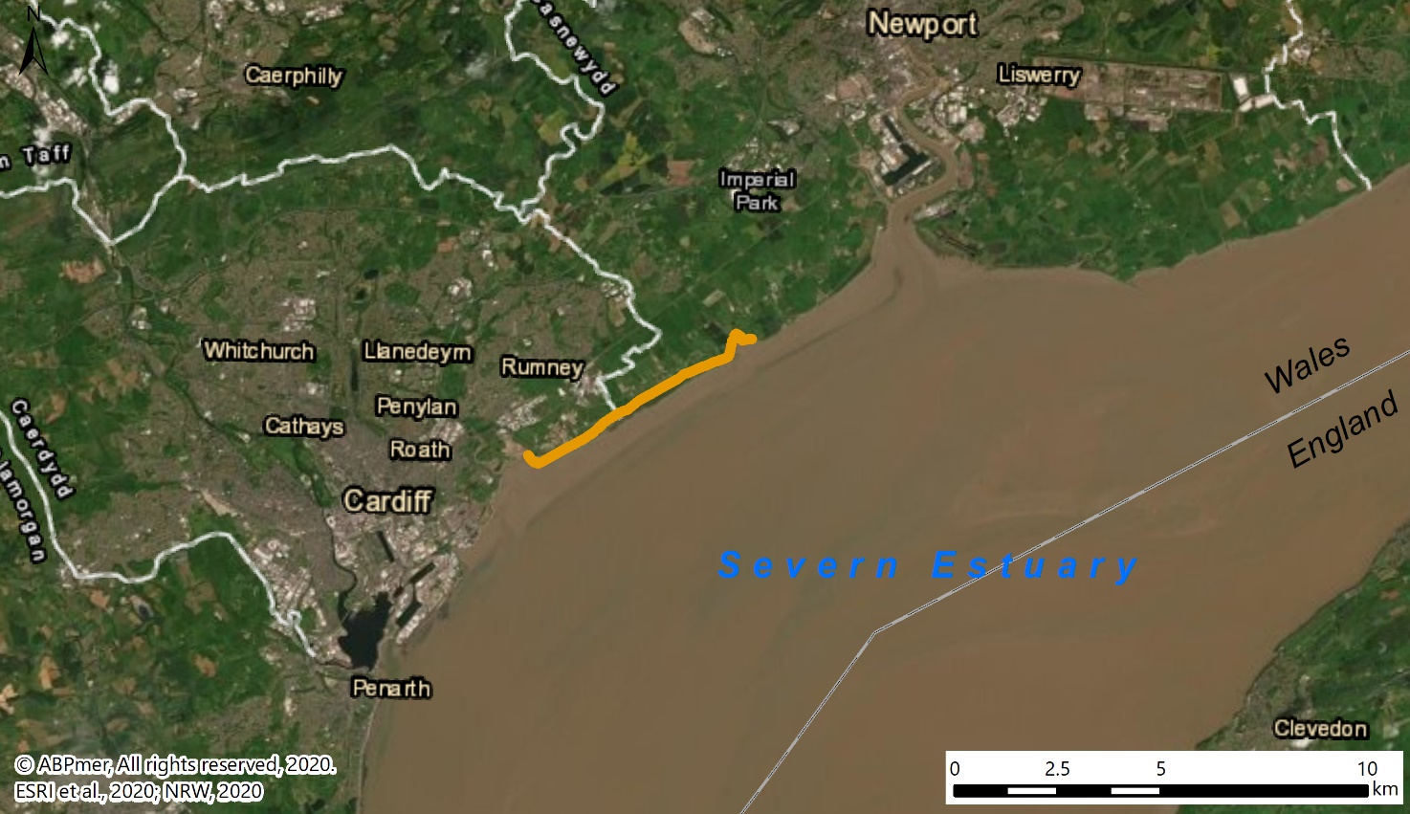
Rumney Great Wharf
to Peterstone Wentlooge
Figure 1 Location of the study area
This report is structured as follows:
- Section 2: Methodology;
- Section 3: Baseline and background review;
- Section 4: Literature review;
- Section 5: Phase 1 – Options review;
- Section 6: Phase 2 – Preferred option development and assessment; and
- Section 7: Conclusions and recommendations.

Methodology
The methodology for this project is now outlined below, with Section 2.1 covering the baseline review and Section 2.2 the literature review. These reviews were undertaken to inform and support the options design and assessment (Phase 1), as well as the Phase 2 preferred design investigations; the methodology for these phases is provided in Sections 2.3 and 2.4 respectively.

2.1 Baseline and Background Review
The baseline conditions review (see Section 3) focused on understanding the strategic context (including nature designations), the study area, as well as saltmarsh. The study area baseline has been established by:
- Undertaking a site visit;
- Reviewing relevant previous studies undertaken for the frontage (including those studying saltmarsh extent);
- Obtaining information on nearby maintenance dredging and disposal activities (for assessment of potential beneficial use options); and
- Carrying out dedicated analysis of available Light Detection And Ranging (LiDAR) to determine the current erosional trends and rates of change within the area.
With regard to the LiDAR analysis, the following have been produced:
- Spatial difference plots (demonstrating areas of change between years); and
- A series of cross sections between Rumney and Peterstone Wentlooge, detailing differences between the available LiDAR years.
Drone data was also obtained in February 2021; this was mainly utilised to review the cross section outputs from Phase 1 and inform the Phase 2 design development. Drone data was, however, only available in unfiltered format, i.e. non-ground features, most importantly vegetation, are included. In contrast the LiDAR data was available in filtered versions.
The immediate area of interest is the Rumney Great Wharf area, whereas the Peterstone Wentlooge frontage has been included in the analysis as this effectively forms part of the same functional unit, and also contains greater expanses of saltmarsh (see Figure 2).
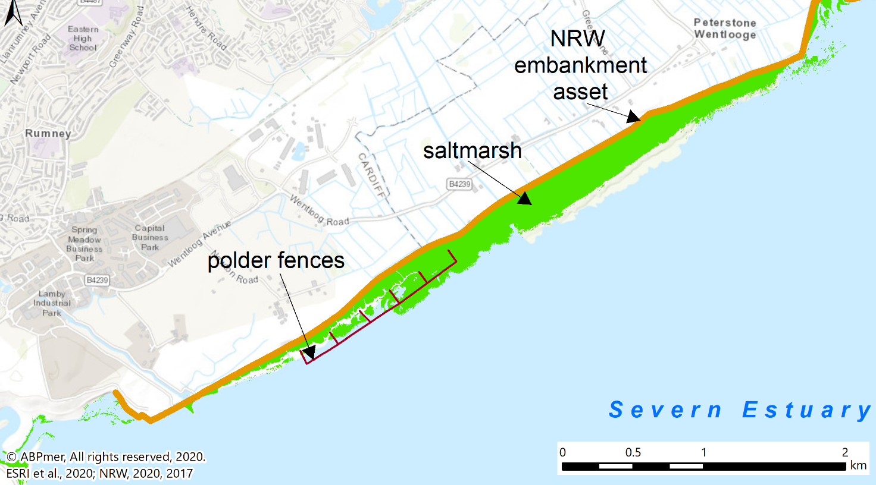
Rumney Great Wharf
(immediate study area)
Peterstone Wentlooge
(wider study area (with Rumney frontage))
Figure 2 Location of immediate and wider study area
The LiDAR datasets which have been used are detailed in Table 1; these were mostly downloaded from the Welsh Lle Geo-Portal (with the exception of 2015).
Table 1 Detail on LiDAR data used
Year | Coverage | Notes
2000 | Full | Not used for difference plots, as ‘ground-truthing’ revealed that the dataset is consistently lower than other datasets. Profile data adjusted by 0.2 m (average of difference across 15 ground truthing points). Filtered.
2005 | Full | Filtered.
2011 | Partial | Covers Rumney frontage only. Filtered.
2012 | Partial | Covers Rumney frontage only. Filtered.
2015 | Full | Provided by NRW. Filtered.
2021 | Full | Provided by NRW. Utilised for Phase 2 studies and cross sections analysis only. Unfiltered.
Considerations for LiDAR data analysis
When examining the results of the LiDAR analysis (Section 3), it is important to take account of the following key limitations to LiDAR data:
- LiDAR data has a stated vertical accuracy of around ± 0.15 m. Thus, where LiDAR analyses are presented, changes within this range should be treated with caution (for this study, changes in the ± 0.1 m range have been removed / coloured in white in the difference plots). It should also be noted that all the LiDAR datasets were ‘ground-truthed’ by checking the elevation of hard surfaces / concrete buildings present across the datasets. This led to one data set being excluded from the difference plots (2000, see Table 1), and data for the profiles being adjusted;
- Water in creeks and reflecting off mudflat can result in erroneous levels (depending on the state of the tide when the data was flown). This was not identified as an issue with the data used for this study;
- Filtering LiDAR data can leave a numeric ‘pattern’ in data and lower some areas inconsistently across different years. This was not identified as an issue with the data used for this study;
- Shadow zones in different LiDAR flights can appear falsely as significant changes in elevation and areas of the flight path that are not directly below the aircraft can show a slight increase in elevation, which can appear as a “swath” in difference plots. This was not identified as an issue with the data used for this study; and
- Changes in LiDAR technology mean that older datasets may be noisier and less reliable. This may be why the elevations in the 2000 dataset were found to be too low (see Table 1).
Despite these limitations, LiDAR offers invaluable insights into site intertidal habitat evolution which cannot be achieved by other means, particularly at sites which have a lot of mudflat due to access difficulties and safety concerns. Thus, provided the above caveats are borne in mind, LiDAR analysis is a very useful tool for assessing changes at intertidal sites, and has thus been used for this study.

2.2 Literature Review
A brief review of grey and peer-reviewed literature has been undertaken (Section 4) to provide insights into:
- Potentially suitable nature-based solutions/techniques appropriate for the Rumney baseline conditions and processes, focussing on beneficial use of dredged sediments and polder techniques and providing relevant case studies from elsewhere in the UK and Northern Europe; and
- Ecosystem services/benefits provided by saltmarshes, and the monetary benefits associated with these in past studies.

2.3 Options Review (Phase 1)
Building on the baseline, background and literature reviews, an options review has been carried out (Section 5).
This involved the following iterative steps:
- Drawing up of a long list of options;
- Discussion and selection of a short list of options during a workshop;
- Undertaking a high-level costs-benefit analysis for five options, including consideration of capital costs, maintenance requirements (where applicable) and ecosystem services related benefits. Sensitivity tests were also incorporated;
- Carrying out a high-level strengths, weakness, opportunities, and threats (SWOT) analysis (presented in the form of a brief table/matrix, see Table 11); and
- Indication of a preferred option, whilst setting out a clear rationale for its selection.
The options review has been informed by the (2019) Welsh Government Business case guidance on Flood and Coastal Erosion Risk Management (FCERM), as well as communication with relevant experts.

2.4 Preferred Option Development and Assessment (Phase 2)
Two distinct tasks have been undertaken for this phase:
- A further development of the design for the preferred option (conceptual, not engineering-stage, design); and
- An environmental scoping study.
With regard to the further design development, this was achieved through further consultation with experts, as well as a review of relevant Dutch and German literature. A further workshop also took place. In addition to refining the design, likely maintenance requirements, as well as revised costings, CBA and timescales have also been developed during this phase.
For the environmental scoping study, the key environmental constraints and opportunities associated with the preferred option have been identified. It should be noted that this was not envisaged to be a formal scoping study to accompany an Environmental Impact Assessment (EIA) process. Anticipated consenting and assessment requirements have also been identified.

Baseline and Background Review
This baseline and background review section is structured as follows;
- The strategic context is explored in Section 3.1;
- The wider background to the site is provided in Section 3.2, including physical processes information, based on existing / previous studies;
- The results of new analysis undertaken for this study are presented in Section 3.2, for the existing saltmarsh and wider foreshore trends, as identified from the review and LiDAR analysis.
- Nearby maintenance dredging and disposal activities are outlined in Section 3.4, in order to inform potential sources of sediment / material for beneficial use options.

3.1 Strategic Context

3.1.1. Introduction
As noted in Section 1, this study has been undertaken with a view to restoring or enhancing saltmarshes at Rumney Great Wharf. This has not only been motivated by nature conservation purposes, but also because saltmarshes provide protection for flood embankments (see Section 4.2 for more information on the services saltmarshes provide). Thus, a strategic context for both of these saltmarsh functions is provided below.
NRW has many roles, but with regard to this study, it is pertinent that it is both responsible for managing many of the nation’s flood defences and also protecting its (marine) environment. It also advises Welsh Government on issues relating to the environment and its natural resources, and is responsible for marine licensing in Wales.
There are a myriad of drivers for saltmarsh restoration. Many international drivers exist, and have often informed / fed into Welsh legislation and policy, which is outlined further in Section 3.1.2 below. International drivers include the 2020 Leaders’ Pledge for Nature, the Global Ocean Alliance and the Post-2020 Global Biodiversity Framework, to name but a few.
It is also worth noting that the restoration of the saltmarsh habitats, and the methods being considered as part of this study, can be interpreted as constituting nature-based solutions. The International Union for Conservation of Nature (IUCN) defines such solutions as ‘actions to protect, sustainably manage, and restore natural and modified ecosystems that address societal challenges effectively and adaptively, simultaneously providing human well-being and biodiversity benefits’.

3.1.2. Welsh legislation, policy and plans
Key Welsh policies, legislation and plans with regard to saltmarsh restoration are now outlined below, to provide the context for a scheme at Rumney Great Wharf.

Well-being of Future Generations (Wales) Act 2015

The Well-being of Future Generations (Wales) Act 2015 seeks to improve the social, economic, environmental and cultural well-being of Wales. This Act put in place seven well-being goals which are outlined in Image 1. Under the ‘resilient Wales’ goal, it aims to create ‘a nation which maintains and enhances a biodiverse natural environment with healthy functioning ecosystems that support social, economic and ecological resilience and the capacity to adapt to change (for example climate change).'

Restoring (and maintaining) the marshes at Rumney, would thus help achieve the ‘resilient Wales’ goal, but would also aid in realising others, such as those in relation to global responsibility and health.

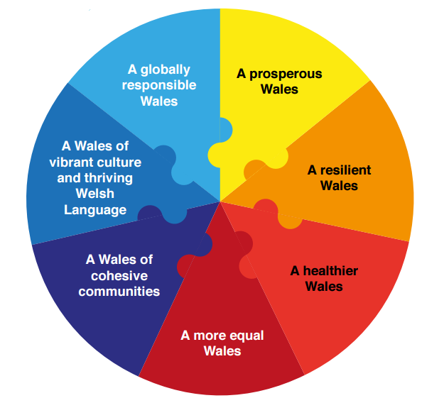
Welsh Government, 2015
Image 1 Seven wellbeing goals of the Well Being of Future Generations (Wales) Act 2015

Environment (Wales) Act 2016

The Environment (Wales) Act 2016 sets out the requirement for the ‘sustainable management of natural resources’. While ‘restoration’ is not explicitly outlined, Sections 3, 4, 6 and 7 of the Act are the key sections which are of relevance to ‘restoration’. Section 3 on the ‘Sustainable management of natural resources’ for example notes that objective is to ‘maintain and enhance the resilience of ecosystems and the benefits they provide’. Section 4 sets out principles for the sustainable management of natural resources, and notes the “principles of sustainable management of natural resources” are to;

‘(a)manage adaptively, by planning, monitoring, reviewing and, where appropriate, changing action;
(f)take account of the benefits and intrinsic value of natural resources and ecosystems;
(i)take account of the resilience of ecosystems, in particular the following aspects—
(iv)the condition of ecosystems (including their structure and functioning).’

Section 6 of the Act requires public authorities to seek to ‘maintain and enhance biodiversity […] in the exercise of their functions’. Section 7 additionally requires Welsh Ministers to publish a list of living organisms and habitats in Wales, which are considered of key significance to sustain and improve biodiversity in relation to Wales Section 7 of the Act.

The Act also notes that the Welsh Ministers must ‘take all reasonable steps to maintain and enhance the living organisms and types of habitat included in any list published under this section and encourage others to take such steps’.

Saltmarshes and mudflats are listed as being ‘of principal importance’ under Section 7 of the Environment (Wales) Act 2016.

The 2017 Natural Resources Policy

The Natural Resources Policy focusses on improving the way Wales’ natural resources are managed. This is a key part of the delivery framework for the sustainable management of natural resources, as established by the Environment (Wales) Act.

The policy highlights three main challenges faced with regard to natural resources as follows:

- Improving ecosystem resilience;
- Climate change and the decline in biological diversity; and
- The UK’s Withdrawal from the EU.

In addition, three national priorities for the management of Wales’ natural resources are listed, namely:

- Delivering nature-based solutions;
- Increasing renewable energy and resource efficiency; and,
- Taking a place-based approach.

Area Statements were developed in response to this policy; it is noteworthy that the Welsh Marine Area Statement has three themes, one of which is ‘nature-based solutions and adaptation at the coast’.

The 2020/21 Nature Recovery Action Plan for Wales

Welsh Government published the national biodiversity strategy ‘The Nature Recovery Action Plan for Wales’ in 2015, and refreshed it in 2020/21. Its ambition is to ‘halt the decline in biodiversity by 2020 and then reverse the decline, for its intrinsic value, and to ensure lasting benefits to society. The Plan sets out how Wales will deliver the commitments of the UN convention on biological diversity, the strategic plan for biodiversity 2011-2020 and the 20 associated Aichi targets (a short term framework for action), as well as the EU biodiversity strategy. It confirms that resilient ecological networks are vital for nature recovery.

The 2020 National Strategy for Flood and Coastal Erosion Risk Management in Wales

The Flood and Water Management Act 2010 sets out how Welsh Ministers must develop, maintain and apply a National Strategy for Flood and Coastal Erosion Risk Management (FCERM) in Wales. Such a Strategy was published in 2020, and it sets out how Welsh Government intends to manage the risks from flooding and coastal erosion across Wales over the next 10 years, whilst strengthening and clarifying roles and responsibilities.

The strategy gives support to Natural Flood Management (NFM), where appropriate. This is the term most widely used in flood risk management when describing nature-based solutions. Measures 13 and 14 of the strategy are particularly pertinent in this regard:

- ‘Measure 13: The Welsh Government will fully fund NFM schemes for a trial period, commencing 2020/21, and publish new guidance to further encourage take-up and the sharing of lessons on its practical delivery.
- Measure 14: The Welsh Government will work cross policy to ensure NFM is considered in wider land and water management, including agriculture and in NRW Area Statements.’

NRW is one of the risk management authorities as defined by the Flood and Water Management Act 2010, with an interest in flooding from main rivers and the sea. Protecting the environment and managing flood risk is a key function delivered by the organisation. NRW has powers to work on main rivers and the sea to manage flood risk. However, it does not have a duty to maintain or construct new works on main rivers or the sea.

Planning Policy and Plans

Intertidal habitats fall under both terrestrial and marine planning rules and regulations; for terrestrial aspects, the Planning Policy Wales, and associated advice notes, provide guidance. The 2021 National Plan, Future Wales, sets the direction for terrestrial development, whereas for marine matters, the 2019 Welsh National Marine Plan should chiefly be considered.

Planning Policy Wales (2016 / 2021)

The Planning Policy Wales (PPW), which was first published in 2016 (and last updated in 2021) primarily sets out ‘to ensure that the planning system contributes towards the delivery of sustainable development and improves the social, economic, environmental and cultural wellbeing of Wales, as required by the Planning (Wales) Act 2015, the Well-being of Future Generations (Wales) Act 2015 and other key legislation’ (Welsh Government, 2018). PPW includes specific policies on conserving and enhancing the natural environment through planning. It states that the planning system should contribute to the delivery of sustainable development and improve the social, economic, environmental and cultural well-being of Wales. The PPW and the associated 2021 National Plan ‘Future Wales’ concentrate on development and land use issues of national significance, indicating areas of major opportunities and change, highlighting areas that need protecting and enhancing and helping to co-ordinate the delivery of Welsh Government.

Technical advice notes (TANs) have been produced in connection with the PPW, for example, TAN 5 is on ‘nature conservation and planning’.

Future Wales – the 2021 National Plan

Future Wales – the National Plan 2040 is the Welsh national development framework, setting the direction for development in Wales to 2040. Future Wales is a spatial plan, which means it sets a direction for where there should be investment in infrastructure and development for the greater good of Wales and its people. Future Wales’ defines 11 ‘Outcomes’, which are overarching ambitions to be achieved by 2040, based on the national planning principles and national sustainable placemaking outcomes set out in PPW.

Outcomes 9 to 11 are particularly pertinent for this report; these aim to achieve ‘A Wales where people live’:

- (9) ‘... in places that sustainably manage their natural resources and reduce pollution’;
- (10) ‘... in places with biodiverse, resilient and connected ecosystems’; and
- (11) ’... in places which are decarbonised and climate‑resilient’.

The 2019 Welsh National Marine Plan (WNMP)

The Welsh National Marine Plan (WNMP) was prepared and adopted under the Marine and Coastal Access Act 2009 and in conformity with the UK Marine Policy Statement. It represents the start of a process of shaping Welsh seas to support economic, social, cultural and environmental objectives. Its overarching objective is to

‘Support the sustainable development of the Welsh marine area by contributing across Wales’ well-being goals, supporting the Sustainable Management of Natural Resources (SMNR) through decision making and by taking account of the cumulative effects of all uses of the marine environment’.

Under the topic ‘living within environmental limits’, the following key objectives of note to this report are as follows:

- ‘Support the achievement and maintenance of Good Environmental Status (GES) and Good Ecological Status (GeS).
- Protect, conserve, restore and enhance marine biodiversity to halt and reverse its decline including supporting the development and functioning of a well-managed and ecologically coherent network of Marine Protected Areas (MPAs) and resilient populations of representative, rare and vulnerable species.
- Maintain and enhance the resilience of marine ecosystems and the benefits they provide in order to meet the needs of present and future generations.’

Many of the policies require the observation of the Environmental Impact Assessment (EIA) mitigation hierarchy. Notably, Policy ENV_01 on ‘Resilient marine ecosystems’ states:

‘Proposals should demonstrate how potential impacts on marine ecosystems have been taken into consideration and should, in order of preference:

a. avoid adverse impacts; and / or
b. minimise impacts where they cannot be avoided; and / or
c. mitigate impacts where they cannot be minimised.

If significant adverse impacts cannot be avoided, minimised or mitigated, proposals must present a clear and convincing case for proceeding. Proposals that contribute to the protection, restoration and / or enhancement of marine ecosystems are encouraged.’

Policy ENV_01 aims to ‘ensure that biological and geological components of ecosystems are maintained, restored where needed and enhanced where possible, to increase the resilience of marine ecosystems and the benefits they provide’. Under this policy, ‘the sensitivities of marine ecosystems and ecosystem impacts should be taken into account when developing proposals and, where possible, proposals should also demonstrate how they will contribute to ecosystem protection, restoration and/or enhancement’.

Also particularly noteworthy is policy ENV_02 on MPAs, which states:

‘Proposals should demonstrate how they:

a. avoid adverse impacts on individual Marine Protected Areas (MPAs) and the coherence of the network as a whole;
b. have regard to the measures to manage MPAs; and
c. avoid adverse impacts on designated sites that are not part of the MPA network.’

There is also a table in the WNMP detailing the Plan policies that support the achievement of Good Environmental Status under the Marine Strategy Framework Directive (MSFD), and the achievement of Water Framework Directive (WFD) goals are referenced in connection with Policy ENV_06 on ‘Air and water quality’.

In 2020, Welsh Government published an implementation guidance document to support the effective and consistent implementation of WNMP policies..

3.1.3. European Directives / transposing regulations (and designations at the site)
The transposing regulations on EIA, WFD and MSFD referenced in the WNMP have been transposed into various pieces of UK and Welsh regulations / legislation, which are not listed separately here. However, these can all drive saltmarsh creation to varying degrees, as can other legislation related to European transposing regulations, notably the Birds and Habitats Directives. The latter seek to establish a network of protected sites, which are known as Special Protection Areas (SPAs) and Special Areas of Conservation (SACs). Marine SACs and SPAs, as well as other internationally and nationally protected sites, make up Wales’ MPA network, which is what WNMP policy ENV_02 refers to.

It is worth noting that, post Brexit, the provisions of the above mentioned directives generally remain; as they are implemented in national law, with adjustments to account for Brexit. For example, the Habitats Regulations have been amended by The Conservation of Habitats and Species (Amendment) (EU Exit) Regulations 2019, which mirror existing provisions.

The Rumney frontage lies in several MPAs; the designations local to the site are now outlined in the following section.

Designations at the Site
The Severn Estuary foreshore has international and national importance, reflected by the following designations:, Special Protection Area (SPA), Special Area of Conservation (SAC), Ramsar and Site of Special Scientific Interest (SSSI). The foreshore is part of the following sites (see Figure 3):
- The Severn Estuary / Môr Hafren Special Area of Conservation (SAC);
- The Severn Estuary / Môr Hafren Special Protection Area (SPA);
- The Severn Estuary / Môr Hafren Ramsar site; and
- The Severn Estuary Special Scientific Interest (SSSI). .

The study area is located seaward of the Wentlooge Sea Defences. The Wentlooge Levels are part of a SSSI site, specifically the Gwent Levels SSSI (Rumney and Peterstone section).
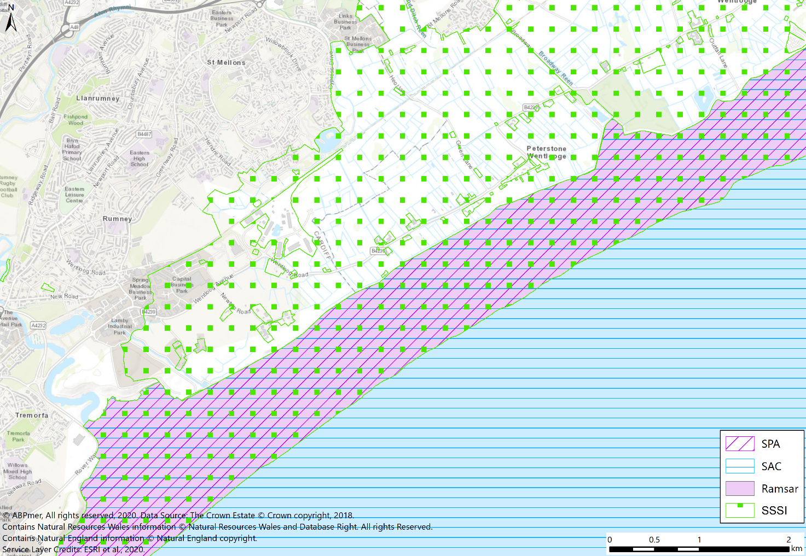
Figure 3 Designations at Rumney to Peterstone Gout
In summary, the following habitats and species are protected features under international designations in, or near, the study area (based on Natural England and CCW, 2009):
- Sandbanks which are slightly covered by sea water all the time - The Severn Estuary subtidal sandbanks contribute approximately 3% of the UK Natura 2000 resource for subtidal sandbanks, by area. The sandbanks play an important role in holding and supplying sediment for other habitats, and it is likely that subtidal invertebrate communities play a role as a food resource for some species of the fish assemblage feature of the SAC and Ramsar site;
- Estuaries - The Estuary is important for its immense tidal range, which affects both the physical environment and the diversity and productivity of the biological communities. The estuary is an over-arching feature which incorporates all aspects of the physical, chemical and biological attributes of the estuary ecosystem;
- Mudflats and sandflats not covered by seawater at low tide - The intertidal part of the Estuary supports extensive mudflats and sandflats, covering an area of approximately 20,300 hectares (ha) - the fourth largest area in a UK estuary and representing approximately 7% of the total UK resource of this habitat type;
- Reefs - The Estuary has areas of biogenic reefs, formed by the tube-dwelling polychaete worm Sabellaria alveolata.;
- Atlantic salt meadows (Glauco-Puccinellietalia maritimae) - The Estuary holds the largest aggregation of saltmarsh in the south and south-west of the UK, covering approximately 1,400 hectares, representing about 4% of the total area of saltmarsh in the UK. Saltmarshes and mudflats have an important role to play in estuarine processes, both through the recycling of nutrients and through their role as soft sea defences, dissipating wave energy. They are also highly productive biologically, and act as a sediment store to the estuary as a whole;
- Migratory fish - The Estuary is of particular importance for migratory fish, particularly for three rare species - river lamprey (Lampetra fluviatilis), sea lamprey (Petromyzon marinus) and twaite shad (Alosa fallax), which are designated features of the SAC. The estuary habitats, tidal stretches of the feeding rivers and saltmarsh morphological features, such as drainage and marsh channels, provide important feeding, breeding and sheltered nursery areas for a wide range of fish; and
- Birds (non-breeding) - The Estuary forms part of the complex chain of estuary sites along the western coast of the UK that provide habitats for migratory waterfowl. Bird species designated as qualifying features of the SPA include Bewick’s Swan, Common Shelduck, Gadwall, Dunlin, Common Redshank, and Greater White-fronted Goose. The Severn Estuary ranks amongst the top ten British estuaries for the size of visiting waterfowl populations that it supports over winter.
The Severn Estuary SSSI is noted for numerous features, most of which have been listed in relation to the international designations above, noting that, with regard to intertidal habitats, the citation lists the following habitats of relevance to the study area frontage:
- Sheltered muddy shores (including estuarine muds); and
- Saltmarshes - Zostera communities; transitional low marsh vegetation with P. maritima, annual Salicornia species and Suaeda maritima, Rayed A. tripolium, P. maritima, P. maritima dominant sub-community, Halimione portulacoides, Juncus maritimus - Triglochin maritima, Festuca rubra, P. maritima sub-community, Artemisia maritima, A. maritimus, Spergularia marina – P. distans, Elytrigia atherica saltmarsh, E. repens, S. Anglica, Annual Salicornia, S. Maritima.

The Gwent Levels SSSI is important due to:
- Reclaimed wet pasture - Reen and ditch habitat; notable plants include hairlike pondweed Potamogeton trichoides, arrowhead Sagittaria sagittifolia, water-crowfoot Ranunculus trichophyllus, small pondweed P. berchtoldii, grass vetchling Lathyrus nissolia and common meadow-rue Thalictrum flavum;
- Insects and other Invertebrates - Very diverse aquatic invertebrate fauna; notable species include Haliplus mucronatus and Hydrophilus piceus, Physa heterostropha and Brachytron pratense. Notable terrestrial invertebrates include the shrill carder bee Bombus sylvarum,. true fly Chrysogaster macquarti, the beetle Hydaticus transversalis and the fly Stenomicra cogani.

3.2 Site Background (Previous Studies)

3.2.1 Estuary-wide processes
The Severn Estuary has the largest tidal range in the United Kingdom (UK), and the second largest in the world. The large and rapid rise and fall of the tides leads to very strong currents through the main body of the estuary (ABPmer, 2009).
These strong currents maintain deep channels and high suspended sediment loads. The estuary is very turbid, with suspended sediment concentrations (SSC) increasing upstream to peak around Sharpness on spring tides. Estimates of SSC vary from 13 million tonnes to 30 million tonnes during spring tides, and 4 million to 9 million tonnes during neaps. This suspended load is thought to generally be at a capacity level, i.e. the amount is relatively constant. SSCs vary significantly and have been measured at >250 mg l⁻¹ to <10,000 mg l⁻¹ in the estuary. These high concentrations are held in suspension throughout the estuary, and are largely prevented from accumulating permanently by the strong tidal currents (ABPmer, 2009).
New material is added to the sediment regime from: the erosion of inter- and subtidal habitats and cliffs, inputs from fluvial sources and marine supply from the Bristol Channel. The greatest volumes of suspended sediments originate from fluvial sources, notably the Rivers Wye, Avon and Severn. Estimates of their collective contribution range from 0.7 to 0.9 million tonnes year⁻¹ (Parker and Kirby, 1982) to 1.25 million tonnes year⁻¹ (Severn Tidal Power Group, 1989).
As a whole, the Severn Estuary is presumed to be under erosional pressure due to rising sea levels and as a major portion of the original natural intertidal area has been reclaimed over the past 2,000 years, hence being affected by coastal squeeze. Both high and low water levels are moving landwards over much of its shoreline. A seasonal influence over intertidal habitat erosion and accretion has furthermore been observed in the estuary. During the summer months, the intertidal areas typically accumulate muddy material, much of which is then removed during periods of greater wave action (i.e. winter storms) (ABPmer, 2009).
The wave climate within the Severn Estuary is considered to be mainly wind generated, with exposure to Atlantic swell waves limited by the change in orientation of the estuary around Flat Holm and Steep Holm (approximately 13 km to 19 km south-south west from the study area). The wave conditions are a function of the exposure to the direction of prevailing winds and fetch distances. At high water, wave fetches can extend over long distances, whereas at low water, intertidal banks dramatically reduce fetches (ABPmer, 2009).

3.2.2 Study area characterisation

General site background
The Rumney Great Wharf to Peterstone Wentlooge frontage lies on the Welsh side of the Severn Estuary, stretching from the mouth of the River Rhymney tributary to an inlet known as Peterstone Gout. The wider study area frontage is nearly 5 km in length, with the Rumney Great Wharf frontage accounting for around 3 km of this. At the study area, the Severn Estuary is between 15 km and 16 km wide.
The local foreshore is home to extensive mudflats and strips of saltmarsh of varying widths, which, along the Rumney frontage, have been faced with rock armour in order to try and halt erosion. Furthermore, wooden fences filled with brushwood have been installed along parts of the frontage in order to better retain sediment (see below for more detail on these measures). The intertidal habitats are backed by substantial embankments which have crest heights which range between 8.8 m and 11 m Ordnance Datum (OD). These embankments protect a large area of flat, low-lying land known as the Wentlooge Levels, which are home to many residential buildings, farms and businesses. Substantial parts of these levels would be inundated with tidal waters on a daily basis without the protection provided by the embankments.
Tide levels have been obtained for the ports nearest to the study area (Cardiff and Newport), and interpolated for the Rumney and Peterstone Wentlooge frontages. These are displayed in Table 2 below, which demonstrates that the mean spring tidal range at the frontage measures approximately 11.3 m, whereas during neap tides, it is 5.2 m.
Table 2 Tide levels for the nearest ports and the study area frontage
Parameter | Astronomic Tidal Level for nearest port (UKHO) Cardiff  m CD | Astronomic Tidal Level for nearest port (UKHO) Cardiff  m OD | Astronomic Tidal Level for nearest port (UKHO) Newport  m CD | Astronomic Tidal Level for nearest port (UKHO) Newport  m OD | Interpolated tide levels Rumney  m OD * | Interpolated tide levels  Peterstone m OD*
Highest Astronomic Tide (HAT) | 13.50 | 7.30 | 13.60 | 7.79 | 7.51 | 7.58
Mean High Water Spring (MHWS) | 12.30 | 6.00 | 12.30 | 6.49 | 6.21 | 6.28
Mean High Water Neap (MHWN) | 9.10 | 2.80 | 8.90 | 3.09 | 2.92 | 2.97
Mean Sea Level (MSL) | 6.58 | 0.28 | 6.26 | 0.45 | 0.35 | 0.38
Mean Low Water Neap (MLWN) | 4.00 | -2.30 | 3.60 | -2.21 | -2.26 | -2.25
Mean Low Water Spring (MLWS) | 1.20 | -5.10 | 0.80 | -5.01 | -5.06 | -5.05
Lowest Astronomic Tide (LAT) | -0.10 | -6.40 | -0.40 | -6.21 | -6.32 | -6.29
Astronomic Tidal Range (HAT-LAT) | 13.60 | N/A | 14.10 | N/A | 13.83 | 13.87
Spring Range (MHWS-MLWS) | 11.10 | N/A | 11.50 | N/A | 11.27 | 11.33
Neap Range (MHWN-MLWN) | 5.10 | N/A | 5.30 | N/A | 5.18 | 5.22
*based on linear interpolation between Cardiff and Newport tide levels, with the distance between the Cardiff and Newport stations set at 16.5 km (as crow flies).
The Rumney to Peterstone Gout frontage is not exposed to the Atlantic swell; however, the maximum wave fetch (i.e. with regard to wind generated waves) is considerable, at up to 48 km (from a south-westerly direction). Predominant wind directions in the area are shown by a wind rose extracted for a mid-estuary location 9 km south/south-east of the Rumney to Peterstone frontage (ABPmer, 2019a). As the aspect of the Rumney to Peterstone frontage is approximately south-west to north-east, it would not be affected by the predominant westerly winds, which would be from the land. The winds with greatest wave effects on the marshes are therefore likely to be from the south, albeit at lower frequency and, and the south-west, with the effects of diffraction around Penarth.
Depth-averaged tidal current speed data extracted from a Severn Estuary tide model along the frontage peak at around 1 m s⁻¹ in the subtidal (2 km offshore) during springs, and 0.5 m s⁻¹ over the mudflats (0.3 to 0.5 km from the shore / defence crest), with flows predominantly aligned with the high water mark, except near the saltmarsh creeks and inlets.
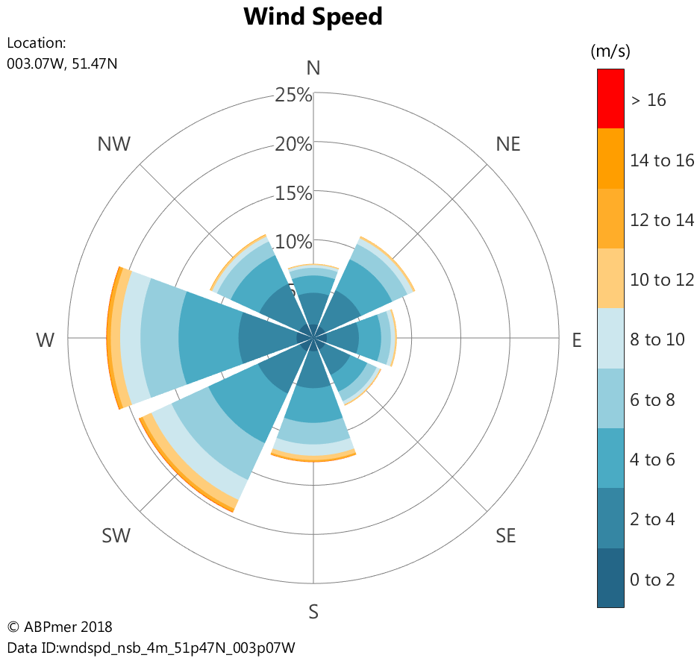
Source: ABPmer, 2019a (based on National Centers for Environmental Prediction 1979 to 2018 hindcast data)
Image 2 Wind rose derived from 40-year hindcast data, for nearby mid-estuary location
There are no major inlets along the frontage, apart from those bounding it, with some minor freshwater inputs from three outfalls, and the Rhymney river.

Intertidal habitats and changes noted by previous studies
As noted above, the foreshore at the Rumney to Peterstone Gout frontage is dominated by wide mudflats and strips of saltmarsh of varying widths.
Such intertidal habitats are generally thought to develop between the levels of the highest astronomical tides (HAT) and mean low water springs (MLWS) on tide-dominated, sheltered, coasts, where the predominant sediments are silts and muds. These fine sediments are kept in suspension where currents are fast, before settling onto the bed and accreting, when the currents are slowest (French, 1997). Intertidal areas can accumulate sediment / accrete where SSC are sufficient, with systems with large SSC known to demonstrate rapid rates of accretion, where conditions are sufficiently calm.
The intertidal surficial sediments of the frontage vary from consolidated cohesive muds, a mud veneer overlying coarser material, mixed sediments to exposed sands (Atkins, 2004).
The high saltmarsh along the Rumney to Peterstone Gout frontage, which locally has traditionally been referred to as a ‘wharf’, is home to a variety of upper saltmarsh grasses which are grazed by cattle and horses and therefore more or less severely cropped (Atkins, 2004).
Lower marsh (traditionally referred to as ‘saltings’) is generally separate from the high marsh by a more or less pronounced cliff (over 3 m high in places) and composed of pioneer species, notably Spartina (Dargie, 1999). Other species observed amongst the Spartina marshes along the Rumney frontage, during the site visit undertaken for this study in August 2020, include: Aster tripolium, Spergularia sp., Puccinellia maritima, Plantago maritima and Triglochin maritima. Although the saltings’ elevation is typically lower than the wharf, it does generally have much greater height of foliage. Image 3 shows photographs of low to high marshes along the frontage.
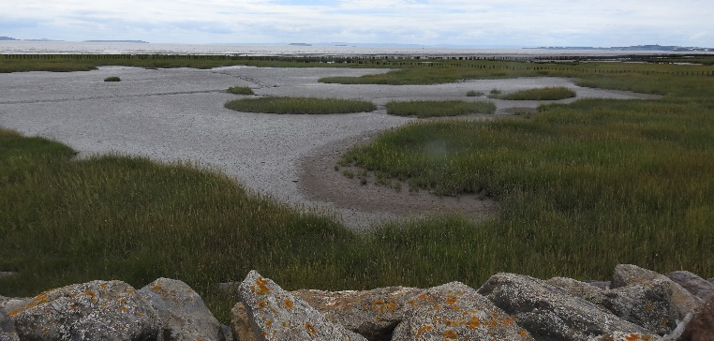 | 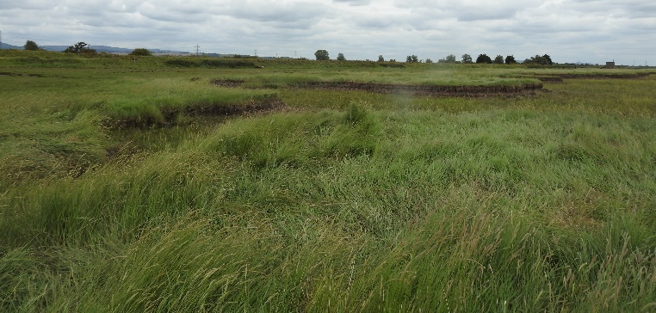
Taken by ABPmer, 2020
Image 3 Spartina dominated low marsh (Rumney frontage) (left) and mid to high marsh (Peterstone frontage), including cliff (right)
Atkins (2004) reviewed previous studies on foreshore changes along the Wentlooge and adjacent Gwent level frontages. The authors provided the following relevant extract from O’Brien (1998):
“The Rumney Valley Sewer provides long term evidence of the erosion of the mudflat [as it] traverses the mudflat. When the outfall was constructed in 1926, it was initially below the level of the mudflat surface but in subsequent years the piles of the structure have become increasingly exposed. By the 1970s, the piles were exposed by about 2 m and by the late 1980s up to 3 m (Kirby, 1994). Kirby (1994) also observed that erosion had been the slowest on the upper shore. This compares well with the situation at Peterstone, where the erosion of the Wentloog formation is less on the upper flat than on the lower. In the year between 1996 – 97, there was 5.9, 10.5 and 6.7 cm of erosion of the exposed Wentloog sediment at Stations A – G respectively [along a transect near Peterstone Wentloog]. When compared with the main erosion rate of 4.3 cm/yr since the 1920s (Kirby, 1994), this suggests that the autumn/winter of 1996/97 was particularly erosional. The long term trend of continual erosion is attributed to sea-level rise (Allen, 1990; Kirby, 1994).”
Analysis of change at a timber and stake breakwater between the Rumney and Peterstone frontage constructed in 1965 suggests that the foreshore here had fallen by approximately 0.01 m yr⁻¹ by 2002 (Atkins, 2004). Therefore, a rate of foreshore lowering of between 0.01 m and 0.04 m yr⁻¹ has been estimated for the study area in the past. Atkins (2004) found evidence of a reduction to erosion rates, in an easterly direction along Rumney Great Wharf. This was largely based on the interpretation of the retreat of the seaward limit of remnant field ditches that traverse the foreshore. It was stated that:
“Increasing numbers of field ditches are becoming exposed along the westerly sections of Rumney Great Wharf. For the eastern areas of Rumney Great Wharf, field ditches that were present in 1946 continue to be present, indicating more marginal erosion.”
Aerial imagery interpretation undertaken by Atkins (2004) furthermore revealed that, at Peterstone Great Wharf, the foreshore had accreted during the post war period, having been colonised by Spartina (or planted with it; ABPmer (2009) note a planting campaign along the frontage in the 1950s). However, temporal variability was observed, as there was apparently net erosion of the saltings between 1971 and 1994, whilst exhibiting relative stability between 1994 and 1999 (with some erosion along the Rumney frontage evened out by accretion along the Peterstone frontage). Please note that further analysis of more recent saltmarsh change encompassing the effects of the polder construction and rock protection (described in next section) placed in 2005 is provided in Section 3.3.

Previous management interventions
Authorities have in the past undertaken interventions in order to slow or halt the erosion of the intertidal habitats at Rumney to Peterstone Gout. Pre-1990s interventions are not known, with the exception of the brief mention of the Spartina planting campaign in the 1950s in ABPmer (2009).
In 1999, a sedimentation polder was implemented by the Environment Agency Wales along the eastern extent of the Rumney frontage (NRW, personal communication), and, in 2005, four more polders were installed to the west of the older polder. These involved the use of two rows of 3 m-long ‘tanalised’ larch stakes at 600 mm centres, with rows 300 mm apart and stakes driven 1.5 m into the mudflat, with willow bundles weaved in-between to a height of 1 m above the mudflat surface. Image 4 is a photograph taken during construction, Image 5 shows a construction drawing, and Figure 4 shows an annotated aerial image of the five polders, numbered from west to east, with Polder 5 representing the oldest, 1999, polder. This work was “an attempt to capture sediment to reinstate the higher level of the mudflats and was carried out over a total length of 2 km” (NRW, 2018).
The intention was for the fencing to be inspected annually and appropriate remedial work to be undertaken if necessary. However, this does not appear to have been the case as, by 2010 at the latest, the willow bundles had largely been washed away, and fencing had become damaged in several locations (as evidenced by a photograph shown in NRW, 2018). During the 2020 site visit, no willow bundles were observed in Polders 1 to 4, with some material remaining in the fencing for Polder 5 (see Image 6 (right)). Extensive damage to the fence posts was furthermore apparent, with those of Polder 1 particularly badly affected, see Image 7. Monitoring has not been undertaken to gauge the success of the polders (NRW, personal communication). The works cost £190,000 in 2005 (£290,000 in 2019 prices; this equates to £202 m⁻¹). Please refer to Section 4.2 for further background on this technique, and Section 3.3.3 on insights on the success of the polders.
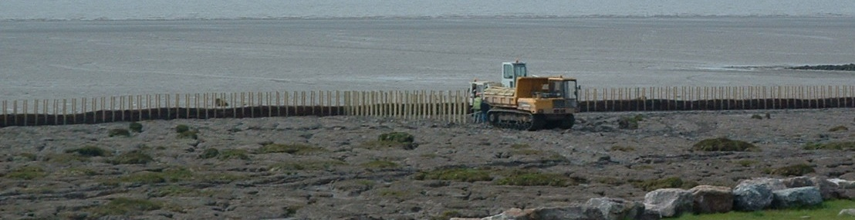
Taken by NRW, 2005
Image 4 Picture of polder fencing under construction
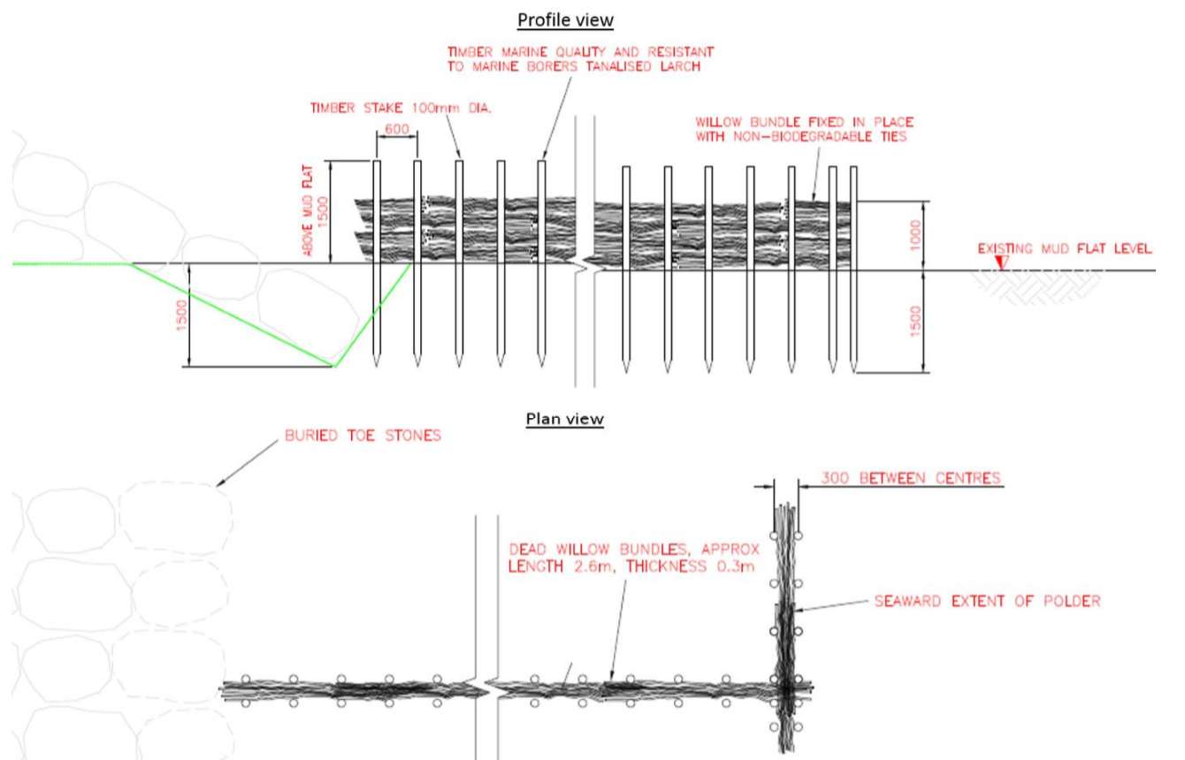
Source: NRW, 2018
Image 5 (Atkins) construction drawing for polders
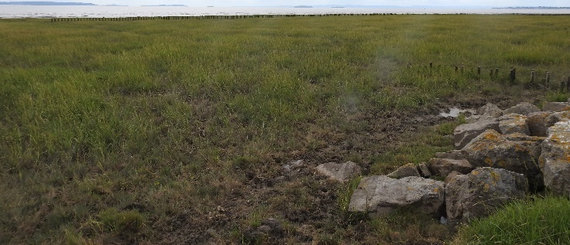 | 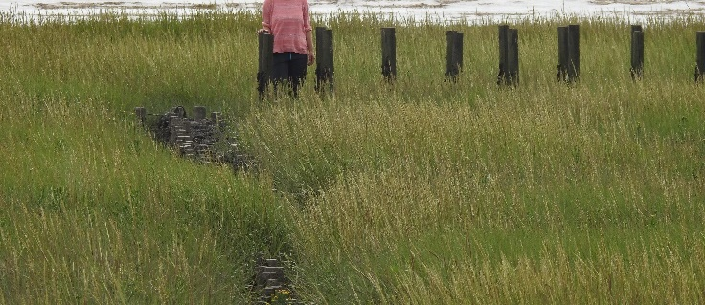
Taken by ABPmer, 2020
Image 6 View from Polder 5 towards Polder 4 (left); zoomed view of corner where 1999 polder fence meets 2005 posts (right)
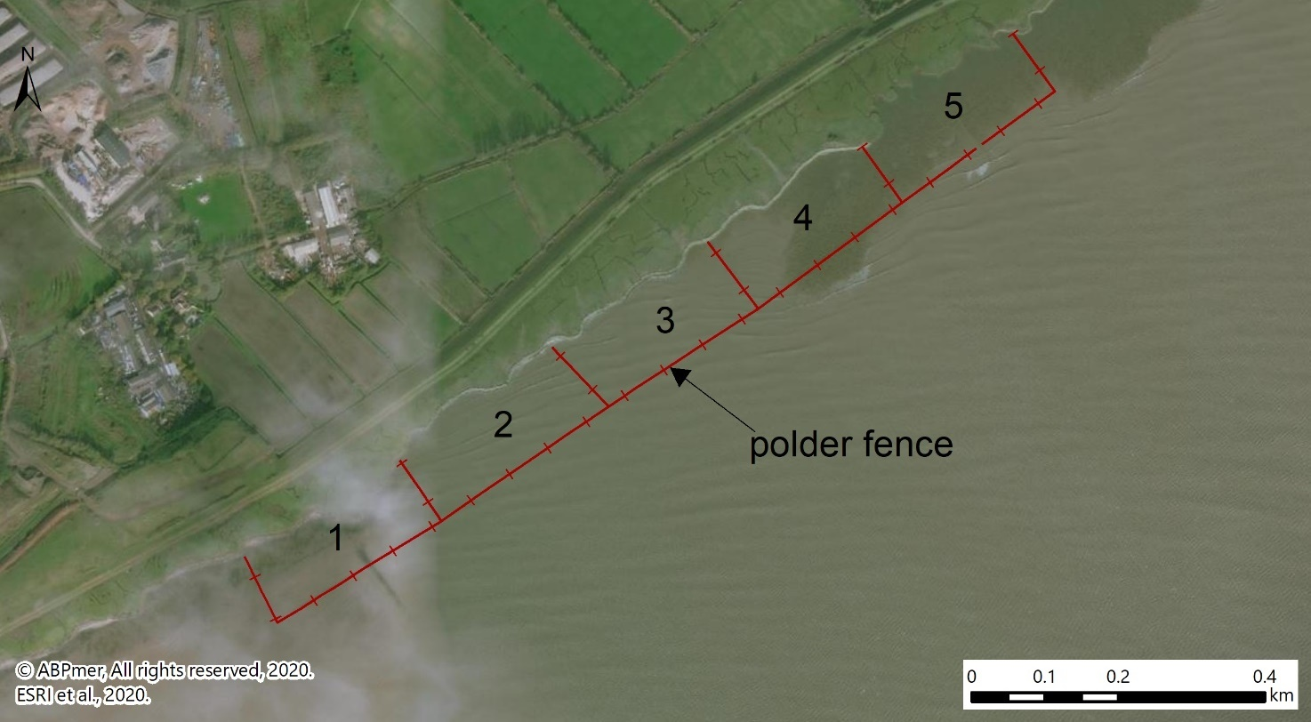
Figure 4 Annotated aerial image showing location of the five polders at Rumney
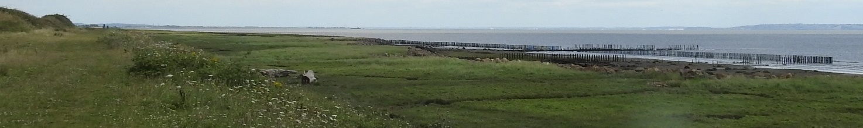
Taken by ABPmer, 2020
Image 7 View towards polders from western outfall (showing damaged posts at Polder 1)
Please note that there appear to have been differences in the construction methods between the 1999 and 2005 polders. Firstly, the 1999 posts were noticeably shorter, and are thus less evident in the landscape today (see Image 6). Secondly, anecdotally, the means of tying the brushwood bundles together, as well as securing these to the posts, may have been more robust for the 1999 polder. This may at least partially explain why some of the bundles remain at Polder 5; however, relatively rapid accretion around the bundles would also have aided in retaining these.
Communication with a company which has been involved with brushwood installation in the UK marine environment on several occasions highlights that brushwood can, at best, be expected to last for five to eight years, and, at worst, it can be broken down and washed away in little as three years (Salix, personal communication). This is particularly the case in exposed locations, where movement induced by tidal currents and waves leads to the branches rubbing against each other, which makes them brittle more quickly. Making sure brushwood bundles are compressed and well tied down helps limit movement; thus brushwood can persist for longer. In addition, brushwood derived from harder woods tend to last longer. The willow branches used at Rumney in 2005 are classed as soft wood.
In 2005, major works to revet the saltmarsh cliff between the saltings and the wharf were also undertaken (over a length of around 1.5 km, along the Rumney frontage only). Major channels were also infilled with large stones, many of which had come close to the foot of the embankments. Stones protecting these cliffs are visible in Image 3 and Image 4 above. These wharf edge block works seem to have largely worked, though some limited erosion behind the stones has been observed during inspection visits, at at least two locations (as evidenced by NRW 2018 inspection photos).

3.3 Foreshore and Saltmarsh Trends (New Analysis)

3.3.1 Saltmarsh trends along the study area frontage
As noted in Section 3.2, the saltmarshes and mudflats at the frontage have long been exhibiting an erosive trend. To gain further insights into this, post-war saltmarsh extent data held by NRW has been analysed to both determine approximate rates of erosion and gain insights into the role the polders have played in slowing this trend.
Results are provided in Table 3. Noting the caveats outlined in the table with regard to the older datasets, particularly pre-2000, the table shows that, in the early 1950s, some 103 ha of saltmarsh could be found in the wider study area. By 1988/89, this had reduced by 17% to 86 ha and in 2017, 81 ha remained (a reduction of 22% when compared to the 1950s). This equates on average to a loss of 0.3 ha per annum in the wider study area. Losses will, however, probably have been higher due to earlier datasets likely mostly having captured the extent of the easily identifiable upper saltmarsh / wharf.
In the polders, which were implemented in 1999 and 2005, some 5 ha of saltmarsh existed prior to the works, in 1989; noting that the polder area measures 13.5 ha (between the fences and the wharf rocks). This had reduced to 3.7 ha by 2006 (noting that this apparent reduction needs to be considered in light of the caveats made in Table 3). By 2009, when the polders may still have been functioning to some extent, this had increased to 6.2 ha, and in 2017, the saltmarsh area was slightly larger yet, at 7.9 ha.
Table 3 Saltmarsh extents in the study areas
Year* | Extent in wider study area (all saltmarsh) (ha) | Extent in polder area (saltings only) (ha)
1950/52 | 103 | 9.6
1988/89 | 86 | 5.0
2006 | Not available | 3.7
2008 | Not available | 5.6
2009 | 83 | 6.2
2017 | 81 | 7.9
* Please note that some of the old mapping may have only captured the upper marsh / wharf which is much easier to distinguish. The 1988/89 dataset was derived using interpretation of (relatively old and not always clear) aerial imagery from that time. Also, within-marsh changes are not apparent from these figures. For example, prior to the 2005 works being undertaken, there were substantial upper marsh / wharf losses in the early 2000s (NRW, personal communication).

Figure 5 illustrates how overall saltmarsh extent has changed between 1950/52 and 2017, also showing the mapped 1988/89 area. This again demonstrates that there has been widespread erosion, and that this has largely taken place along the seaward face of the saltmarshes. The marsh edge has retreated between 20 m to 140 m in around 65 years, with some infilling of previously bare areas observed. Some 5 ha of the losses can be attributed to land claim, as evident by some of the 1950/52 marsh being found behind the embankment in Figure 5, notably along the western and eastern edges of the study area.
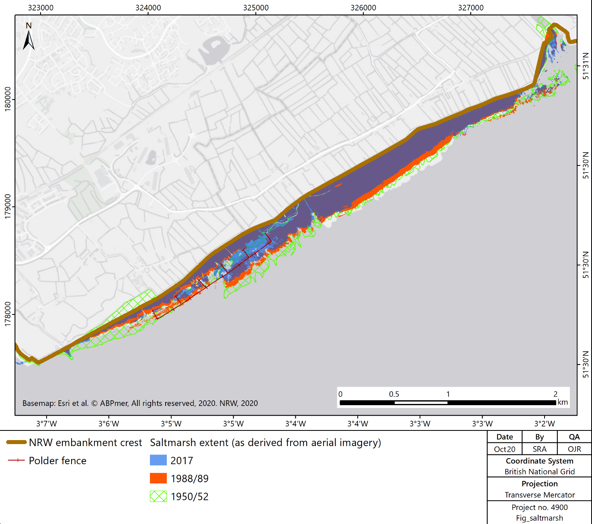
Figure 5 Saltmarsh extent changes between 1950/52 and 2017

3.3.2 LiDAR analysis of foreshore trends
As noted in Section 2.1, difference plots and cross sections have been created in order to gain insights into foreshore trends at the study area. In interpreting the data presented below, the LiDAR data limitations set out in Section 2.1 should be borne in mind.
Figure 6 below displays a difference plot between the 2005 and 2015 LiDAR datasets, thus charting 10 years of evolution along the frontage. This demonstrates that, seaward of the defences, the lower shore along the frontage appears to have eroded. In contrast, the saltings and wharfs have generally accreted. However, the marshes along the Peterstone frontage have seen fairly low rates of elevation increases, especially over the high marshes. In addition, significant marsh edge retreat is evident here (see Figure 6), equivalent to vertical erosion rates of up to 2 m (though more generally between 1 m and 2 m). In the polder area, Polders 4 and 5 have net accreted with sediment, by 0.3 m to 0.6 m over 10 years. Polders 1 to 3 have been subject to both erosion and accretion, with erosion rates of between 0.2 m and 0.6 m observed.
A volumetric (net gain/loss) analysis undertaken in ArcGIS reveals that, overall, there has been a net gain of sediment within the polder area, of just over 18,000 m³ over the 10 years studied. This equates to 150 m³ ha⁻¹ yr⁻¹ having been gained on average. Net accretion has taken place across 8.3 ha, and erosion across 3.7 ha, with the latter focussed in the lower lying areas of Polders 1 to 3. This contrasts with net losses seen at the wider study area overall, where there has been an average net loss of 44 m³ ha⁻¹ yr⁻¹.
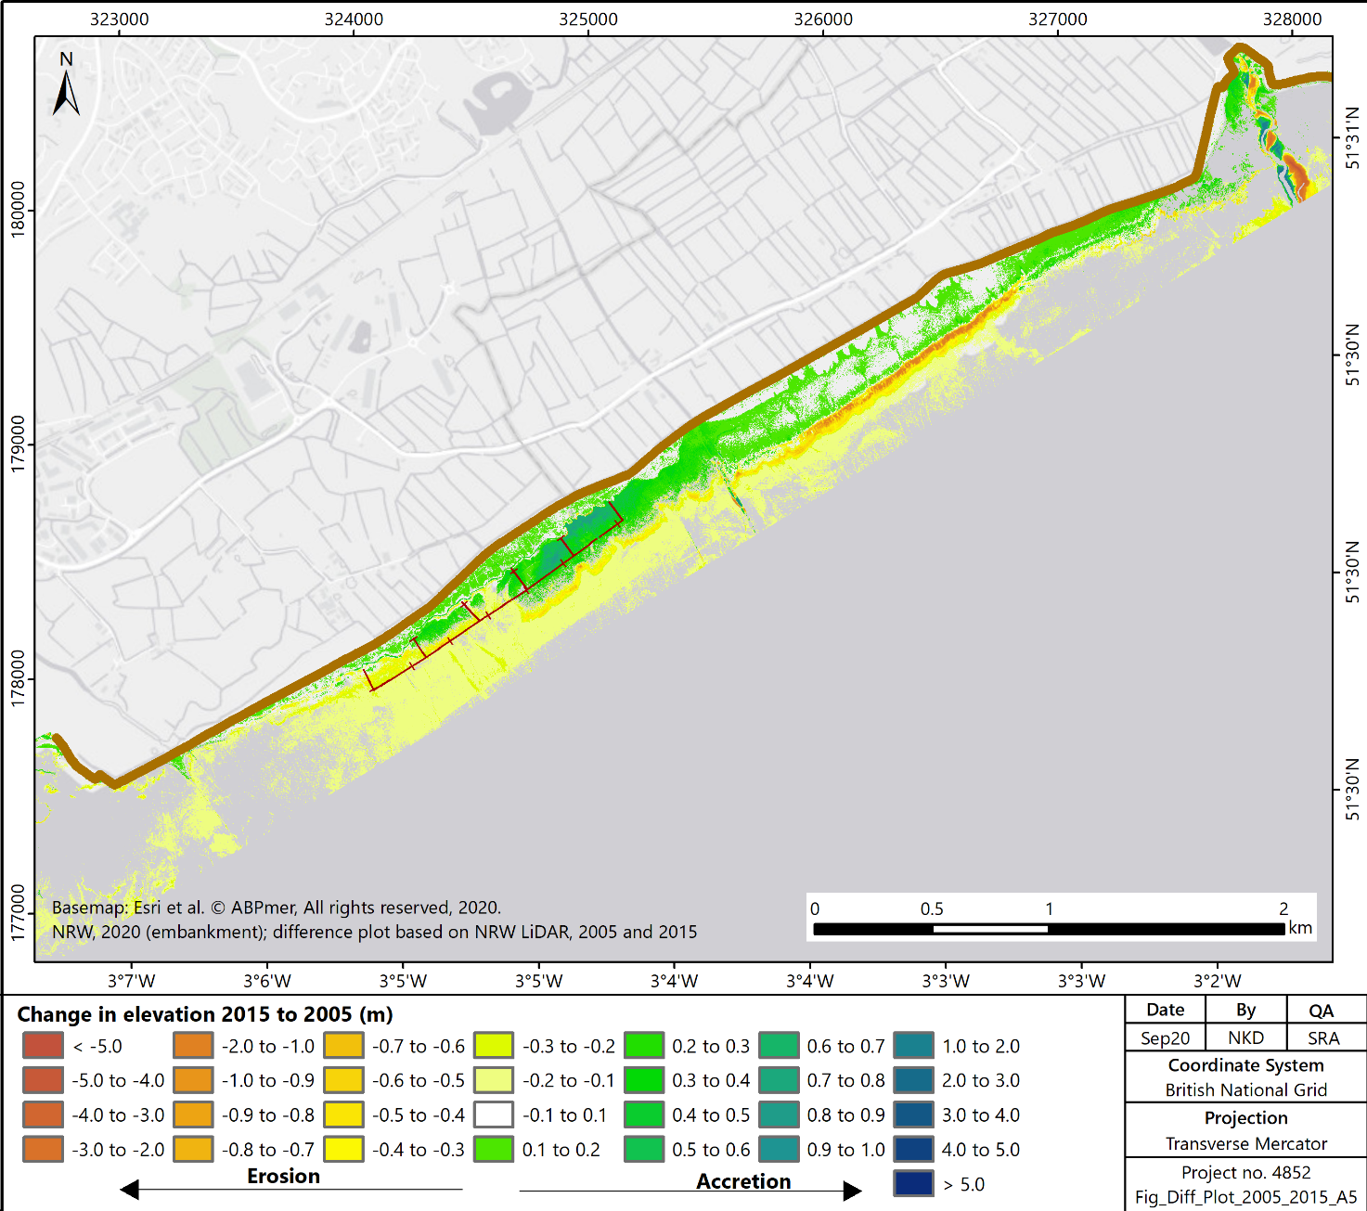
Rumney 2
Rumney 3
Rumney 1
Polder 5 (a and b)
Polders 1 to 4
Peterstone 3
Peterstone 1
Figure 6 LiDAR difference plot for Rumney to Peterstone frontage, showing 2005 to 2015 elevation changes (arrows indicate cross section location and orientation)
With regard to the cross sections, two graphs are firstly presented which demonstrate how the shoreline differs along the frontage. In interpreting these, it should be noted that not all of the profile lines which have been produced are shown here (see Appendix A for the full set), and that the arrows in Figure 6 show location and orientation. Image 8 demonstrates how, furthest west, at ‘Rumney 1’ in the mouth of the River Rhymney, the elevation of the foreshore is very low and quickly slopes to elevations below Mean High Water Neap (MHWN) levels. Going east, the elevations generally increase, being highest along the centre of the Peterstone frontage. Image 9 shows that Polder 4 is the highest lying of the five polders; this also has the widest strip of high/wharf marsh, as evidenced by the cliff apparent furthest offshore, at chainage 110. Please note that the saltings are thought to have become established somewhere between 3.2 mOD and 4 mOD along the frontage.
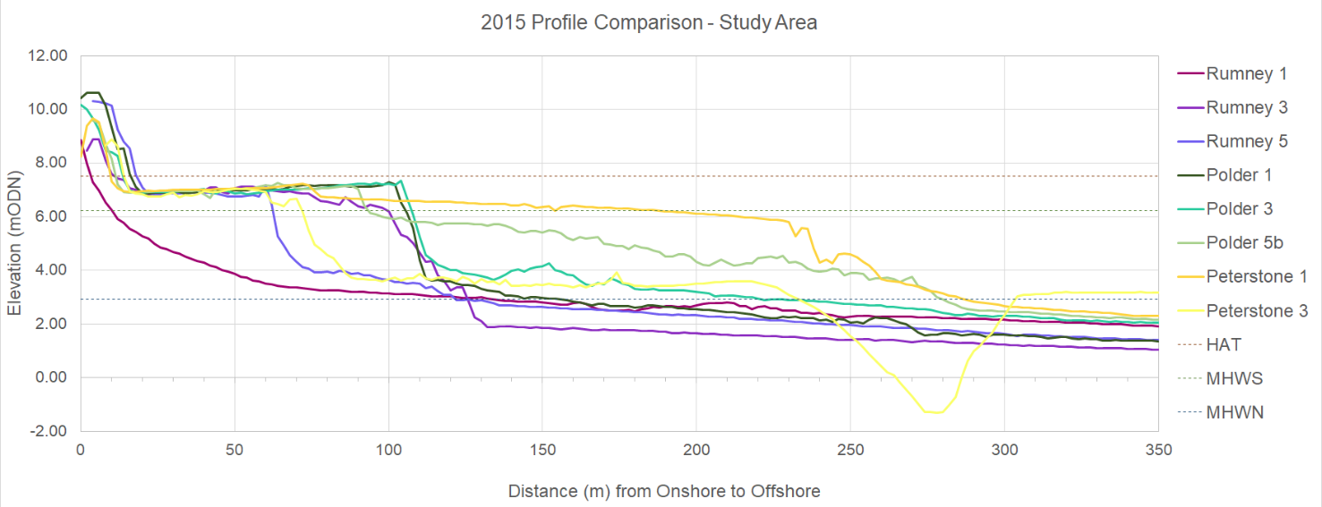
Image 8 LiDAR cross sections for 2015, showing differences in slope and elevation along the study area frontage (see arrows in above figure for location and orientation)

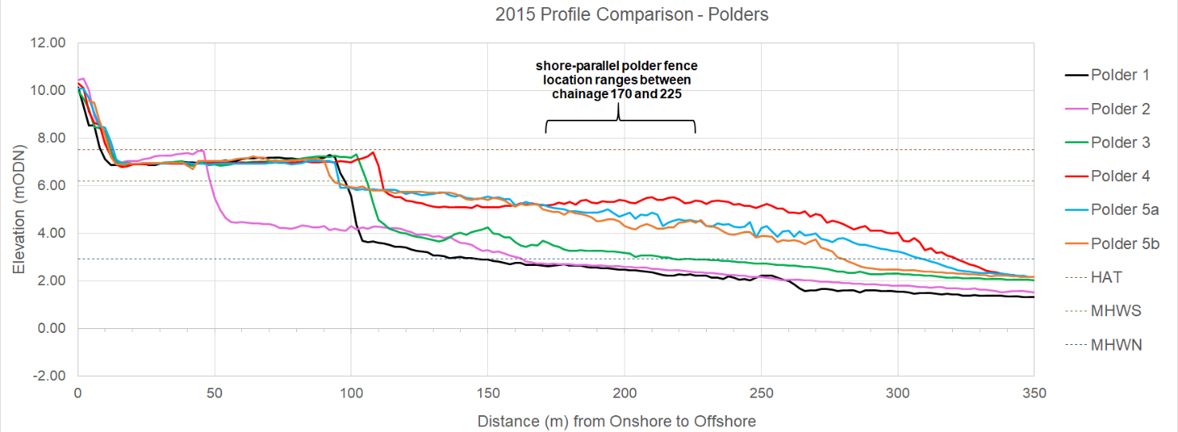
Image 9 LiDAR cross sections for 2015, showing differences in slope and elevation along the Rumney polder frontage (see arrows in above figure for location and orientation)
Image 10 below displays three of the six cross sections extracted along the polders, for Polders 1, 3 and 4 respectively, together with one from the Peterstone frontage for comparison. A full set of 2000 to 2021 cross sections, as well as two shore-parallel long-sections, can be found in Appendix A.
The cross sections displayed confirm insights gained from the difference plot shown in Figure 6, in that Polders 1 to 3 demonstrate limited accretion, with mostly erosion instead. No accretion is observed in the Polder 1 profile in the area below the wharf cliff, but above, some limited sedimentation is indicated. This is also the case for much of the wharf marsh along the frontage. At Polder 1, elevations which were below 3.8 mOD have, however, steadily declined since 2000, with lowering of up to 0.6 m evident in Image 10. Lower shore erosion to the west of Polder 1 follows similar, though slightly less pronounced, trends (see Images A1 to A5 in Appendix 6); this is also the case with the profiles at Polders 2 and 3. However, in the latter two polders, some accretion / warping up is evident along the upper saltings, for example at chainages 120 to 160 in the Polder 3 profile shown in Image 10 (and chainages 80 to 155 in Polder 2 / Image A9 in Appendix A). This sedimentation is particularly pronounced post 2005, though, in both cases, some limited accretion occurred between 2000 and 2005, i.e. pre-polder installation.
In Polders 4 and 5, more noticeable accretion is evident, with significant increases in elevation evident in the Polder 4 profile between chainage 125 and 255, interestingly to just beyond the polder fence. Elevations which were at circa 4.6 mOD to 4.8 mOD in 2000 had accreted by around 0.6 m by 2015, with some accretion occurring between 2000 and 2005, but around 85% of it taking place between 2005 and 2015. Some accretion is also indicated post 2015, noting that the 2021 dataset was not filtered, and some of the apparent elevation increase can likely be attributed to the presence of vegetation. In Polder 5, the oldest polder, slightly lower rates of accretion were seen, with accretion again being more pronounced between 2005 and 2015, and rates observed between 2000 and 2005 only being slightly higher than seen elsewhere during that time. Along the Peterstone frontage, the profile shown confirms the steepening observed in the above difference plot (Figure 6), and also lower rates of accretion than those seen along the polder frontage. At this Peterstone profile, accretion is restricted to the higher elevations above circa 5.2 mOD (see chainage 30 to 230), with low rates of around 0.01 m on average observed.
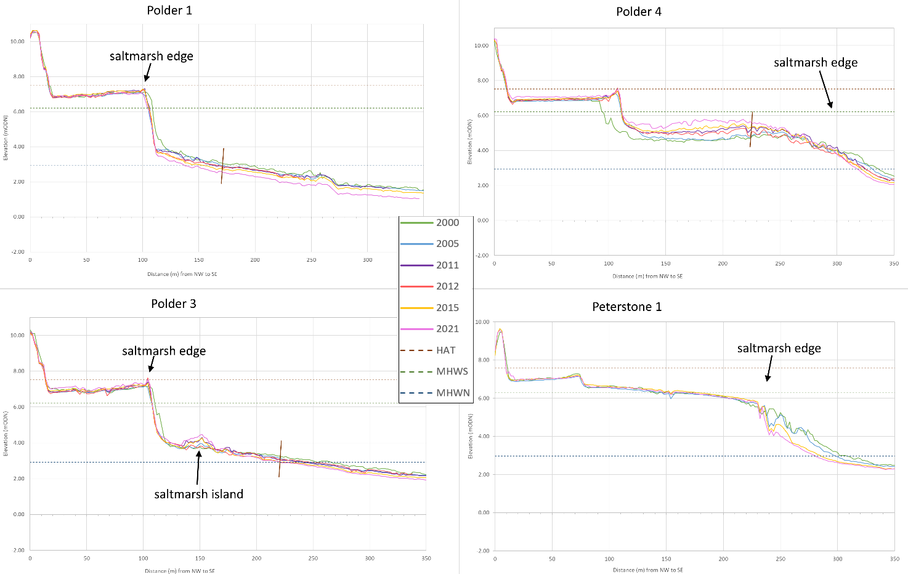
Image 10 LiDAR / drone cross sections along three of the polders, and the centre of the Peterstone frontage, comparing available years (see arrows in Figure 6 for location / orientation)

3.3.3 Summary and discussion
In summary, the data presented above indicates that the polders have been successful in trapping sediments and thus aiding in the retention, and in fact slight expansion, of saltmarsh along the Rumney Great Wharf frontage.
This particularly applies to the two most easterly polders (4 and 5), which were at higher initial levels. The most westerly polders have been less effective, particularly Polder 1. This could be related to the elevation at which the shore parallel polder fences were driven into the ground in 2005. At Polders 1 to 3, these were positioned close to MHWN levels (i.e. 2.92 mOD), whereas at Polders 4 and 5, they were located 1.6 m to 1.9 m higher (at around 4.8 mOD and 4.5 mOD respectively). Furthermore, Polders 4 and 5 likely benefited from some saltmarsh already being in place in front of them; though how much is unclear, as no relevant data or imagery close to the implementation year of 2005 was available. At Polder 1, likely in relation to its more exposed position (particularly wave exposure), and closer proximity to the River Rhymney channel (where currents tend to be faster), the majority of the corner posts were likely damaged early on in its existence, and it hence possibly never functioned as intended.
In the absence of monitoring data, and certainty as to how long the polders were properly functioning, caution should be exercised in reading too much into the above analysis and data in terms of polder success. This is particularly the case as some confounding observations from the data have been made, which, whilst not necessarily contradicting polder success, cast some doubt as to the extent of the role the fencing has played in the saltings’ expansion, including:
- Accretion / expansion clearly still continuing post circa 2009/10, when most of the polders were likely no longer fully functioning. The posts themselves may have played a role, as may other factors, such as the lunar-nodal cycle;
- Expansion / accretion taking place in front of, and immediately to the east of, some of the polder fences (e.g. at profile Rumney 12, see Image A12 in Appendix A); and
- Polder 5 not having accreted as much as Polder 4, despite it being the oldest polder, and it possibly having retained the willow materials for longer (as evidenced by some still being in place in 2020, albeit surrounded by saltmarsh). Whilst compaction of older sediments may have played a role in this, it is considered that the slightly lower starting elevations are likely to have been more important, i.e. water depth relative to the height in the tidal frame of the 1 m-high brushwood fence.
Whilst saltmarsh at the Rumney polders has expanded slightly, within the wider study area, overall saltmarsh extent has reduced and widespread foreshore lowering, and retreat has been observed below saltmarsh elevations. In addition, the saltmarsh edge has generally moved landwards, even along the Rumney frontage, where the saltmarsh expansion in the polders has mostly been sideways.
Thus, whilst the polders at Rumney appear to have contributed to a temporary reversal of the erosive trend, erosion has continued where no protection works had been constructed. Along the Peterstone frontage in particular, significant erosion and saltmarsh edge retreat can be seen.

3.4 Nearby Maintenance Dredging and Disposal Activities
Ports at Cardiff and Newport undertake routine maintenance dredging operations. Information on dredging campaigns and disposal activities at these ports have been extracted from licensing and disposal data held by NRW; this is displayed in Table 4. At Cardiff and Newport, Associated British Ports (ABP) hold licences to undertake year-round maintenance dredging, as required, with large quantities regularly removed using mainly trailing suction hopper dredgers operated by UK Dredging (UKD). At Cardiff, the Cardiff Harbour Authority also dredges, normally twice per year, utilising both UKD and Boskalis dredgers. Cardiff materials are disposed of at Cardiff Grounds, which is at least 3.5 km from Cardiff Harbour and has a depth of around 7 m below Chart Datum (CD), and Newport materials at Newport Deep, which is has a depth of some 5 m below CD and lies 6 km from Newport Docks. These site are 5 km and 9.3 km to the south and east of the centre of the Rumney frontage, see Figure 7.
Table 4 Maintenance dredge statistics for the ports of Cardiff and Newport
Port/Authority | Cardiff Harbour Authority | ABP Cardiff | ABP Newport
Vessel(s) | Boskalis trailing suction hopper dredgers (Sospan Dau, Deo Gloria) | UKD trailing suction hopper dredgers (Bluefin, Orca, or Marlin); Boskalis trailing suction hopper dredger Sospan Dau; and the UKD grab hopper dredger Cherry Sand. | UKD trailing suction hopper dredgers (Bluefin, Orca, or Marlin); Boskalis trailing suction hopper dredger Sospan Dau; and the UKD grab hopper dredger Cherry Sand.
Disposal method | Bottom dumping* | Bottom dumping* | Bottom dumping*
Disposal area | Cardiff Grounds LU110 | Cardiff Grounds LU110 | Newport Deep LU140
Amount | Licence max: 180,000m³ p.a,. 466,085 m³ deposited 2016-2019. Just over 150,000 m³. July 2018 and Jan 2019. | Licence max: 999,999 tonnes p.a. (approx. 770,000 m³**); approx. 1,270,000 m³ tonnes deposited July 2016 – June 2019). Just over 560,000m³ Apr 2018 to Mar 2019. | Licence max: 499,999 tonnes p.a. (approx.. 385,000 m³⁾; approx. 570,000 m³ deposited 2016-2019.
Timing and duration | Twice a year (summer and winter dredge). Each campaign usually takes approx. 2 weeks. | Year round, as required (e.g. nine campaigns in one recent year). | Year round, as required. Usually four campaigns of three days per year.
Physical composition of materials | 100% silt | Dock: Silt 80%, Clay 20%; channel: Silt 60% , Sand 15%, Clay 25%. | Channel: Silt 60%, Sand 15%, Clay 25%. S dock: Silt 80%; Clay 20%.
* Boskalis Sospan Dau vessel is also suitable for pumping ashore and rainbow installation
** tonnes converted to metres cubed, applying an average density of 1,300 kg m⁻³
Please note that Rumney Great Wharf, at Polder 1 (the approximate centre of the Rumney frontage), lies at a ‘steaming’ distance of around 11.5 km from Newport, and 8.5 km from Cardiff Harbour; this is illustrated in Figure 7 below.
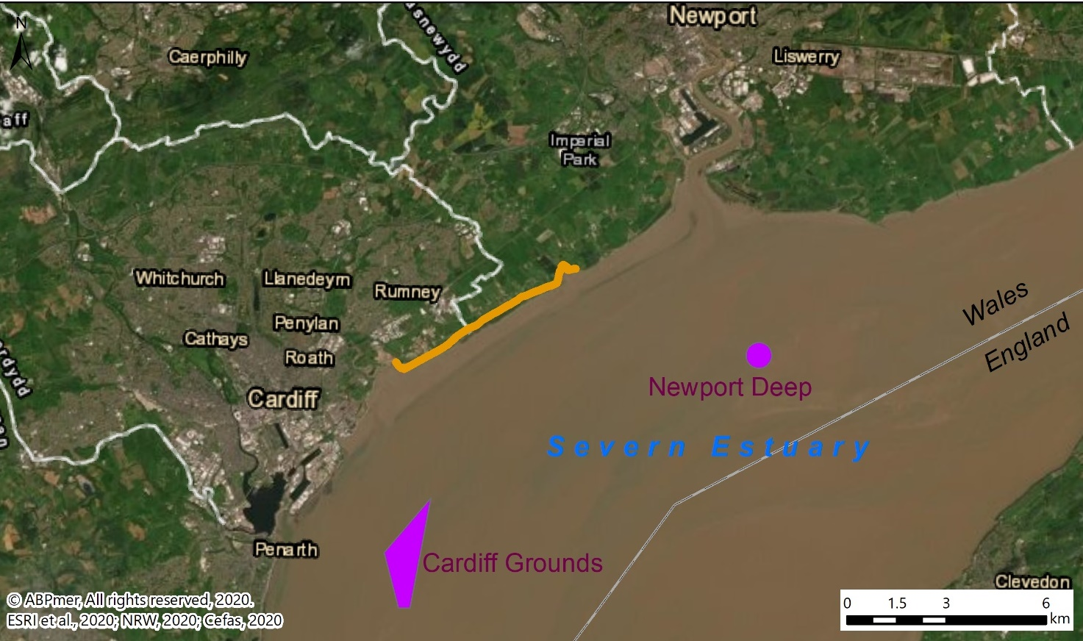
Rumney Great Wharf
to Peterstone Wentlooge
Figure 7 Location of nearby dredge disposal grounds
Whilst the licences combined allow for up to around 1.1 million m³ of materials to be dredged every year, in reality less than that would tend to be extracted. For example, the data displayed in Table 4 shows that, combined, in one recent year, around 0.8 million m³ of materials were deposited at the two licensed grounds, with the vast majority of this consisting of very fine silt, with some clay and generally very little sand at a low average density.
Table 4 shows relatively large volumes of predominantly silt are deposited into the Severn Estuary both up and down estuary of the Rumney Great Wharf frontage each year. The deposit locations are predominantly dispersive; therefore, the material is suspended into the high background load of the Severn Estuary, some of which would be moved through the foreshore areas of Rumney, increasing the supply available for potentially trapping along the foreshore.

Literature Review
This literature review firstly presents background on nature based solutions for saltmarsh restoration in Section 4.1 (with emphasis on the beneficial use of dredged materials and the use of sedimentation polders), before Section 4.2. discusses ecosystem services associated with saltmarshes, as well as their valuation. This background understanding informed the selection of foreshore management options for the saltmarshes at Rumney Great Wharf as well as the cost benefit analysis undertaken for each option.

4.1 Nature Based Solutions

4.1.1 Soft sediment recharge (beneficial use)
Soft sediment recharge in intertidal areas is a process by which dredged sediments are placed over or around intertidal mudflats and saltmarshes to either create habitat (most often saltmarshes), or restore or protect intertidal habitats from ongoing erosion (e.g. Nottage and Robertson, 2005). This approach is particularly valuable for protecting habitats that are sediment starved or subject to erosion and where the introduction of dredge arisings will allow the habitat to cope with, or respond to, sea level rise.
In the UK, just over 20 intertidal recharge projects have been undertaken to date; some of which recur on a regular basis. These have all been in England, with many projects in Essex, Suffolk and on the South Coast.
Such projects can differ greatly in scale (i.e. the area of deposition or the volume of sediment used), environmental setting, and on the basis of the number and type of structures, if any, that might be put in place to retain sediments once they are deposited. In simple terms, the following five approaches represent the main ways in which dredged sediment has in the past been placed directly onto intertidal habitat (ABPmer, 2017):

- Back-hoe extraction translocated for back-hoe placement (e.g. Maldon Hythe Quay (Essex, England));
- Back-hoe extraction translocated for pumped placement via pipe (e.g. Lymington Boiler Marsh Recharge by Wightlink Ltd. (Hampshire, England); see Image 11);
- Back-hoe extraction translocated for intertidal bottom dumping (e.g. recent and on-going recharge work at Lymington by the Lymington Harbour Commissioners (LHC) (Hampshire, England);
- Suction dredge with direct pumped placement (e.g. Levington Marina (Suffolk, England)); and
- Suction dredge translocated for pump/rainbow release (e.g. Horsey Island (Essex, England)).

In addition to these approaches, nearshore bottom placement has also been trialled in several locations, whereby sediment is placed subtidally within an estuary / harbour or sediment cell. Often, this is done to ensure that the sediment is not removed from the system or, better still, that a proportion of the deposited sediment feeds back onto intertidal areas. This ‘sustainable relocation’ approach is for example adopted at Treloar Hole at the mouth of Chichester Harbour (England). Here, a maximum of 10,000 tonnes of maintenance dredged sediment can be deposited each year (on a flooding tide to ensure that the sediment is carried back into the harbour). The trials and modelling work that was undertaken to inform the use of the Treloar Hole site indicate that large proportions of sediment remain in the harbour and principally in the marginal areas of the main channels. This site is only intermittently used, which is understood to be due to the costs associated with carrying out the required diver-based monitoring work (ABPmer, 2020).

A larger scale variation of this ‘sustainable relocation’ approach has recently been undertaken near Harlingen (Friesland, northern Netherlands). The Port of Harlingen dredges around 1.3 million m³ of sediment each year and has historically deposited close to the harbour entrance. Much of the sediment would then wash back towards the port. Recently, an alternative shallow subtidal deposit ground was identified further north along the coast, with the aim of feeding mudflat and marsh in front of the town of Koehoal. On a trial basis, 470,000 m³ of maintenance dredge sediment was deposited subtidally over two seasons (2016/2017) from a small barge on a flood tide (Baptist et al., 2019). Whilst tracer studies showed that sediments drifted towards the target intertidal areas (some 5 km from the deposit locations), the habitats did not obviously accrete more rapidly as a result. The authors theorised that the sediment had been spread thinly over a wider area than anticipated, with such minor changes not being picked up by the monitoring.

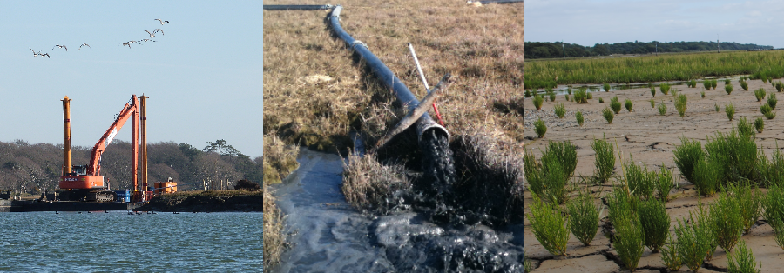
Source: ABPmer, 2018
Image 11. Photographs from the Lymington project

It is worth noting that there has been a long-term desire to see more dredge arisings used beneficially for environmental and/or socio-economical activities, at a national and international level. For example, the need to seek beneficial use opportunities was identified within the 1996 International Maritime Organisation (IMO) London Protocol and other dredge management reviews and guidance (HELCOM, 2015). The Welsh National Marine Plan also contains a narrative noting that ‘the beneficial use of dredged material is encouraged’. Many organisations/studies over many years have described this situation (RSPB, 2018; Ausden et al., 2016; Permanent International Association of Navigation Congresses (PIANC), 2009). The reasons why there is limited beneficial use are therefore well-rehearsed, and can be summarised as follows:

- Technical difficulties of achieving projects and the resulting extra costs incurred;
- Extra tasks that are required to progress through consenting processes;
- Lack of bespoke legislation or single government body/department to champion this subject;
- Absence of any transparent mechanism for identifying sediment sources and linking these locations with sites that have a need for sediment; and
- Concerns regarding the environmental effects that could arise from the beneficial use activity.

In essence these factors mean that it is almost always easier to maintain long-established ‘business as usual’ practices and place sediment at an established disposal site rather than go through a new and lengthy process to undertake a beneficial use project. Of all these issues, the fundamental ones are that it typically costs more money and also that those who incur the costs (the dredging operators, marina owners and harbour authorities) are not those that benefit and so there is a fundamental disincentive for beneficial use measures to be pursued.

A relatively rare example of a nearly cost neutral project is LHC’s Boiler Marsh scheme, whereby, as noted above, materials extracted using back hoes is then bottom dumped on mudflats in a nearby embayment. LHC’s average costs have reduced from £9.80 m⁻³ during the trial phase to £8.70 m⁻³ for deposition over the following two winters. These average costs are slightly lower than the costs of taking this material to the disposal ground (which is £8.78 m⁻³ on average). This reduction has largely been due to a reduction in monitoring costs/effort. Comparisons between this cost and those from other beneficial use approaches at Lymington are shown in Image 12. It is also worth noting that, due to the relatively compacted nature of the backhoed materials, around half of the materials have persisted, and that a clearly raised mudflat feature which measures around 1.4 ha, has become established (ABPmer, 2019b).

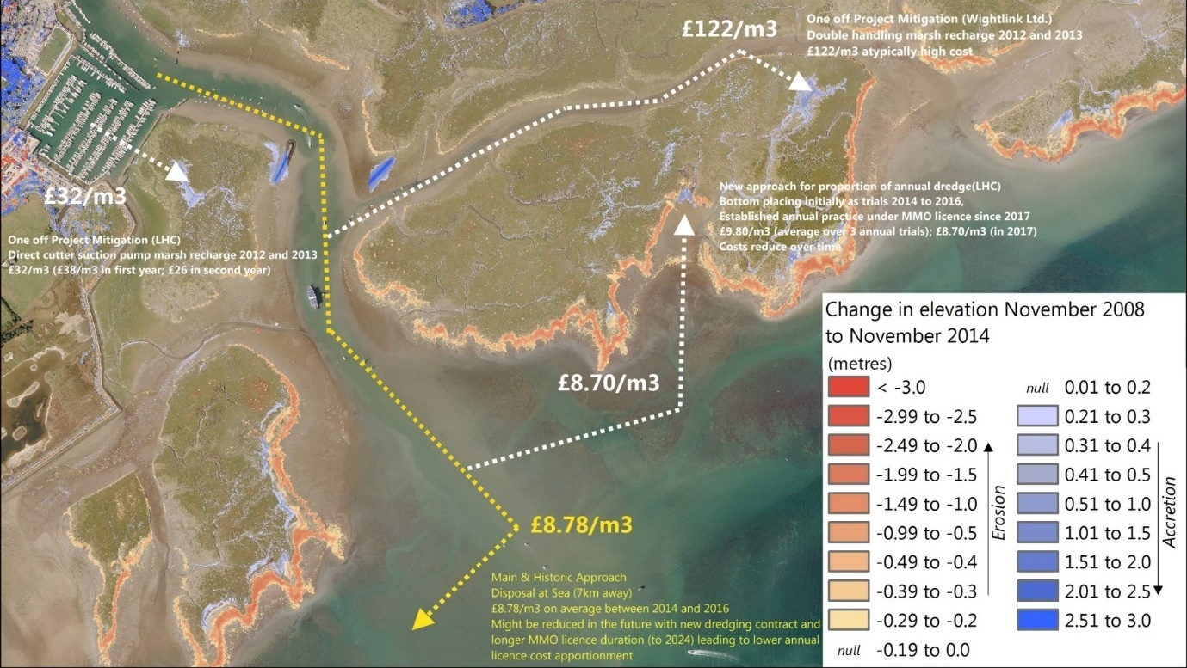
Environment Agency LiDAR data; ESRI et al., 2019. Source: ABPmer, 2019b
Image 12. Overview of the costs (per m³) of recent Lymington beneficial use options
2006 Rumney feasibility study
It is worth noting that soft sediment recharge has in the past been mooted for the Rumney frontage, and, in 2006, a feasibility study was undertaken by Atkins (Atkins, 2006). This noted a key difficulty associated with using dredged materials in that:
“In contrast to free-draining non-cohesive sands and gravels, muds are won by maintenance dredging plant at very high production rates and very low solids content. Mud is not free-draining and if pumped ashore would remain as a slurry taking up to 2 years to consolidate. The speed of winning the material is far higher than the capability of placement. Very dilute fluid mud dredged arisings have a strong tendency to run off the flats under gravity or to be driven off by tidal currents and waves.”
This is why dewatering was investigated by the 2006 study, with the aim being to produce a more solidified product. This not only makes dredged material easier to work, but also makes on-site retainment more likely.
The following three placement options were evaluated in 2006:
- Derived wet from seaward – this assumed that dredged material from a local source (such as ABP Cardiff) would be placed on the foreshore from the seaward side (by pipe from a dredger), without being dewatered. Atkins (2006) discussed that, whilst this may appear an inexpensive option, the practicality of placing aqueous dredged material from a barge onto the foreshore was problematic if one was hoping for precision. Given the flat and wide nature of the mudflats at Rumney, access to the polders would be difficult, as navigable water at high tide would only cover the polder area briefly, and waters would also often be rough, all factors which would severely inhibit placement. Bottom dump barges would be unable to penetrate into the polder area (due to the required clearance to open the doors) and any material placed immediately outside these areas would be likely to be swept away by tides and waves. Thus, there would be large scale material losses and thus greater volumes of material would be needed to counter this likely loss. It was also noted that, from an environmental perspective, the potential impact of dumping material from seaward on intertidal communities would not be acceptable. The conclusion was that this option was not ‘remotely’ practical or economically viable.
- Derived wet from landward – this assumed that dredged material from a local source would be placed on the foreshore from the landward side (by land-based transport or pipeline) without being dewatered. Access restrictions and the requirement for landward dewatering fields were noted. The idea would have been to discharge light piped material into a backshore lagoon / bunded field. From here, it could be densified (either naturally, over time, or artificially, by machine) and supplied to the polder in a controlled manner. However, it was thought that the costs would likely be prohibitively high, and environmental impacts unacceptable, both with regard to the designated hinterland, as well as the existing saltmarshes.
- Seaward or landward placement with intermediate dewatering – this assumed that dredged material would initially be dewatered, transported to site and manually placed on the foreshore. This considered that dewatering / densification onshore close to the polders could be achieved, noting that ‘the finer the grain size of the material being dewatered, the slower the output rate’. As a consequence, the cost implications of dewatering increase when dealing with dredged silts and muds. A short system of linked conveyors with a swinging head was seen as a possible method of placing materials in the polders at low tide. In contrast, supplying densified material by barge, an adapted version of Option 1, was considered slower and more expensive, as placement could only take place over a short period of time on the flood tide. This option was deemed to be the only viable option worthy of further consideration / more detailed analysis. The latter concluded that environmental impacts could be significant adverse, particularly with regard to invertebrate smothering. Costs for dewatering and placing 150,000 m³ were estimated at just under £1 million (or 1.4 million in 2020 prices, translating to £9.3 m⁻³). At the time, this was around one third more expensive than the cost of disposing at the offshore disposal grounds.
The main conclusion of the report was that ‘the placement of dredged material within the polders is not appropriate at Rumney Great Wharf’. This was due to the hydrodynamic exposure of the site, potentially significant environmental impacts, and costs being much higher than the existing disposal costs.

4.1.2 Manipulation of natural processes (incorporating polders)
The manipulation of natural processes encompasses projects which alter the existing sedimentary regime along a shoreline in order to protect habitat and possibly create mudflat and saltmarsh. This includes a wide range of possible techniques such as introducing obstructions or altering shorelines. In the UK, to date, these have generally focussed on saltmarsh erosion protection and mudflat accretion encouragement.
There are techniques such as shore perpendicular groynes, which can potentially be used to expand mudflat seawards, onto existing subtidal areas, though there are no known (intentional) examples of this in the UK, with success generally very much dependent on local conditions, notably sediment loads.
The polder technique employed at Rumney Great Wharf has been used historically in the UK; however, it has only had limited use more recently and generally with limited success, which has in part been attributed to the fences typically not being maintained (for long) (e.g. Dornbusch, 2019). The method is more commonly, and historically applied along the Wadden Sea coasts of the Netherlands and Germany, where they are referred to as sedimentation fields, rather than polders. Such structures are installed in areas which are exposed to relatively high tidal or wave energy forces which would normally prevent the settling of sediments or re-suspend any that had settled during slack periods. This is provided that the suspended sediment loads in the system are high enough for accretion to take place. Thus, the artificial import of sediment is not necessary, but instead, structures are put in place to reduce energy and encourage sediments to settle and accrete. In the past, the main methods used for increasing sedimentation in intertidal areas have included brushwood fencing, polders / sedimentation fields, wave breaks or groynes. Burgess-Gamble et al. (2018) note that, when applying this technique, an important consideration is local causes of erosion, as ‘success will be limited if there is a highly erosive environment with limited sediment feed’.
In Germany and the Netherlands, the polder technique has its origin in the process of land claim; this motivation has only been superseded by nature conservation and coastal defence in the last few decades here. A combination of predominantly brushwood fences and ditches arranged in a shore perpendicular and parallel fashion would be used to speed up the accumulation of mud and silt in the intertidal (see Image 13 and Image 14). The ditch system is considered important in terms of drainage and dewatering, as well as guiding the flow of water. Ditches are regularly cleared out, with excavated materials sidecast, thus aiding in the accumulation of sediment in a polder. In the German federal state of Lower Saxony, about £1 million per year is spent on the maintenance and management of foreland areas along 70 km. This includes repair of brushwood fences (approximately every 5 years), but also the repair of the dyke toe protection and the maintenance of ditches, and is equivalent to ~£15 per metre (Dornbusch, 2019).
Construction methods vary along the Dutch and German North Sea coasts, and are often informed by local traditional experience. However, the fences tend to be constructed at 1 m height, and the top of the fences would be constructed to be at, or near, the MHW mark (e.g. von Lieberman et al., 1998; Blumenthal, 1966). The bottom of the fences is frequently protected by small wedges, with materials scraped from adjacent mudflats. Furthermore, the shore parallel fence line, where located in an exposed location, would tend to be reinforced using a variety of methods, including armouring with rocks or concrete, double fencing / installation of additional brushwood bundles, and the utilisation of filled geotextile tubes (e.g. Erchinger, 1970). Field dimensions vary from around 100 m by 200 m to 400 m by 400 m (e.g. von Lieberman et al., 1998; Blumenthal, 1966).
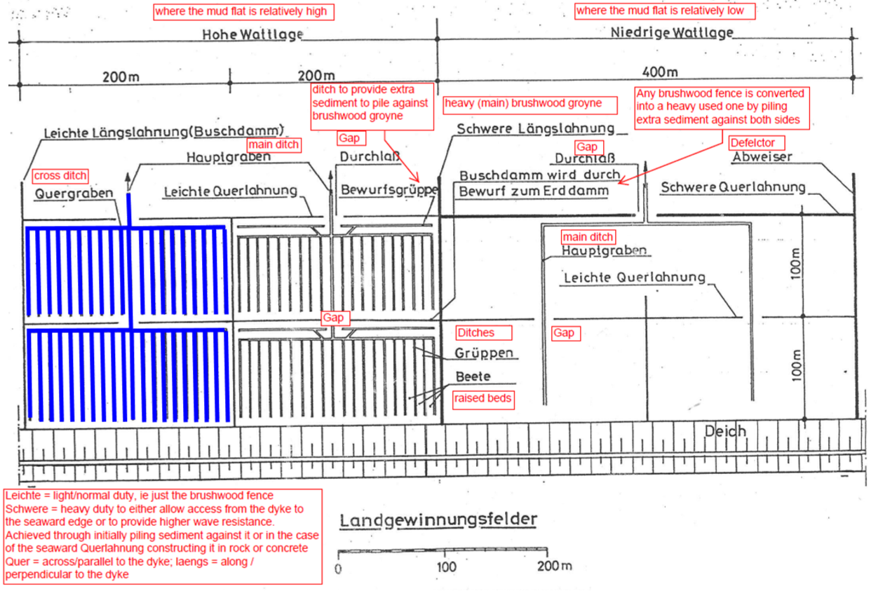
Source: Dornbusch, 2019
Image 13. Schematic plan view of a brushwood barrier system in Lower Saxony (Germany), with translations
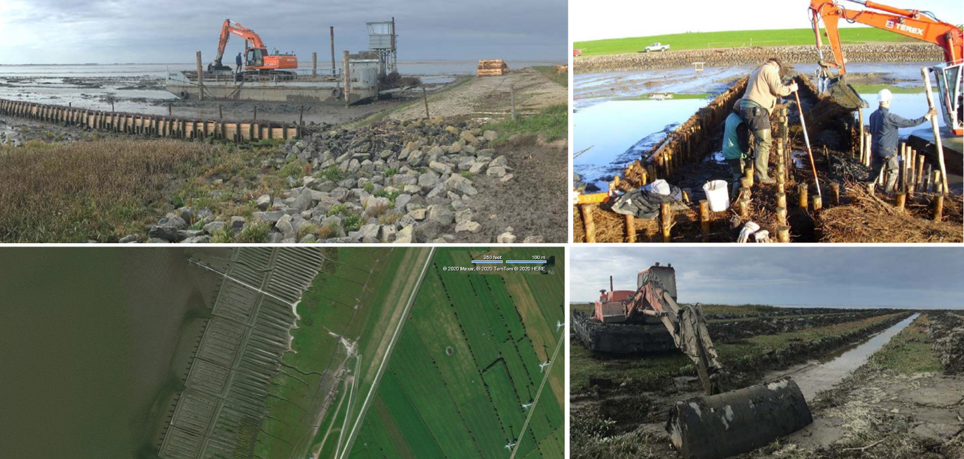
Source: Dornbusch, 2019, BingMaps (aerial bottom left)
Image 14. Polders in Germany; top left shows construction barge; top right construction of a ‘heavy’ (duty) perpendicular fence line; bottom right shows creek maintenance, bottom left is aerial view of polders near Dorum, Lower Saxony

4.2 Saltmarsh Ecosystem Services and Valuation

4.2.1 Natural capital and ecosystem services
In order to inform this review of saltmarsh restoration options at Rumney Great Wharf, or similar work at any other location, it is important to understand the costs and benefits of a potential project as clearly as is possible. Having this understanding, and communicating it clearly, is vital when seeking to prioritise, fund and implement any restoration schemes.

‘Natural Capital’ can be defined as ‘the world's stocks of natural assets which include geology, soil, air, water and all living things’. It is from this natural capital that humans derive a wide range of services, often called ecosystem services, which make human life possible (World Forum on Natural Capital, 2019). Thus, the saltmarshes and mudflats, with their flora and fauna, make up part of the natural capital of the Severn Estuary.

Ecosystem services can be defined as ‘the outcomes from ecosystems that directly lead to good(s) that are valued by people’ (Austen et al., 2010). The ecosystem services framework explicitly links ecosystem structure, processes and functioning to outcomes in the form of services which contribute to human wellbeing / welfare. Intertidal habitats have long been known to be very valuable habitats which provide a wider range of beneficial ecosystem services. The evidence on key services is now summarised below.
Primary production
Saltmarshes are generally considered to be one of the most productive ecosystems in the world, rivalling that of intensive agriculture (Niering and Warren 1980; Peterson et al., 2008). They fulfil important functions in providing other marine habitats (and their fauna) with nutrients and fixed carbon (McKinney et al., 2009). Intertidal mudflats are also important in the functioning of estuarine systems and may have a disproportionately high productivity compared to subtidal areas (OSPAR, 2009)). Biofilms, comprising microalgae at the air-mud interface, sustain all primary production on mudflats during the day (Herlory et al., 2005). The biomass of benthic algae may exceed that of the phytoplankton in the overlying water column. In turn, this highly productive ecosystem supports macroinvertebrates (secondary production) and hence provides an important year-round feeding ground, for example, for fish and wading birds (including birds such as Dunlin and Curlew, designated features of the Severn Estuary SPA).
Fish and shellfish
Many juvenile fish, crustaceans and molluscs use saltmarshes as nurseries. When vascular plants die, the plant matter is broken down by microbes, invertebrate detritivores, deposit and filter feeders. Bivalves, shrimp and fish predate on invertebrates which are in turn prey for fish (Pennings and Bertness, 2001). Juvenile stages of many fish species (including several commercial species) feed and find refuge amongst saltmarsh vegetation and within its shallow creeks (Dickie et al., 2014). Laffaille et al. (2000) showed that saltmarshes play a fundamental role in the feeding of juvenile sea bass, which ingested great quantities of live and detritic organic matter, even though foraging in the vegetated areas was only possible for about 5% of the tides. Intertidal mudflats have a low species diversity but very high overall invertebrate productivity, resulting in an important and perpetually exploited food source for fish (and birds) (OSPAR, 2009). The most notable fish predators on intertidal mudflats are sole, dab, flounder and plaice which feed on polychaetes, young bivalves and other molluscs (Jones et al., 2000). Mudflats are thought to be at least twice as productive as their subtidal counterparts (Elliott and Taylor, 1989).
Provision of habitat
Saltmarsh is an important habitat and refuge from predators and physical stress for a wide range of fish and bird species (Peterson et al., 2008). Upper saltmarshes provide breeding grounds for birds such as Lapwing, Redshank and many species of gulls. Many waders furthermore rely on these habitats as safe resting/roosting grounds. Mudflats (and shallow water areas) are also important sites for wading birds (Bale et al., 2007). At low tide, mudflats provide feeding and resting areas for internationally important populations of migrant and wintering waterfowl, whereas at high tide they are also important nursery areas for flatfish and feeding grounds for numerous fish species (OSPAR, 2009). Intertidal mud is not usually associated with species rich communities but there are often very high abundances of those species present (Jones et al., 2000).
Natural hazard regulation, increased resilience
Wave action on land can cause erosion. Saltmarshes act to shelter coasts from erosion (Pennings and Bertness, 2001). Saltmarsh can significantly increase attenuation of incident waves compared to unvegetated sand/mudflats. This is especially relevant with the increased risk of sea level rise and an increase in storm frequency (Möller, 2006; Möller et al., 2014). In the US, Costanza et al. (2008) estimated that restored saltmarsh provided an economic value of US$ 8,236 ha⁻¹ yr⁻¹ in reduced hurricane damages. Filamentous algae, cyanobacteria and macrophyte roots strengthen sediment, further supporting erosion control (Aspden et al., 2004). Saltmarshes accumulate sediment and organic matter at a rate that tends to compensate for sea level rise (Morris and Gibson, 2007). Mudflats also help protect coastal margins from erosion by dissipating wave and current energy (Bale et al., 2007). Thus, any embankment stretches of the Rumney Great Wharf frontage without significant saltmarsh cover will ultimately require more maintenance and repair than those without.
Waste breakdown, detoxification and storage
In areas receiving pollution, saltmarsh sediments sequester contaminants such as mercury, heavy metals (OSPAR, 2009; Coehlo et al., 2009) and other substances such as uranium (Church, 1996). Saltmarsh plants have been shown to lead to TBT remediation in sediments (Carvalho et al., 2010), and are able to regulate faecal pollution (Kay et al., 2005). Microbial saltmarsh assemblages carry out nitrogen and carbon fixation services (Aspden et al., 2004). Benthic microalgae on mudflats play significant roles in biogeochemical reactivity (MacIntyre et al., 1996).

With regard to water quality and nutrient cycling, coastal saltmarsh vegetation is involved in the regulation of water purity through the take up of excess inorganic nutrients such as nitrates and phosphates, therefore reducing the potential for eutrophication (Peterson et al., 2008). Saltmarsh sediments tend to be anoxic and carbon-rich, providing ideal conditions for denitrifying bacteria (Drake et al., 2009). Denitrification rates in saltmarshes are generally high, and can be accountable for a majority of nitrogen flux in saltmarshes (Davis et al., 2004). The vegetation found on saltmarshes is also an important nutrient sink through the generation of plant biomass (Verhoeven et al., 2006). A recent study by Watson et al. (2020) (focussed on the Solent in England) estimated the capacity of saltmarshes (and other marine habitats) to remove nitrogen (N) and phosphorus (P), alongside monetary values associated with the resulting benefits. Intertidal sediments were considered to be the largest contributors to total N and P removal in the Solent, reflecting their extent in this system.
Climate regulation, carbon sequestration
Research on carbon sequestration in tidal habitats indicates that, while the extent of these habitats on a global scale might be relatively small (<2% of the ocean’s surface), they are ‘hot spots’ for carbon burial and have a significant role to play in global carbon storage (Laffoley and Grimsditch, 2009, Chmura et al., 2011). One mechanism for this carbon retention is through plant biomass growth (Pidgeon, 2009). However, the biomass of living plants is not seen as a key carbon trapping mechanism (Trulio et al., 2007). Instead, the crucial process driving carbon trapping in coastal ecosystems is sediment accretion; the higher accretion rates are, the more carbon is stored away. This process, coupled with the anaerobic conditions in the saline sediments, leads to an accumulation of organic matter in the soil which effectively creates a carbon sink that can continue to grow over timescales of thousands of years (Connor et al., 2001; Duarte et al., 2005).

Sediment deposition also traps the algal matter of macrophytes and microflora that grow on soil surfaces (Conner et al., 2001). It has been estimated that globally at least 430 Tg (teragrams) (or million tonnes) of carbon is stored in the upper 50 cm of tidal saltmarsh soils, with healthy saltmarsh able to sequester around 200 g C m⁻² yr⁻¹ (Chmura et al., 2003). This is equivalent to around 7.33 t CO₂ ha⁻¹ yr⁻¹, though it is unclear what accretion rates this value related to. A 2015 Welsh study reported on by Ford et al. (2019) sampled a total of 23 saltmarsh sites to determine carbon stocks, though none of these were in the Severn Estuary. The study determined that stored carbon calculated for the top 10 cm of soil varied from 32 t C ha⁻¹ (or 3.2 kg C m⁻²) for the Atriplex portulacoides vegetation class to 50 t C ha⁻¹ for the Juncus gerardii vegetation class. Sandy soils were found to store less carbon (average 29 t C ha⁻¹) than muddier soils (43 t C ha⁻¹). In addition to locking carbon away, coastal wetlands are also less likely than inland freshwater habitats to release greenhouse gases though bacterial processing within the sediment. This is because the sulphate/salinity suppress methanogenic bacteria and thus the release of methane (which is 25 times more potent as a greenhouse gas than CO₂) (Forster et al., 2007).

A 2020 report on the carbon sink potential of the Welsh marine environment found that, by area, saltmarshes and intertidal flats sequester the most carbon in the Welsh marine environment, at estimated rates of just under 15,000 tonnes of carbon every year (NRW, 2020).
Other benefits
This review focussed on key ecosystem services; in addition to these, there will also be further services that can be provided, including cultural heritage, education and research, soil formation, and tourism/amenity/recreation. Many of these will be relevant in the Severn Estuary. The nature and value of such benefits will vary greatly, depending on the scale of a given project and the extent to which marsh habitat is increased or its loss delayed. The practical benefits of key saltmarsh restoration options identified in this review are considered further in the Cost Benefit Analysis (CBA) presented in Section 5.2.

4.2.2 Benefits valuation
Background
The National Ecosystem Assessment Follow-on project (NEAFO) developed a framework for describing marine ecosystem services (Turner et al., 2014) (see Image 15) and the benefits that humans derive from them. This framework is useful in supporting the valuation of environmental benefits, as it focuses on the final ecosystem services benefits that humans derive from ecosystems and thus avoids the risk of double counting.
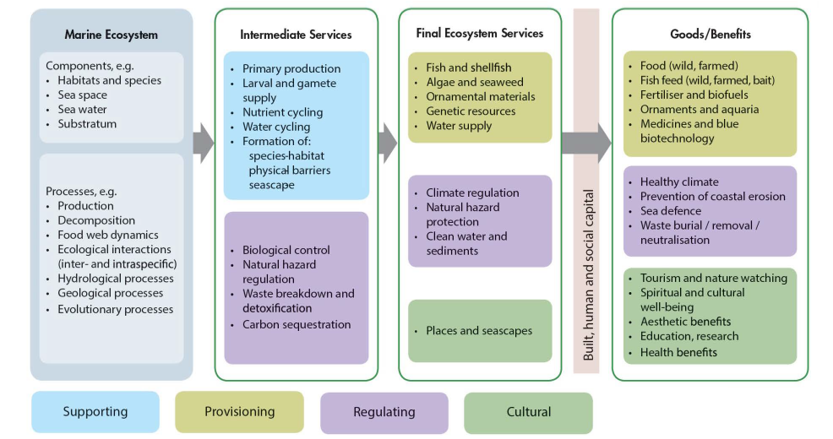
Source: Turner et al., 2014
Image 15 Marine Ecosystem Services Framework showing key benefits to humans
Various estimates of the monetary value of marine ecosystem services, and of the specific contributions from saltmarsh and mudflat habitats, are available from The Economics of Ecosystems and Biodiversity (TEEB) database (Balmford et al., 2008) and other online sources.
However, care needs to be taken in order to avoid double counting, as well as seeking to transfer habitat values to other situations. This is because the values often reflect bundles of marine ecosystem services relating to a specific location which may not be transferable to different situations (United Nations Environment Programme World Conservation Monitoring Centre (UNEP-WCMC), 2011).
The CBA approach is however not favoured by some authors, as not all of the costs and benefits can generally be expressed in monetary terms (Gómez-Baggethun and Ruiz-Pérez, 2011). An alternative economic approach that is sometimes used for environmental management evaluation is a cost-effectiveness analysis. This method compares the investment cost with management effects, and has the advantage that effects can be expressed in any unit (e.g. Boeremaa et al., 2018). Hence data requirements are lower and issues in relation to valuation gaps, double counting and value transfer can be avoided.
Nevertheless, the benefits of CBA can be substantial. This is because the risk of not valuing non-market environmental goods and services is that positive and negative environmental outcomes get ignored in decision-making, resulting in losses to welfare and wellbeing. Valuation of often ‘hidden’ benefits can contribute to enabling decision-makers to understand the contribution that an ecosystem makes to an area, or determine whether an intervention is justified, or determine priorities. It can also clarify who the beneficiaries or losers might be (Defra, 2020).
In this context, it is worth noting that HM Treasury’s recently published Dasgupta Review (on the economics of biodiversity) stresses how the economy is underpinned by nature. It highlights how protecting and enhancing both biodiversity and economic prosperity can be achieved simultaneously by rebalancing our demand for nature’s goods and services with its capacity to supply them. Whist this review builds on literature estimating the value of stocks of natural capital and flows of ecosystem services, it does not itself produce a valuation of biodiversity or global cost-benefit analyses of biodiversity policies (Dasgupta, 2021).
Values
Available data does indicate that the ecosystem service values of intertidal habitats such as saltmarsh can be high. For example, a review of European wetland valuations by Brander et al. (2006) concluded that saltmarsh had a value of approximately £1,400 ha⁻¹ yr⁻¹ (at 2008 prices) (across a range from £200 to £4,500 ha⁻¹ yr⁻¹), while that of intertidal mudflats was around £1,300 ha⁻¹ yr⁻¹ (at 2008 prices) (ranging from £200 £4,300 ha⁻¹ yr⁻¹). This was based on default ‘indicative economic values’ for habitats on the basis of them providing the following ‘bundled’ ecosystem services of: water quality improvement, recreation, biodiversity and aesthetic amenity.
Water quality benefits have frequently been valued at higher rates than the bundled values quoted above. For example, Morris and Camino (2011) put average water quality benefits provided by coastal wetlands at £ 2676 ha⁻¹ (£ 3,335 in 2020 prices). A recent study on water quality related benefits of marine habitats in the Solent calculated very high values for related saltmarsh services. Watson et al. (2020) estimated the value of saltmarshes on the basis of replacement costs, i.e. the difference in costs associated with reaching a nutrient reduction target by relying on the capacity of natural systems as opposed to utilising a manufactured alternative (e.g. wastewater treatment upgrades, use of alternative fertilisers). The total economic value provided by a hectare of saltmarsh was estimated to be £111,009 yr⁻¹ for N, and £13,807 yr⁻¹ for P (for the Solent, noting that this system is prone to eutrophication).
The bundled Brander values do not include values for several benefits, notably those associated with carbon sequestration or flood protection. Both carbon sequestration and flood protection are potentially important additional ecosystem services benefits provided by saltmarsh compared to mudflat. As noted in Section 4.2.1 above, healthy saltmarsh can sequester significant quantities of carbon, equivalent to up to around 7.33 t CO₂ ha⁻¹ yr⁻¹. Based on the current non-traded price of carbon of £70 per tonne (2020 prices), this equates to a value of over £500 ha⁻¹ yr⁻¹. As non-traded carbon prices increase significantly over time, the economic value of carbon sequestration will also increase in the future. For example, the non-traded carbon price is projected to reach £300 per tonne of CO₂ over the next 50 years.
Flood protection benefits associated with saltmarsh restoration can also be large. As saltmarshes erode, this will result in greater wave energy reaching the sea wall, exacerbating the decline in sea wall condition and advancing the need for repair/replacement. However, such benefits are very site specific. For many UK saltmarshes, the main benefit may relate to reduced maintenance costs for landward flood defences. For example, Shepherd et al. (2007) estimated that fronting saltmarsh provided a net saving of £4,950 km yr⁻¹ in flood defence expenditure on the Blackwater Estuary. The presence of healthy saltmarsh may also avoid the need for the construction of new flood defences. King and Lester (1995) indicated than an 80 m width of saltmarsh could avoid a construction cost of £4,800 m⁻¹ of new sea defence. .
There is limited information on wider non-use values associated with intertidal habitat restoration / creation projects, but Willingness-to-Pay studies have shown that non-use values can be significant. For example, Luisetti et al. (2011) estimated a non-use benefit of around £2,000 yr⁻¹ for a hypothetical 81.6 ha managed realignment project on the Blackwater Estuary (around £25 ha⁻¹ yr⁻¹). However, it is unclear whether the non-use value of saltmarsh might be different from mudflat and thus whether there is any additional non-use value associated with the creation of saltmarsh in place of mudflat.
From the above, it is evident that the creation or restoration of saltmarsh and mudflat habitats can provide significant ecosystem service benefits, but that the scale of the benefits can be quite site specific, particularly flood protection benefits. In addition, the scale of intervention can affect the per-hectare benefits, with a reduction in per-unit benefits with increasing size of the intervention (Brander et al., 2006; Luisetti et al., 2011).

Options Review (Phase 1)
The optioneering work undertaken during Phase 1 of the project is summarised in this Section. An overview of the long list of nature based management options for the saltmarshes at Rumney Great Wharf is first provided in Section 5.1, before the CBA is presented in Section 5.2. The SWOT analysis and preferred option identification can be found in Sections 5.3 and 5.4 respectively.

5.1 Overview of Options for Rumney Great Wharf saltmarsh restoration / enhancement
To identify what options could be applied at Rumney Great Wharf in order to enhance / restore saltmarshes, a two-step process was followed. Firstly, a long list of options was identified, informed by the baseline and literature reviews provided in Sections 3 and 4 above. These are set out in Table 5 below, and were discussed during a workshop where the short-list options, which would be assessed in more detail, were selected. The aim was to assess a range of options which could realistically be achieved given the local conditions. The options deliberately ranged from small to large-scale, in order to indicate the spectrum of approaches that could be pursued. Having such a range was also important for illustrating the implications of undertaking projects with different levels of ambition, cost, benefits and ultimately effectiveness in reducing saltmarsh loss. Further detail on the shortlisted options is provided in Section 5.2.1.
Table 5 Long list of options considered for Rumney Great Wharf saltmarshes
Group Option | Sub-Option | Narrative
I. Polder works only | a) Do minimum: (re)install brushwood in polders 2-4 (1 too broken). Maintain annually and repair as necessary. Monitor annually. | Not chosen, primarily as it would not protect enough areas
I. Polder works only | b) Medium: as above, + repair polder 1 | Chosen (Option 1)
I. Polder works only | c) Maximum: as above, plus installation of further polders west of existing, to end of NRW assets. | Chosen (Option 2)
II. Low cost beneficial use with polders | a) Bottom dumping of sediment on lower shore south of polders. Possible with most currently employed dredging vessels in vicinity. | Chosen, as no better (more dewatered) materials near (Option 3)
II. Low cost beneficial use with polders | b) Rainbow sediment straight into polders, several loads per annum. Only be possible with one vessel. | Not chosen; mostly as unlikely to be feasible.
III. High cost beneficial use | - With polders:  - Pipe sediment into polders, using special dewatering pump (would require double handling) | Not chosen; as unlikely to be feasible. Likely prohibitively expensive
III. High cost beneficial use | - Pipe sediment into polders without using dewatering pump | Chosen (Option 4)
III. High cost beneficial use | - Pipe into landside dewatering basin and then backhoe over seawall once more compact | Not chosen due to likely prohibitive costs and environmental impacts.
III. High cost beneficial use | b) Constructing substantial retainment bund using: | Not chosen due to likely prohibitive costs and environmental impacts.
III. High cost beneficial use | - Gravel bund (rainbowed, some shaping required). Then pipe soft materials behind. | Not chosen due to likely prohibitive costs and environmental impacts.
III. High cost beneficial use | - Geotextile bags | Not chosen due to likely prohibitive costs and environmental impacts.

The selected four options were further refined as follows (see Image 16 for an illustration, and see Section 5.2 for cost and benefits assumptions):

- Option 1: Repair and re-instate all existing polders. This would involve repairing all the polder fences, by replacing heavily damaged posts and inserting brushwood between the posts (and fixing the latter in place very robustly). The installation of a sub-division fence line at Polders 1 to 3 is proposed to increase sediment trapping efficiency, as the current outer fence line is likely at suboptimal elevations. The outer fence at Polder 1 would be double fenced to improve wave protection on this outer corner of the polder field (accepting that this would likely need regular repair). There would be a 10-year monitoring programme to verify the effectiveness of the polders, and also a substantial budget requirement for annual inspection and repair.
- Option 2: Extend and repair polders. This would involve extending the polders to cover the whole NRW Rumney frontage. It would incorporate the works to the existing polders as envisaged under Option 1, as well as the installation of a further six polders to the west of the existing polder. Given the lower elevations along this section of the frontage, these would be smaller, with the shore-parallel fences closer to the shore, following the approximate 3 mOD contour where possible, but staying at least 50 m from the defence crest. At the corner into the mouth of the Rhymney River, the shore parallel fences would thus be installed at relatively low elevations of around 2.3 mODN. The corner polder fence line would be double fenced, to provide additional protection against waves at this lowest and more exposed location.
- Option 3: Low cost beneficial use (with polder Option 2). Working with local materials and frequently utilised dredging vessels, this would involve the annual deposit of some 48,000 m³ of materials over the low mudflats, some 0.7 km to 1 km off the Rumney frontage (or 0.5 km to 0.8 km from the saltmarshes). The works would be undertaken over several dredge campaigns when (spring) tides are suitably high (minimum clearance of 7 m to 8 m required to open the bottom doors). This amount of sediment equates to around 40 loads of a dredger commonly used at Cardiff by ABP, the UKD Bluefin. It is estimated that, at best, 1 to 2 % of the sediment would actually reach the intertidal habitats at Rumney, and accrete here. This is because, due to dredged sediment consistency and dredging methods, a large percentage of a given dredge load is water.
- Option 4: High cost beneficial use (with polder Option 2). Using local materials, this option would involve piping the materials from the dredger into the polders at low tide, where the brushwood fencing would help to retain some of the sediment. Pumping directly into the polders has the advantage of the sediment being deposited closer to the saltmarshes; however, the strong flood and ebb flows and wave activity would still remove much of the materials from the area (likely 90% to 95%), given the very high water content in the dredged loads. This approach is theoretically feasible using most of the dredgers utilised at Cardiff and Newport. For example, the UKD Bluefin can pump to shore through a pipe on the side of the dredger. The pipe would need to be installed to the back of the polders, and a distributer added to the pipe (as the discharge would otherwise erode away the mudflat). Discharge would need to be as slow and diffused as possible, leading to likely per-load discharge times of 1 h to 2 h. Because of the draught of the dredger, and the pipe infrastructure required, there would need to be a concerted campaign specifically to the Rumney polders; therefore, the dredger would need to access the pipe at all states of tide. Given the tidal range and the slope of the foreshore, the pipe would need to be very long, likely at least 1 km. The dredger would need to anchor, and a pipe connection facility, and possibly intermediate supports, provided.

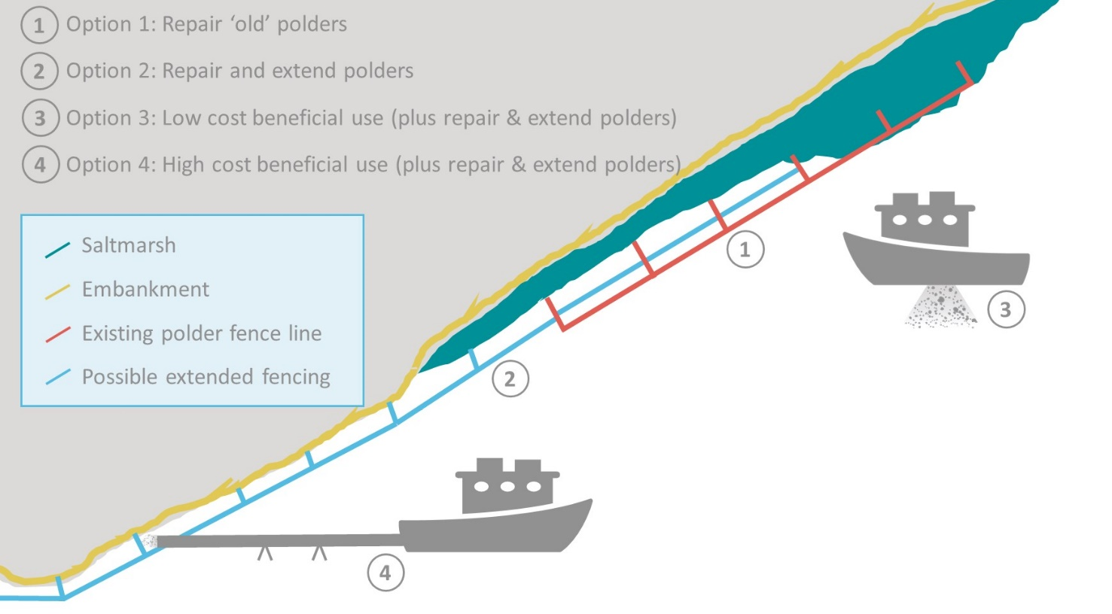
Image 16 Illustration of shortlisted options

5.2 Cost-Benefit Analysis (CBA)

5.2.1 CBA approach
To understand and help prioritise possible nature based interventions along the Rumney Great Wharf frontage, the potential costs and benefits of four example options have been assessed. Cost and benefit estimates (2020 prices) have been prepared for the four options, based on assumptions about continued change along the Rumney frontage and the impacts of the proposed interventions. An assessment has been carried out of the costs and benefits associated with each option, as well as a business as usual (‘No Intervention’) scenario.
These estimates have sought to focus on those costs and benefits that are likely to be different between the ‘No Intervention’ and ‘Intervention’ options and therefore provide a partial CBA. For example, the assessment does not consider the flood risk related benefits of the embankment remaining in place (though deferred investment and reduced maintenance costs are considered), or the costs of dredge disposal, as these benefits and costs will be the same in both the ‘No Intervention’ and ‘Intervention’ scenarios.
The assessment has been carried out using a 50-year time period to 2070, reflecting that many of the benefits will only accrue over long time scales. Costs have been discounted over time following HM Treasury Green Book guidance (HM Treasury, 2018) to estimate a Net Present Value (NPV) which enables the costs and benefits of ‘No Intervention’ and ‘Intervention’ for each option over time to be compared.
It is important to note that in comparing the costs and benefits, the main interest is in the relative NPV for ‘No Intervention’ and ‘Intervention’. This is because the CBA is only examining those costs and benefits that may change as a result of ’Intervention’. Thus, for example, where ‘Intervention’ results in an overall reduction in net cost compared to ‘No Intervention’, then the ‘Intervention’ is providing an overall benefit.
In order to undertake the CBA, a large number of assumptions needed to be made in relation to:
- The costs of the nature based options;
- The consequences of doing nothing (likely future rates of intertidal decline and timing of new capital flood defence works);
- The effects of the nature based options in reducing rates of marsh erosion and deterioration and in deferring capital investment in flood defence works; and
- The monetary values of these benefits.
These assumptions were informed by evidence from the baseline and background review (Sections 3 and 4), including that of costs and benefits (see Section 5.2.2). In particular, the quality of evidence on historic and current rates of saltmarsh erosion and deterioration for the Rumney saltmarshes is good and provides a reasonable basis for projecting future change. Similarly, emerging confirmation on the effectiveness of existing beneficial use schemes in the UK and elsewhere provides a useful evidence base in understanding the effectiveness of different interventions in reducing erosion and deterioration of the saltmarshes. This can be further used to inform judgements on the extent to which interventions might delay the requirement for capital investment in flood protection works.
With regard to the sediment required for Options 3 and 4, it is assumed that at least 48,000 m³ will be available from various sources every year. Given that this represents a relatively small proportion of the regularly dredged volumes, as outlined in Section 3.4, this should in principle be feasible, although haulage distances would generally be greater; thus, there is no scope for cost savings to dredging licence holders at present.

5.2.2 Option assumptions on costs and benefits
To inform the CBA, cost assumptions have been developed for the options, informed by cost information available for the 2005 works, as well as from the literature (as summarised in Section 4.1). Cost assumptions for the four shortlisted options are set out in Table 6. Table 7 then lists the high level assumptions made with regard to intertidal losses and gains, and defence / flood risk management investment costs and timescales for the ‘business as usual’ and ‘do something new’ / intervention options. The defence assumptions for ‘do nothing’ were informed by communication with NRW asset managers, and the intertidal loss and gains assumptions from the baseline review presented in Section 2.1.

Table 6 Cost assumptions for four short listed options
Option | Cost Assumptions*
1: Repair and re-instate all existing polders. | - Planning and consents/licences: £20,000.  - Construction: £432,000. Fence line current length: 1.9 km. Subdivision of Polder 1 to 3: + 0.8 km. Double fence Polder 1 outer fence: + 0.3 km. Assume ¼ of old posts require replacement (0.5 km); thus 1.6 km new / replacement fence required (at circa £120 m ⁻¹). Brushwood to be (re)installed along whole length (3 km) (circa. £80 m⁻¹).  - Monitoring: £6,000 every 2 yrs, for 10 yrs, using drone to undertake topographical survey (at £6,000 per survey, including reporting/analysis).  - Annual inspection & repair costs: £21,600 (5% of capital costs; no decline over time**).
2: Extend polders to cover whole Rumney frontage. | - Planning and consents/licences: £20,000.  - Construction: £832,000. As Option 1), + 2 km of new fence with brushwood.  - Monitoring: £6,500 every 2 yrs, for 10 yrs, using drone to undertake topographical survey (including reporting/analysis).  - Annual inspection & repair costs: £41,600 (5% of capital costs; no decline over time**).
3: Low cost beneficial use (with polder Option 2) | - Planning and consents/licences (incl. EIA & modelling): £100,000.  - Construction / operation: As Option 2), plus:  £86,400 yr⁻¹ (£1.8 m⁻³ = approx. differential between normal dredging and disposal costs and beneficial use; difference due to additional time in transit / at site and ‘dropped’ loads***).  - Monitoring: £15,000 every 2 yrs, for 10 yrs (for benthic invertebrate and drone topographic surveys (incl. reporting / analysis)).  - Annual inspection & repair costs: £41,600, same as for Option 2.
4: High cost beneficial use (with polder Option 2) | - Planning and consents/licences (incl. EIA & modelling): £100,000.  - Construction / operation: As Option 2), plus:  £208,400 yr⁻¹ for 20 yrs (£3.3 m⁻³ (approx. differential), with £50,000 yr⁻¹ for pipeline and hire/installation of spud barge (for pipe connection)).  - Monitoring: As for Option 3.  - Annual inspection & repair costs: £41,600, same as for Option 2.
* Please note that, for Options 1, 2 and 4, a low confidence is associated with the cost assumptions, as these are not approaches which have been regularly carried out in the UK to date. For the Option 3 costings, confidence is medium in relation to the beneficial use element, due to insights gained from conversations with UKD.
** due to brushwood in exposed locations needing to be re-inset every 5 years, and posts also requiring repair. For example, the old posts will likely need substantial mending over the next 5 to 10 years, and any new posts in 15 to 25 years. Averaging these costs out, 5% is considered a realistic percentage.
*** Personal communication with UKD revealed that the longer haulage distance to Rumney would lead to at least one ‘dropped’/missed load; e.g. whereas around 10 daily loads can typically be achieved (when dredging the approach channel at Cardiff and disposing at Cardiff Grounds), at least one less would be feasible if one load was to be deposited at Rumney at high tide.
Table 7 Benefit assumptions related to business as usual and four intervention options
Option | Intertidal habitat (natural capital)and defence assumptions
0: Business as usual | - Intertidal: to 2025, Losses 0.25 ha of saltmarsh, and 3 ha of mudflat per annum (yr⁻¹). Thereafter, losses accelerate to 0.6 ha and 6.9 ha respectively (to 2055)*.  - Defence: maintenance costs of around £4.3 m⁻¹yr⁻¹ (based on NRW pers. comm.). Significant bank refurbishment will occur in 10 years’ time (2030), at a cost of £1,300 m⁻¹, after which maintenance is reduced by half to £2.15 m⁻¹ for the next 15 years (until 2045). Rock armour revetment will require repairs every 5 years at cost of £25,000 (or approx. 7.6 m⁻¹ (assuming it is spread along whole frontage measuring 3.3 km)).
1: Repair and re-instate all existing polders. | - Intertidal: gains of + 0.5 ha yr⁻¹ saltmarsh to 2025, thereafter reduced to 0.2 ha yr⁻¹ (until polder area is filled with saltmarsh at around 2040, then no change). Saltmarsh losses are halted at polder frontage. Whilst there may be slight benefits to adjacent mudflats, these have not been quantified due to substantial uncertainties. Losses at remainder of frontage continue (at proportionate rate for shorter non-polder frontage).  - Defence: along 1.3 km of polder frontage, bank refurbishment is deferred by 10 years, and rock armour revetment repair no longer required. Seawall maintenance costs are halved to 2.15 m⁻¹yr⁻¹ here.
2: Extend polders to cover whole Rumney frontage. | - Intertidal: + 0.8 ha yr⁻¹ saltmarsh to 2025, thereafter reduced to 0.25 ha yr⁻¹ (until polder area is filled with saltmarsh at around 2055**, then no change along frontage). Saltmarsh losses are halted at polder frontage. Mudflat losses continue (despite likely slight benefit).  - Defence: along whole Rumney frontage (3.3 km), bank refurbishment is deferred by 10 years, and rock armour revetment repair no longer required. Seawall maintenance costs are halved to 2.15 m⁻¹yr⁻¹.
3: Low cost beneficial use (with polder Option 2) | - Intertidal: + 0.85 ha yr⁻¹ saltmarsh to 2025, thereafter reduced to 0.28 ha yr⁻¹ (to 2059, until polders filled with saltmarsh**; thereafter, 0.03 ha yr⁻¹, to reflect likely minor benefits outside polders). Saltmarsh losses are halted and mudflat losses slowed by 0.05 ha yr⁻¹ to 2025, 0.03 ha yr⁻¹ thereafter.  - Defence: along 3.3 km of frontage, bank refurbishment is deferred by 11 yrs, and rock armour revetment repair no longer required. Seawall maintenance costs are halved to 2.15 m⁻¹yr⁻¹ here.
4: High cost beneficial use (with polder Option 2) | - Intertidal: increase of 1.2 ha yr⁻¹ saltmarsh to 2025, then reduced to 0.7 ha yr⁻¹ to 2040 (end of dredging campaigns, assumes some expansion beyond polders). Saltmarsh losses are halted and mudflat losses slightly reduced. After 2040, values are as per Option 2.  - Defence: along 3.3 km of frontage, bank refurbishment is deferred by 15 years, and rock armour revetment repair no longer required. Seawall maintenance costs are halved to 2.15 m⁻¹yr⁻¹ here.
* ratio of 2.6, in line with Welsh Government sea level rise allowances rising by same factor from 2026.
** old polders, which measure 13.5 ha, contain almost 8 ha of saltmarsh, thus another 5.5 ha of saltmarsh can be created here. The new polders, which measure just under 7 ha, contain very little saltmarsh (around 0.1 ha only).
With regard to mudflat and saltmarsh values, ‘bundled’ Brander et al. (2006) rates have been applied; these were discussed in Section 4.2.2 above. In summary, the values have been derived from a comprehensive metastudy, with values of up to £6,140 ha⁻¹ quoted for saltmarshes for example. The bundled values is understood to incorporate water quality improvement, recreation, biodiversity and aesthetic amenity.
For this CBA, three values have been applied to take account of the ecosystem services of intertidal habitats.
Firstly, a ‘bundled; value has been applied, building on the metastudy undertaken by Brander et al. in 2006, as quoted in Section 4.2.2. This is frequently practiced in saltmarsh valuation studies (e.g. Eftec, 2010). As part of the ‘bundle’, the following ecosystem services are taken account of: water quality improvement, recreation, biodiversity and aesthetic amenity. As Brander et al. (2006) quoted a range of potential values, a judgement has needed to be made on the value which should be applied. It has been assumed that all the intertidal habitats at Rumney Great Wharf are healthy, and thus full values can be applied. Furthermore, given the highly designated nature of the frontage, as well as recent studies quoting high potential values for featured services, notably for water quality benefits, the Brander et al. (2006) median values have been doubled. The following unit values have been applied:
- £3,821 ha⁻¹ yr⁻¹ (at 2020 prices) for saltmarshes; and
- £3,548 ha⁻¹ yr⁻¹ (at 2020 prices) for mudflats.
Secondly, carbon sequestration has also been valued; this is the only intertidal habitat ecosystem service which has been assessed separately. A constant value of 15.4 tCO₂ ha⁻¹ yr⁻¹ has been applied to new saltmarsh habitat which is anticipated to establish. Where erosion is slowed, and less carbon thus being released from eroding intertidal habitats, this has also been valued, by estimating the amount of carbon, and then CO₂ (equivalent), contained within a cubic metre of mudflat or saltmarsh sediment. This has been estimated at 0.041 t⁻¹, based on an organic matter content of 5 %. This is then multiplied by the non-traded (central) price for CO_{2e} (DBEIS, 2012). For example, in 2020, a tonne of CO_{2e} is valued at £ 70; the carbon value of a cubic metre of intertidal sediment would thus be £2.9. It is worth noting that CO2_{e} prices increase exponentially going forward; for example, in 2050, the price is £231, and the carbon related value of a cubic metre in 2050 would thus be £9.5.
Flood risk management related benefits have been valued by deferring capital and maintenance expenditure, i.e. increasing the design life of defences and decreasing maintenance costs as a consequence of the presence of wider saltmarshes. This has been achieved in consultation with NRW FCERM staff; see Table 7 above for assumptions.
Due to current gaps in data or research, it was not possible to quantify and / or monetise all the ecosystem service impacts. The results should therefore be considered as approximations of the value of the options, with an order of magnitude level of accuracy for individual services. A qualitative assessment of the of the potential ecosystem services impacts which could arise from implementing nature based-intervention at Rumney Great Wharf is provided in Table 8 below.

Table 8 Potential ecosystem services impacts resulting from the options
Category | Narrative | Impact quantified? | Explanation / assessment
Provisioning | N/A | N/A | N/A
Food | Creation / maintenance of nursery habitat will lead to an increase in fish stocks. Grazing areas are sustained and possibly extended | N | Could be of high value, but could not be valued (insufficient valuation data)
Regulating | N/A | N/A | N/A
Air quality improvements | Intertidal habitat may assist in absorption of air pollutants | N | Could be of low to moderate value, but could not be valued (insufficient valuation data)
Climate regulation | Saltmarshes and mudflats sequester and store large amounts of carbon | Y | Valued by calculating amount of carbon sequestered; also avoided stock losses
Natural hazard regulation | Saltmarshes, and to a lesser extent mudflats, attenuate wave energy (reduced wave attack) | Y (in part) | Valued indirectly by deferring FCERM capital & maintenance costs
Erosion regulation | Erosion of saltmarshes and embankments may be slowed. | Y (in part) | Valued indirectly by deferring FCERM capital & maintenance costs
Water quality and nutrient cycling | Saltmarshes take up pollutants and excess inorganic nutrients such as nitrates and phosphates, therefore reducing the potential for eutrophication | Y (bundled) | Valued, included in the Brander bundle (but this may underestimate value)
Cultural | N/A | N/A | N/A
Recreation and tourism | Visits to coastal margins are popular; retaining saltmarsh is likely to be beneficial | Y (bundled) | Valued, included in the Brander bundle
Aesthetic value | Saltmarshes are of high visual amenity | Y (bundled) | Valued, included in the Brander bundle
Intellectual and scientific, educational | There is good potential for research in relation to the options | N | Could be of low to moderate value, but could not be valued (insufficient valuation data)
Existence value (of biodiversity) | Saltmarshes may be perceived as important to others and future generations | N | Could be of high value, but cannot be valued due to insufficient valuation data (though value transfer could be considered)

For the purpose of the CBA, the extent of the saltmarshes along the Rumney frontage at baseline (2020) has been estimated as 36.75 ha, and that of mudflats as 448.5 ha.

5.2.3 CBA results
The four options examined through the CBA for potential nature based interventions at Rumney Great Wharf differ in terms of their scale of intervention, and in their cost and expected benefits. This has been deliberately done to show the scale of what could be done and understand the societal benefits across the range of options available. It should also be noted that the options assessed within the CBA are hypothetical examples, and while they are sensible projects in their own right, the findings of the CBA are primarily intended to inform the development of a strategy for the Rumney frontage. This future strategy will need to be based on further communication with dredging operators and commissioning organisations, as well as licensing and regulatory bodies.
Based on the assumptions used, the CBAs for all bar one of the options show higher overall net costs than benefits (see Table 9). These lower benefits are related to the relatively modest habitat gains and small reductions in erosion rates. Under all scenarios, mudflat areas is expected to continue to decline due to coastal squeeze, with extent reduced by 71 to 64 % by 2070; for example, under ‘do nothing’, only 130 ha of the current 449 ha are expected to remain.. As set out in Table 8, only the options which incorporate beneficial use, i.e. Options 3 and 4, are anticipated to help slow the mudflat erosional trend (though the polders might help, but this could not be quantified due to substantial uncertainties). All the ‘intervention’ options are anticipated to slow or reverse the trend of saltmarsh erosion at Rumney, with losses slowed by over 50 % for Option 1 (when compared to doing nothing) and increases of 34 %, 35 % and 46 % assumed for Options 2, 3 and 4 respectively. Without intervention, only 9 ha are predicted to remain by 2070, applying the assumptions set out in Section 5.2.2.
Costs are highest for Option 4, though these are only slightly higher than for Option 3. This is because, with Option 4, the (higher cost) sediment recharge measures are only envisaged to be undertaken for 20 years, whereas with Option 3, beneficial use is expected to occur every year to the end of the assessment period.
For each of the ‘intervention’ options, the beneficial effect of reducing saltmarsh erosion was assumed to facilitate the deferral of capital investment in flood protection, as well as the reduction in some maintenance costs. In each example, the monetary benefits of deferring this capital expenditure (by 10 to 15 years) only offset small proportions of the costs associated with the nature based interventions. However, the ecosystem services did offset high proportions of the costs; for one of the options, a ratio of more than 1 was achieved, a value which tends to indicate that a given option might generate greater societal benefit than cost. The highest value is 1.25, for Option 2, with the CBA for Option 3 returning the lowest value of 0.34.
In part, the highly suboptimal ratio for the beneficial use options, 0.34 and 0.54 for Options 3 and 4 respectively, can be attributed to the fact that they have been combined with polder extension, and the additional benefits from beneficial use are fairly marginal on top of this.
Option 2 had the highest benefit:cost ratio of all the intervention options, with the increased ratio largely related to the reduction in erosion rates (and avoided carbon loss), and increases in saltmarsh area. The deferral of flood defence capital investments along the whole frontage, rather than only parts, as would be the case with Option 1, does not offset the increased capital costs of this option, as can be gleaned from its net costs still being higher than those for Option 1.
Table 9 Summary of Cost Benefit Analysis (£m discounted costs at 2019 prices)
Option | Intervention Net Cost (discounted value to 2070 at 2020 prices) | Benefit:Cost Ratio
Option 0: Business as usual | £3,418,222 | n/a
Option 1: Polder repair and reinstatement | £3,966,715 | 0.84
Option 2: Polder extension | £4,153,235 | 1.25
Option 3: Polder extension + low cost beneficial use | £6,271,013 | 0.34
Option 4: Polder extension + high cost beneficial use | £6,961,331 | 0.54

Sensitivity testing has been undertaken, to gauge how varying key assumptions may affect the benefit:cost ratio. This has been achieved by applying higher bundled values, specifically the highest values quoted by Brander et al. (2006), and / or also including non-use values (existence value). Existence value reflect ‘the willingness to pay that people have towards improvements in or protection of the ecological quality of a resource where there is no intention of using or consuming that resource’ (Environment Agency, 2003). As no local study was available, willingness to pay of £0.06 per hectare per household per year (2020 price levels) was derived for the frontage based on a study by Luisetti et al. (2008) (in the Blackwater in Essex / England). This was conservatively only applied to 5 % of the households in Cardiff (2019 numbers taken from StatsWales, 2019), so 7,750 households. Results are displayed in Table 10. This demonstrates that Option 2 remains the option with the highest ratio, increasing to 1.33 where both tests are combined. None of the other options achieved a value greater than 1.
Table 10 Results of sensitivity tests (Benefit:Cost Ratio)
Option | Increased bundled value only | Plus existence value only | Both
Option 1: Polder repair and reinstatement | 0.88 | 0.85 | 0.89
Option 2: Polder extension | 1.32 | 1.26 | 1.33
Option 3: Polder extension + low cost beneficial use | 0.36 | 0.34 | 0.36
Option 4: Polder extension + high cost beneficial use | 0.58 | 0.54 | 0.58
For All Options: Bundled Value - £ 6,140 (saltmarsh); £ 5,867 (mudflat)
Existence value - £ 465 (saltmarsh only)

The key conclusions from the CBA are:
- Due to the relatively high costs of nature based inventions at Rumney, only one of the interventions is likely to be cost effective, despite the deferral of capital expenditure on flood risk management, and reduce maintenance costs;
- Where interventions significantly reduce rates of erosion of existing marshes or create new saltmarsh, this can provide substantial benefits, albeit not at a very high tangible value, due to the relatively small gains;
- The assessments are particularly sensitive to assumptions on cost of beneficial use projects, this is largely due to these having been combined with polder extension in each case, and extra benefits from adding sediment through beneficial use thus being relatively marginal; and
- While there are uncertainties concerning the monetary values of some of the ecosystem service benefits associated with Severn Estuary saltmarshes (the ‘Brander bundle’ benefits), these uncertainties do not appear to be material to overall decision-making, which is more influenced by assumptions on the timing of capital investment and the potential habitat gains / slow down of the erosion.

5.3 SWOT Analysis
A high-level strengths, weakness, opportunities, and threats (SWOT) analysis has been undertaken on the options; this is presented in Table 11 below. This shows that many of the aspects are similar across the options, particularly where the technique is the same. For example, beneficial use has several strengths and opportunities, which are similar regardless of the technique that is applied.

Table 11 SWOT analysis
Option | Strengths | Weaknesses | Opportunities | Threats
Option 1: Polder repair and reinstatement | - Nature based solution using natural materials  - Construction would have low impacts on existing habitats  - Positive cost/benefit ratio  - Increase in saltmarsh area along polder frontage | - Exposed position of frontage may lead to excessive damage to fencing and large proportions of brushwood being washed out every year  - Large tidal range means that 1 m high brushwood does not trap much of the suspended sediment  - Suboptimal cost/benefit ratio | - Likely to trap substantial amounts of sediment if properly maintained  - Takes advantage of high local SSC  - Environmental impacts likely relatively benign  - Likely to lead to saltmarsh gains in polders, even with accelerated sea level rise | - May be viewed as obtrusive by public  - Success not fully proven due to lack of monitoring and maintenance at previous scheme (and similar historic UK schemes)  - Erosion of fencing materials highly likely, given exposed aspect of frontage
Option 2: Polder extension | - As Option 1, though better cost/benefit ratio and larger increase in saltmarsh area | - As Option 1 | - As Option 1, though increased trapping and saltmarsh benefits | - As Option 1
Option 3: Polder extension + low cost beneficial use | - As Option 2, plus:  - Makes use of locally available sediments and dredging vessels  - Combines two nature based solutions (with the latter endorsed by many organisations)  - Delivers dredged materials closer to eroding habitats  - Polder fencing utilises natural materials only  - Positive cost/benefit ratio  - May benefit both saltmarshes and mudflats | - As Option 2, plus:  - Locally available dredged sediments have very high water content - no guarantees that sediment reaches /accretes on local intertidal habitats  - Limited tidal windows limits deposition volumes  - Longer haulage distance leads to higher costs; unlikely to improve with increased application  - Relatively high costs for limited additional benefit | - As Option 2, plus:  - Potential to help slow intertidal habitat erosion along frontage, leading to improved ecosystem services provision (inc. benefits to designated features)  - May defer capital works to ‘hard’ structures and reduce maintenance costs  - Better adherence to waste hierarchy | - As Option 2, plus:  - There may be detrimental environmental impacts  - Obtaining the necessary permissions and licences for a new disposal site can be tricky  - Port operators may feel unduly pressured to absorb costs when they do not benefit directly  - Erosion / re-suspension of large percentage of beneficial use sediments highly likely  - Benefits of beneficial use may be hard to prove
Option 4: Polder extension + high cost beneficial use | - As Option 3, plus:  - Piping delivers materials closer to the shore, thus more likely to be deposited on saltmarshes | - As Option 3, though no tidal restrictions under this scenario, and better likelihood of more sediment accreting on intertidal habitats | - As Option 3 | - As Option 3 (excl. disposal ground issue), plus:  - Potentially increased impacts  - Uncertainties around feasibility of option (re. piping over great distances)

5.4 Recommended Preferred Option
The results obtained from the Phase 1 options review, as informed by the baseline and literature reviews would indicate that one of the options has slightly greater relative benefit when compared to the other options. This is Option 2, the ‘extend polders’ option. As noted in Section 5.1, this option envisages the implementation of sedimentation polders along the whole Rumney frontage. It would incorporate the repair of the existing polders, as well as the installation of a further six polders to the west of the existing polders. Given the lower elevations along this section of the frontage, these would be smaller, with the shore-parallel fences closer to the shore (but staying at least 50 m from the defence crest).
This option was recommended after Phase 1, because it has the highest benefit:cost ratio of all of the options, at 1.25, and thus has lower overall net costs compared to the ‘Business as usual’ scenario. Based on insights gained during the baseline review, notably the LiDAR analysis presented in Section 3.3.2, it is considered that this option has a good chance of achieving a reversal of the trend of saltmarsh erosion along the frontage, leading to potential increases in saltmarsh extent of around 35 % by 2070. It is furthermore a nature based solution, the implementation of which would be anticipated to have relatively benign impacts on the local, highly designated, habitats, as well as the associated flora and fauna. The baseline review has shown that this approach has likely been effective at this location in the past, though to a relatively limited extent, due to the polders not having been adequately maintained and repaired.
Option 3, the low cost beneficial use option, could potentially benefit from additional research to inform future management options for the coastline. Such an option could benefit relatively long stretches of saltmarsh, albeit likely in a relatively subtle manner. Certainly, should the designation of additional, or new, disposal grounds for dredge arisings be considered at any point in the future, designating such a ground closer to the saltmarsh edge would be advantageous for this habitat.

Preferred Option Development and Assessment (Phase 2)
For Phase 2 of this project, the design for the preferred option (Option 2) has been further developed; this process is described in Section 6.1. The design presented below would in due course need to be converted into an engineering design and related specifications, should the project progress past this stage. An environmental scoping exercise has furthermore been undertaken, and is outlined in Section 6.2.

6.1 Preferred Design Development

6.1.1 Design refinements
The high level design presented in Section 5 for Option 2, the ‘Extend and Repair Polder’ option, has been further developed into a preliminary outline design during Phase 2 (building on the high level design outlined in Sections 5.1 and 5.2). In summary, the design which was developed in Phase 1 for Option 2 envisaged installing brushwood sedimentation fields / polders along 2.5 km of the Rumney Great Wharf frontage, extending slightly into the mouth of the River Rhymney.
The design development during Phase 2 has been supported by the baseline review, further exploration of the literature (particularly from The Netherlands and Germany, see Section 4.1.2), as well as some consultation with German and UK practitioners with expertise in the sedimentation polder method. A workshop with NRW staff was also held in February 2021, to discuss possible refinements.
Based on the above, the fence itself would be created by installing two rows of 2.5 m-long 100 mm diameter posts at 600 mm centres, with rows 300 mm apart and stakes driven circa 1.3 m into the mudflat level. Hardwood (e.g. hazel) bundles would be weaved in-between, four deep, to a height of 1 m above the mudflat surface. These bundles should ideally be 2 m long, and compacted well before being tied down using pre-stretched synthetic 6 mm rope.
This following key design adjustments have also been made when compared to the Phase 1 design:
- Fences have been moved so the top of the 1 m high brushwood is approximately aligned with the MHW tide level (MHW is at around 4.6 mOD at the site, so the bottom of the fence would be at 3.6 mOD). Along the western frontage, achieving this elevation was not possible due to the steep profiles. Here, in order to provide sedimentation space, the fence is envisaged to be at least 30 m from the wharf cliff, or embankment toe (where there is no marsh remaining). This would necessitate the installation of fences at elevations up to 1 m lower than is considered ideal (i.e. MHW -2 m to MHW -1.5 m, which is at 2.6 mOD to 3.1 mOD);
- To minimise fence length, the fence line was straightened (rather than following the undulations of the 3.6 m contour for example);
- Polders / fields have been kept to a relatively small size, so they are no more than 200 m long; this is with the exception of the old polders, where the previous distance of circa 270 m is maintained so as to utilise the surviving fence posts.
- Where there are wharf promontories, the shore perpendicular fence lines have been shifted to tie in with those, thus slightly reducing overall fence length;
- Gaps in the shore parallel fence line are included at regular intervals, generally two per field (to both facilitate better drainage and fish escape). These gaps should be around 10 m wide; and
- Brushwood is to be placed at least four bundles deep (so it can be compacted well, and thus potentially last longer).
Two variations of the design have been costed and evaluated, namely a minimum and a maximum version (Figure 8).
- The maximum version seeks to maximise new saltmarsh extent and envisages that:
  - New seaward fences are installed at Polders 4 and 5, with the aim of extending the saltmarsh further here;
  - The old polder fence lines in Polders 2 to 3 are repaired and brushwood reinserted (not at Polder 1, as the elevation of the outer fence is considered too low, and as around 60 to 70 % of the posts would need replacing here, whereas at the other polders, replacement requirement is estimated at between 10 and 30%); and
  - New fences are installed at / near the MHW -1 m line, extending west into the Rhymney, and sub-dividing Polders 2 and 3;
- The minimum version seeks to establish, or extend saltmarsh, where it is not already at least 200 m wide, whilst minimising fence length and costs; thus:
  - Polder 5 is excluded, as saltmarsh is at least 230 m wide here;
  - Half of Polder 4 is excluded; and
  - For Polders 1 to 3, the old outer fence line is not utilised (as many posts are missing and it is generally at least 1.5 m below MHW).
For both options, the fence line at the corner into the mouth of the Rhymney is double fenced over a length of 250 m; this is to facilitate better protection from wave attack. However, it is recommended that, when the engineering design is drawn up during later project phases (should it progress further), alternative, and possibly more robust methods, such as revetments or rock matting, are investigated as either an alternative to brushwood fencing, or to better protect such a fence.
The ‘maximum’ version extends along slightly more of the frontage, at 2.5 km, whereas the ‘minimum’ version stretches along 2.1 km.

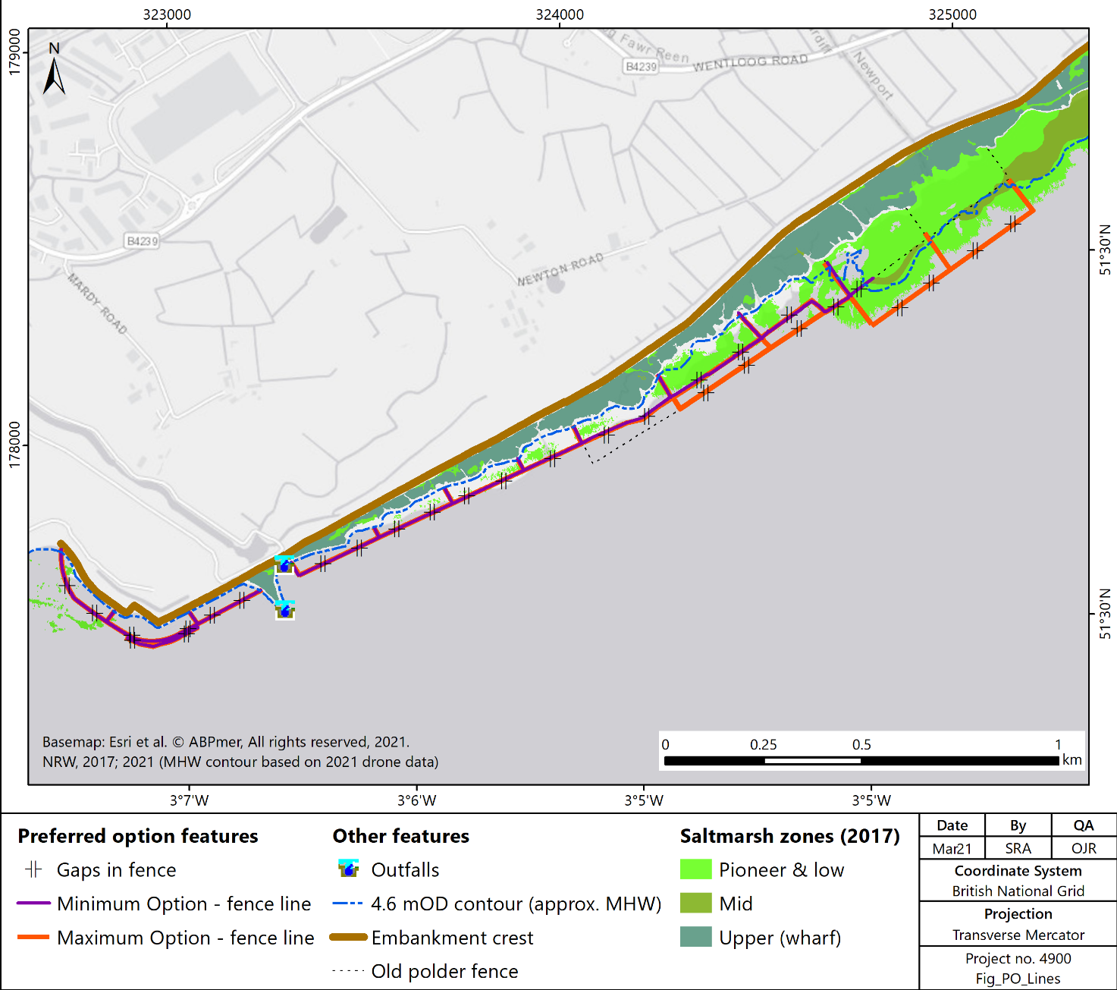
Figure 8 Preferred option – refined concept design

6.1.2 Costing
An indicative costing for implementing the preferred option is provided in Table 12, together with a benefit:cost ratio; the latter has been derived by using very similar assumptions to those made for the short-listed options during Phase 1 (see Section 5.2.2). The table shows that capital costs will be higher for the ‘maximum’ version, at around £790,000, and that maintenance costs will be fairly high for both versions, at around 6 % of the capital costs. This is slightly higher than the 5% applied for the Phase 1 CBA, and reflects insights gained from the Phase 2 consultations, notably the relatively short lifespan of the brushwood bundles. In addition, whilst it is considered that a large percentage of the old posts can be reused in Polders 2 to 5, many of them will nevertheless need replacing in the near future, likely within 5 to 10 years. The benefit:cost ratio for the minimal fence version is much more favourable than the ‘maximum’ version, with that for the latter being very similar to the Option 4 ratio of 1.25, as presented in Table 9. The high ratio for the ‘minimum’ version reflects the lower costs of this scenario, whilst achieving the same FCERM related benefits (of deferred investment and reduced maintenance) as the ‘maximum’ version, as well as similar ecosystem services benefits.
Table 12 Costs for preferred option (minimum and maximum versions)
Preferred Option Version | Fence lengths (km) New | Fence lengths (km)Old** | Capital costs | Annual maintenance costs (as averaged across 20 years)* | Benefit:Cost Ratio
Minimum | 3.4 | 1.0 | £576,000 | £31,000 | 3.4
Maximum | 2.7 | 0.4 | £790,000 | £47,000 | 1.1
* this considers that some of the brushwood will become buried in sediment, and thus not need replacing. For the purpose of this costing, it has been assumed that this will apply to 25 % of the bundles after 5 years, and 50% after 10 years (and similarly smaller values at years 15 and 20). Other assumptions include: 25 % of the old posts needing replacement after 5 years; 50 % of the new ones after 20 years.
** this would initially only require brushwood insertion, as well as repair to some 20 % of the posts.

Please note that the above include fence and brushwood installation costs, but do not account for access issues, notably in relation to getting machinery, such as tracked flatbed carriers, onto the foreshore in the presence of very high saltmarsh cliffs. This would need to be resolved in collaboration with a potential contractor. In 2005, this was solved by installing a temporary ramp using the rocks ultimately used for the cliff face revetments (personal communication, NRW; see Image 17). Alternative solutions may exist today.

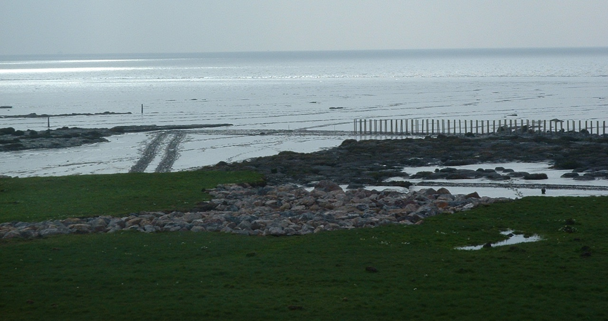
Taken by NRW, 2005
Image 17 Access ramp and vehicle tracks during 2005 installation

6.1.3 Required consents and assessments
Should NRW decide to go forward with the extended polder option at Rumney Great Wharf, various consents and licences would most likely be needed. These include:
- A marine licence from NRW;
- A works licence from ABP (the Statutory Harbour Authority, Competent Harbour Authority and Local Lighthouse Authority for the ports of Cardiff and Newport). ABP’s Cardiff-related jurisdiction extends to the Rumney Great Wharf frontage; and
- Protected species licences from NRW, should any such species be on site.
It is not thought that planning permission would be required from the Local Authority, due to the works being located below the MHWS line. However, this should be confirmed with the relevant authority should the project obtain funding and progress further.
It is recommended that pre-application consultation is undertaken with the relevant bodies listed above to determine the requirement for the respective permissions and licences. Early liaison with owners / occupiers of adjacent land parcels, as well as local shooting clubs holding rights along this stretch, is also advised.
It is considered unlikely that a full Environmental Impact Assessment (EIA) would be required. Instead, an environmental appraisal would likely be sufficient. This would focus on key receptors which may be impacted, notably the intertidal habitats at the site. Other assessments which may be requested include:
- A Water Framework Directive Assessment (likely);
- A Flood Risk Assessment (unlikely); and
- A Habitats Regulations Assessment (unlikely).
As the works would essentially constitute a management measure in relation to the ongoing conservation management of the Severn Estuary SAC and SPA, it is unlikely that a HRA will be required.

6.1.4 Timings
With regard to timings, those for obtaining the required licences and permits will very much depend on whether or not an EIA is requested, as this can lead to longer timescales and more involved consultations. The degree and nature of the associated stakeholder engagement will also influence these timescales. Without EIA, a licensing process involving the production of a supporting environmental appraisal would likely take at least six months , and one involving EIA one to two years.
Prior to works commencing, surveys may be required; time will need to be allowed for those (e.g. a rare saltmarsh plant needed to be avoided during the 2005 works, thus a vegetation survey may be needed). It should be noted that some surveys are subject to fairly specific survey windows; early dialogue with NRW colleagues with regard to what may be required is encouraged in order to facilitate smooth implementation.
Construction itself would be tide restricted, meaning at best, crews could work around 4 hours per day. In 2005, works took around 5 weeks to complete. Given that the ‘maximum’ version would involve around double the fence installation works when compared to 2005, and the ‘minimum’ version 50% more, then works should be anticipated to take 7 to 10 weeks to complete. As spring tides would need to be avoided, the actual installation period would be longer yet. Timing these works may be difficult due to the site’s location in an SPA, as works during overwintering bird periods (October to March) would tend to be avoided in such areas if possible. Tracking across the high saltmarsh during the breeding bird season may also be problematic, although this could be circumvented by defining a clear access route and making sure this remained free of nests throughout the works. Thus, construction should be able to progress from late spring to early autumn, which are also more optimal months with regard to weather, storminess, tides and daylight hours.
It should also be noted that consultation has revealed that the quantities of brushwood which would be required for the preferred option cannot be met by UK suppliers; these tend only be able to provide relatively small quantities of 2,000 to 3,000 bundles. Greater quantities would tend to be imported from mainland Europe, including Germany, and substantial lead in times may be required for this. Whilst traditionally, brushwood from Europe has tended to be slightly cheaper than UK branches, costs are changing due to Brexit (personal communication, Salix), and some uncertainty is recognised in this regard. This has not been factored into the costs provided in Section 6.1.2.

In light of the above, it is considered that, for the planning and licence application phase for the preferred option, 1 to 2 years should be allowed, and 2 to 4 months for the construction period itself.

6.2 Environmental Scoping
As noted in Section 6.1.3, given the information presented in this report, and the currently envisaged design, it is not anticipated that a full EIA will be required. However, an environment appraisal to accompany the marine licence application would be necessary. Such an environmental appraisal could be in the form of a concise technical document which could include:
- Background Information – to include the project description and rationale;
- Legislative Framework – to outline the legislative and policy requirements associated with the proposals;
- A high level evaluation of potential impacts arising from the works; and
- Conclusions.
Supporting assessments, if requested, could then be appended to the environmental appraisal. Potentially affected environmental topics / receptors, related pathways, and potential mitigation measures are briefly summarised in Table 13.

Table 13 Environmental topic and potential impacts, and further work
Topic | Receptor | Impact Pathway/ Potential Effect | Summary of potential impacts & further work
Marine Physical processes | Estuary hydrodynamics | Changes to flow and hydrodynamics  Changes in sedimentation patterns | Impacts are unlikely to be moderate or major adverse. May require modelling, though qualitative assessment will likely suffice.
Water and sediment quality | Water and sediment quality | Potential for contamination (including accidental spillages) during construction  Potential changes to SSC during operation | Mitigation measures during construction will include following standard best practice pollution prevention guidelines.  Impacts unlikely to be moderate or major adverse given the high background SSC levels in the estuary.  A WFD Assessment may need to be undertaken following the latest available guidance.
Nature Conservation | Protected habitats and species | See respective receptor categories (marine ecology, ornithology). | A Habitats Regulations Assessment (HRA) should not be required (as option should constitute a management measure in relation to the ongoing conservation management of the SAC and SPA).
Marine ecology | All marine ecology | Changes in water quality during construction | As above, appropriate pollution prevention measures during construction would minimise this risk.
Marine ecology | Mudflats and saltmarshes | Compaction of habitat during construction | Impacts unlikely to be moderate or major adverse.  Mitigation measures would include soft track machinery and avoidance of sensitive saltmarsh areas (for access route).  Given the dynamic nature of the Severn, mudflat tracks would not persist for more than a few days (as evidenced during 2005 works).  Benthic invertebrates and vegetation surveys may be requested.
Marine ecology | Mudflats and saltmarshes | Changes in benthic habitat extent during operation | Impacts unlikely to be adverse; both saltmarsh and mudflat gains are anticipated, though the latter cannot be quantified. In addition, saltmarsh will establish over what is now mudflat. However, saltmarsh would have historically been present. In addition, this will only affect a small relatively area, and saltmarsh erosion (changing to mudflat) along the (unprotected) Peterstone frontage will essentially offset it.
Marine ecology | Fish | Trapping of fish within polders | This will be mitigated by including gaps in the shore parallel fences, at regular intervals, to provide escape routes, as envisaged above.
Marine ecology | Marine mammals | Underwater noise and vibration during construction | Construction will be during low tide, thus will not take place in the water column (so no underwater noise or vibration can be caused).
Marine ecology | Ornithology | Disturbance during construction | This is mitigated by avoiding the overwintering bird period, and sticking to defined access route(s) across saltmarshes to avoid nest disturbance.
Marine ecology | Ornithology | Loss of feeding habitat including change in functional value | Impacts unlikely to be moderate or major adverse. Whilst some mudflat will change to saltmarsh in the short to medium term, this will be small in area, and saltmarsh erosion (changing to mudflat) along the (unprotected) Peterstone frontage will essentially offset it.
Marine ecology | Invasive non-native species | Introduction of non-native species during construction and operation | An assessment of the risk of the introduction or spread of non-native species (in the form of a biodiversity risk assessment) may need to be undertaken.
Population and infra-structure | N/A | N/A | Likely to be scoped out of an environmental appraisal or EIA, as the works would be on the low intertidal, and cannot be observed by humans, unless they are on the embankment. Disruption during construction would be minimal and restricted to slightly increased traffic (in order to bring machinery and staff to and from the site, as well as deliver the materials). There may be some health benefits from the saltmarshes being extended / retained.
Air quality and greenhouse gas emissions | N/A | N/A | Likely to be scoped out of an environmental appraisal or EIA, though there are likely minor benefits in relation to air quality and major benefits in relation to carbon sequestration (lowering greenhouse gas concentrations).
Airborne noise and vibration | N/A | N/A | Likely to be scoped out of an environmental appraisal or EIA, noting very minor impacts may arise in relation to traffic, see below.
Traffic and transport | Road network and transport users | Increased traffic during construction | Impacts unlikely to be moderate or major adverse  A traffic assessment is unlikely to be required, though there would be some very minor increases in relation to construction traffic.
Archaeology and cultural heritage | Cultural heritage | Damage of known and unknown archaeological remains | Impacts unlikely, as no excavation is envisaged. Desk based assessment may be required.
Landscape/ seascape and visual impact | Footpaths with views of the development | Change in the seascape during construction and operation | The seascape would change, but the polder features are already present at the location, so an extension would be unlikely to have a significant impact.
Coastal and flood protection | Coastal and flood protection | Changes in the level of coastal flood risk during operation | Likely to be scoped out of an environmental appraisal or EIA, though substantial FCERM benefits are anticipated.
Cumulative and in-combination effects | All | Potential for cumulative and in-combination effects | A review of potential effects in the context of wider plans and projects will be required.

Conclusions and Recommendations
A two-phase study investigating the options for nature based interventions along the Rumney Great Wharf intertidal frontage near Cardiff on the Severn Estuary has been undertaken.
During Phase 1, the optioneering phase, an iterative process was followed to identify a preferred option. First, a long list of options was drawn up. From those, four options were then shortlisted and subsequently further assessed before a preferred option was selected. This is Option 2, which envisages the extension of polders along the whole Rumney frontage, including repair of the ‘old’ polders. It was chosen because it has the highest benefit:cost ratio of all the intervention options considered, at 1.25 (a value above 1 is generally desired). Benefits of Option 2 related mostly to reduced rates of erosion of the existing marshes, as well as the creation of some new saltmarsh, and consequent betterments with regard to key ecosystem services, notably carbon sequestration and storage, biodiversity, water quality, wave attenuation and amenity.
Option 2 is considered to have a good chance of reversing the trend of saltmarsh erosion along the frontage. It is furthermore a nature based solution, the implementation of which would be anticipated to have relatively benign adverse impacts on the local, highly designated, habitats. The baseline review has shown that this approach has been effective in trapping substantial amounts of sediment at this location in the past. There is however considerable uncertainty as to the scale of the accretion which can be attributed to the polders, as well as the persistence of the brushwood inserts. This is due to no monitoring or maintenance having been undertaken after the ‘old’ polders were installed.
During Phase 2, the preferred design has been further developed, and two versions proposed; a minimum version (with 3.1 km of brushwood fencing installed or repaired), and a maximum version (with 4.4 km of fencing). Both would be relatively time consuming and expensive to implement and maintain. As brushwood has a relatively short lifespan of around 5 years in the marine environment (unless it is covered in silt), a substantial maintenance / repair budget of around £ 10 per metre of fence is needed every year (on average). Fairly high capital costs of between £576,000 and £790,000 are likely. Interestingly, whilst the benefit:cost ratio for the ‘maximum’ option is similar to that calculated for Option 2 during Phase 2, that for the ‘minimum’ option is much higher at 3.4. This reflects the lower costs of this scenario, whilst achieving the same FCERM related benefits as the ‘maximum’ version, as well as having similar habitat benefits.
Consultation with experts and more in-depth literature review revealed some crucial additional insights which then prompted design changes when compared to the Phase 1 design for Option 2. Key modifications include the alignment of the top of the fencing with the MHW tide level (where possible), and the insertion of gaps. Another important insight gained during Phase 2 relates to brushwood’s short lifespan in estuaries. This means, that, in order for any polder option to work along the frontage, or elsewhere, a substantial maintenance budget will be required for the technique to be successful. Monitoring is also strongly recommended, as this would not only help validate predicted impacts and saltmarsh developments, but it would also be invaluable in furthering the evidence base on this technique in Wales, and indeed the UK.
Installing such fences at Rumney would likely require several consents and licences, though a full EIA is unlikely to be required. Potentially affected receptors have been identified; the local mudflat and saltmarsh habitats have the greatest potential of being impacted in a significantly adverse manner, though impacts will be minimised by the application of appropriate mitigation measures. In addition, substantial beneficial impacts are anticipated in relation to intertidal habitat gains and reduced saltmarsh losses.
It should be recognised that the above conclusions are based on a series of high level assumptions that have been factored in to the analysis. Residual uncertainties remain which need to be recognised and addressed during any subsequent project stages in the development of a strategy for the Rumney frontage.
Some of these uncertainties relate to technical detail, and others to costs. For example, the efficacy of using double fencing along especially exposed locations (as envisaged for the corner into the Rhymney) would benefit from discussions with engineering consultants, as would overcoming the issue of access past the 2 m to 4 m high saltmarsh cliffs.
Small scale initial trials are recommended, as these could help reduce some of the uncertainties by:
- Investigating sedimentation rates, and controlling factors (this could lead to larger benefits on carbon sequestration, as currently, relatively conservative rates of 0.01 m yr⁻¹ have been assumed);
- Testing what brushwood materials and tie down techniques work best (e.g. rope or wire);
- Determining how many bundles of brushwood are needed (to facilitate more appropriate costing for the full option),
- Finding out whether fences could be slightly lower or higher than 1 m; and
- Comparing how fences installed at various tidal heights fare (to inform likely maintenance requirements, and practicality, of installing at suboptimal heights, e.g. 2 m below MHW rather than no more than 1 m below).
Two of the old polders, Polders 3 and 4, would particularly lend themselves to such trials, as the old fences are at various tidal elevations, and many posts remain here. Sufficient maintenance and monitoring budgets would need to be made available for such trials.
Further consideration could also be given to beneficial use in this location (this was studied during Phase 1), in order to inform future management options for this stretch of coastline. Further clarification on cost differentials would be particularly useful.
Notwithstanding the noted uncertainties, it is evident that the intertidal habitats at Rumney Great Wharf will continue to rapidly decline without intervention, and that there are viable, if expensive, avenues for slowing this decline. If nothing is done, then the highly valuable, designated, saltmarshes will have all but disappeared from the study area frontage by 2070, and designated mudflat width will have substantially decreased. This would, in time, lead to much higher flood defence costs being incurred, and will also result in a greatly diminished estuarine environment.

References
ABPmer 2009. PART A: Severn Estuary SMP2: Baseline Understanding of Coastal Behaviour and Dynamics. Prepared for Atkins Ltd. Southampton: ABPmer.
ABPmer 2017. White Paper: Using Dredge Sediment for Habitat Creation and Restoration: A Cost Benefit Review, A summary of the techniques, costs and benefits associated with using fine dredge sediment to ‘recharge’ intertidal habitat. Southampton: ABPmer.
ABPmer 2018. Beneficial Use of Dredge Sediment in the Solent (BUDS), Phase 1 Project Scoping and Partnership Building, A report produced by ABPmer for the Solent Forum. Southampton: ABPmer.
ABPmer 2019a. Coastal Impact Study for Marine Aggregates Area 531 (470). Southampton: ABPmer.
ABPmer 2019b. Lymington Saltmarsh Recharge by Bottom Placement: 2019 Monitoring Report. Bathymetric Survey Report produced in fulfilment of Condition 5.2.11 of Marine Licence L/2014/00396/2. A report produced for Lymington Harbour Commissioners. Southampton: ABPmer.
ABPmer 2020. Beneficial Use of Dredge Sediment in the Solent (BUDS) Phase 2, Feasibility Review for Sediment Recharge Project(s) on the West Solent Saltmarshes, A report produced for the Solent Forum. Southampton: ABPmer.
Allen, J.R.L. 1990. Saltmarsh growth and stratification: a numerical model with special reference to the Severn Estuary. Marine Geology 95 (1990), 77-96.
Aspden, R.J., Vardy, S., and Paterson, D.M. 2004. Saltmarsh Microbial Ecology :Microbes, Benthic Mats and Sediment Movement. In: Fagherazzi, S. Marami, M. Blum, L.K. (eds).The Ecogeomorphology of Tidal Marshes, American Geophysical Union.
Atkins 2004. Gwent Levels Foreshore Management Plan Phase III.Prepared for the Environment Agency. Swansea: Atkins. 241p.
Atkins 2006. Feasibility Study: incorporating Dredged Material within Polders at Rumney Great Wharf. Swansea: Atkins.
Atkins 2017. Medmerry Ecosystem Services Valuation. Report for the Environment Agency. Swansea: Atkins. 29p.
Austen, M.C., Malcolm, S.J., Frost, M., Hattam, C., Mangi, S., Stentiford, G., Benjamins, S., Burrows, M., Butenschön, M., Duck, C., Johns, D., Merino, G., Mieszkowska, N., Miles, A., Mitchell, I., Pimm, E., and Smyth, T. 2010. Marine (Chapter 12). In: The UK National Ecosystem Assessment Technical Report. UK National Ecosystem Assessment. Cambridge: UNEP-WCMC.
Bale, A.J., Stephens, J.A. and Harris, C.B. 2007. Critical erosion profiles in macro-tidal estuary sediments: Implications for the stability of intertidal mud and the slope of mud banks. Continental Shelf Research, 27, 2303-2312.
Balmford, A., Rodrigues, A., Walpole, M. J., ten Brink, P., Kettunen, M., Braat, L., and de Groot, R. 2008. Review of the Economics of Biodiversity Loss: Scoping the Science. Brussels: European Commission.
Baptist, M., Vroom, J., Willemsen, P., van Puijenbroek, M., van Maren, B., van Stejn, P., van Regteren, M., and Colosimo, I. 2019. Beneficial use of dredged sediment to enhance salt marsh development by applying a ‘mud motor’: evaluation based on monitoring. Deltares: Wagingen.
Blumenthal. 1966. Some Aspects of Land Reclamation in the Netherlands. 19p. From: Proceedings of the Tenth International Conference on Coastal Engineering. September, 1966. Tokyo, Japan.
Boeremaa, A., van Passel, S. and Meire, P. 2018. Cost-Eﬀectiveness Analysis of Ecosystem Management With Ecosystem Services: From Theory to Practice. Ecological Economics. 152, 207-218.
Brander, L.M., Florax, R.J.G.M. and Vermaat, J.E. 2006. The empirics of wetland valuation: A comprehensive summary and a meta‐analysis of the literature, Environmental and Resource Economics, 33(2), 223–250.
Burgess-Gamble, L., Hankin, B., Chappell, N.A., Page, T.J.C., Kipling, K., Whitling, M., 2018. Mapping the potential for Working with Natural Processes – technical report. Bristol: Environment Agency.
Carvalho, P.N., Basto, M.C., Silva, M.F., Machado, A., Bordalo, A.A., and Vasconcelos, M.T. 2010. Ability of salt marsh plants for TBT remediation in sediments. Environmental Science and Pollution Research, 17(6), 1279-86.
Chmura, G.L. 2011. What do we need to assess the sustainability of the tidal saltmarsh carbon sink? Ocean and Coastal Management, 83, 25-31.
Chmura, G.L., Anisfield, S.C., Cahoon, D.R., and Lynch, J.C. 2003. Global carbon sequestration in tidal, saline wetland soils. Global Biogeochemical Cycles 17(4), 22-1 – 22-12/1111.
Church, T.M. 1996. Saltmarshes: An Important Coastal Sink for Dissolved Uranium. Geochimica et Cosmochimica Acta, 60, 3879-3887.
Clarke, R.T., Gray, A.J., Warman, E. A., and Moy, I.L. 1993. Niche modelling of saltmarsh plant species. Wareham: ETSU.
Coelho, J.P., Pereira, M.E., Duarte, A.C. and Pardal, M.A. 2009. Contribution of primary producers to mercury trophic transfer in estuarine ecosystems: Possible effects of eutrophication. Marine Pollution Bulletin, 58, 358-365.
Connor, R. Chmura, G.L., and Beecher, C.B. 2001. Carbon accumulation in Bay of Fundy salt marshes: implications for restoration of reclaimed marshes. Global Biochemical Cycles, 15, 943-954.
Costanza, R., Perez-Maqueo, O., Martinez, M.L., Sutton, P., Anderson, S.J. and Mulder, K. 2008. The value of coastal wetlands for hurricane protection. Ambio 37, 241–248.
Dargie, T. 1999. NVC survey of saltmarsh habitat in the Severn Estuary 1998. CCW Contract Science Report No. 341. Cardiff: CCW.
Dasgupta, P. 2021. The Economics of Biodiversity: The Dasgupta Review. London: HM Treasury. 610p.
Davis, J.L., Nowicki, B., and Wigand, C. 2004. Denitrification in fringing saltmarshes of Narragansett Bay, Rhode Island, USA. Wetlands, 24, 870–878.
Davis, K.J., Binner, A., Bell, A., Day, B., Poate, T., Rees, S., Smith, G., Wilson, K. and Bateman, I. 2018. A generalisable integrated natural capital methodology for targeting investment in coastal defence. Journal of Environmental Economics and Policy. 18p.
Department for Environment, Food and Rural Affairs (Defra) 2020. Enabling a Natural Capital Approach: Guidance. London: Defra. 76p.
Department for Business, Energy and Industrial Strategy (DBEIS), 2012. Green Book supplementary guidance: valuation of energy use and greenhouse gas emissions for appraisal. Data tables 1 to 19: supporting the toolkit and the guidance (Table 3 on ‘Table 3: Carbon prices and sensitivities 2010-2100, 2018 £/tCO_{2e}’). Accessed at https://www.gov.uk/government/publications/valuation-of-energy-use-and-greenhouse-gas-emissions-for-appraisal [last accessed March 2020]
Dickie, I., Cryle, P. and Maskell, L. 2014. UK National Ecosystem Assessment Follow-on. Work Package Report 1: Developing the evidence base for a Natural Capital Asset Check: What characteristics should we understand in order to improve environmental appraisal and natural income accounts? London: eftec.
Dornbusch, U. 2019. Fact-finding tour: Saltmarsh (Vorland1) management in Germany. oint report by Environment Agency and Natural England, 19-11-2018. Worthing: Environment Agency.
Drake, D.C., Peterson, B.J., Galva, K.A., Deegan, L.A., Hopkinson, C., Johnson, J.M., Koop-Jacobsen, K., Lemay, L.E., Picard, C. 2009. Saltmarsh ecosystem biogeochemical responses to nutrient enrichment: a paired 15N tracer study. Ecology, 90, 2535–2546.
Duarte, C.M., Middelburg, J.J, and Caraco, N. 2005. Major role of marine vegetation on the oceanic carbon cycle. Biogeosciences 2, 1-8.
Eftec 2010. Flood and Coastal Erosion Risk Management: Economic valuation of Environmental Effects. Handbook for the Environment Agency for England and Wales. Revised March 2010. London, Eftec, 143p.
Elliott, M. and Taylor, C.J.L. 1989. The production ecology of the subtidal benthos of the Forth Estuary, Scotland. Scient. Mar. 53 (2-3), 531-541.
Environment Agency. 2003. Guidance: Assessment of Benefits for Water Quality and Water Resources Schemes in the PR04 Environment Programme.
Erchinger, H.F. 1970. Land reclamation and groin-building in the tidal flats. Coastal Engineering Proceedings, 1(12), 66.
Ford, H., Garbutt, A., Duggan-Edwards, M., Harvey, R., Ladd, C. and Skov, M.W. 2019. Large-scale predictions of salt-marsh carbon stock based on simple observations of plant community and soil type. Biogeosciences, 16(2), 425-436.
Forster, P., Ramaswamy, V., Artaxo, P., Berntsen, T., Betts, R., Fahey, D.W., Haywood, J., Lean, J., Lowe, D.C., Myhre, G., Nganga, J., Prinn, R., Raga, G., Schulz, M., Van Dorland, R. 2007. Changes in atmospheric constituents and in radiative forcing. In: Solomon, S., Qin, D., Manning, M., Chen, Z., Marquis, M., Averyt, K.B., Tignor, M., and Miller, H.L. Climate change 2007: The physical science basis. Contribution of Working Group I to the Fourth Assessment Report of the Intergovernmental Panel on Climate Change; p. 129-234.
French P.W. 1997. Coastal and Estuary Management. London: Routledge. 268 p.
Gómez-Baggethun, E. and Ruiz-Pérez, M. 2011. Economic valuation and the commodiﬁcation of ecosystem services. In: Progress in Physical Geography: Earth and Environment. 35. 613–628.
HELCOM 2015. HELCOM Guidelines for Management of Dredged Material at Sea Adopted by HELCOM 36-2015 on 4 March 2015. Available at: http://www.helcom.fi/Lists/Publications/HELCOM%20Guidelines%20for%20Management%20of%20Dredged%20Material%20at%20Sea.pdf [last accessed March 2018]
Herlory, O., Blanchard, G.F., Planche, S., Huet, V. and Richard, P. 2005. Does the size of the microphytobenthic biofilm on intertidal mudflats depend on the available photosynthetic biomass? Marine Ecology Progress Series, 298, 95-100.
HM Treasury 2018. The green book central Government guidance on appraisal and evaluation. London: HM Treasury.
Jeuken, M.C.J.L., Wang, Z.B., Keiller, D., Townend, I. and Like, G.A. 2003. Morphological response of estuaries to nodal tide variation. International Conference on Estuaries and Coasts November 9-11, 2003, Hangzhou, China.
Jones, L.A., Hiscock, K. And Connor, D.W. 2000. Marine habitat reviews. A summary of ecological requirements and sensitivity characteristics for the conservation and management of marine SACs. Peterborough: JNCC.
Kay, D., Wyer, M.D., Crowther, J., Wilkinson, J., Stapelton, C. and Glass, P. 2005. Sustainable reduction in the flux of microbial compliance parameters from urban and arable land use to coastal bathing waters by a wetland ecosystem produced by a marine flood defence structure. Water Research, 39, 3320-3332.
King, S.E. and Lester, J.N. 1995. The value of salt marsh as a sea defence. Marine Pollution Bulletin, 30, 180-189.
Kirby, R. 1994. The evolution of the fine sediment regime of the Severn Estuary and Bristol Channel. Biological Journal of the Linnean Society 51, 37-44.
Laffaille, P., Feunteun, E. and Lefeuvre, J.C. 2000. Composition of Fish Communities in a European Macrotidal Saltmarsh (the Mont Saint-Michel Bay, France). Estuarine, Coastal and Shelf Science, 51, 429-438.
Laffoley, D. and Grimsditch, G. (eds). 2009. The management of natural coastal carbon sinks. Gland, Switzerland: International Union for Conservation of Nature.
Luisetti, T., Turner, R.K., Bateman, I.J., Morse-Jones, S., Adams, C. and Fonseca, L. 2011. Coastal and marine ecosystem services valuation for policy and management: managed realignment case studies in England. Ocean and Coastal Management, 54, 212-224.
MacIntyre H.L., Geider R.J. and Miller D.C 1996. Microphytobenthos: The ecological role of the ''secret garden'' of unvegetated, shallow-water marine habitats. Estuaries, 19, 186-201.
McKinney, R.A., Charpentier., M.A. and Wigand, C. 2009. Assessing the wildlife habitat value of New England saltmarshes: II. Model testing and validation. Environmental Monitoring Assessment, 154, 361 -371.
Möller, I. 2006. Quantifying saltmarsh vegetation and its effect on wave height dissipation: Results from a UK East coast saltmarsh. Estuarine, Coastal and Shelf Science, 69, 337-351.
Möller, I., Kudella, M., Rupprecht, F., Spencer, T., Maike, P., Wesenbeeck B.K. van, Wolters, G., Jensen, K., Bouma, T.J., Miranda-Lange, M., Schimmels, S. 2014. Wave attenuation over coastal salt marshes under storm surge conditions. Nature Geoscience, 7, 727–731.
Morris, J. and Camino, M. 2011. Economic assessment of Freshwater, Wetland and Floodplain Ecosystem Services. UK National Ecosystem Assessment Working Paper. Bedford: Cranfield University. 81p.
Morris, R. and Gibson, C. 2007. Port development and nature conservation. Experiences in England between 1994 and 2005. Ocean and Coastal Management, 50, 443-462.
Natural England and Countryside Council for Wales (CCW) 2009. The Severn Estuary/Môr Hafren European Marine Site. Natural England and the Countryside Council for Wales’ Advice Given Under Regulation 33(2)(a) of the Conservation (Natural Habitats, &c.) Regulations 1994, as amended. Peterborough: Natural England.
Natural Resources Wales 2018. Case study 57. Rhymney Great Wharf. Prepared for 'Working with Natural Flood Management: Evidence Directory' project. Cardiff: NRW.
Natural Resources Wales (NRW). 2020. Estimating the Carbon Sink Potential of the Welsh Marine Environment. Report No 428. Produced by ABPmer for NRW. Cardiff: NRW. 81p.
Niering, W.A. and Warren, R.S. 1980. Vegetation patterns and processes in New England saltmarshes. Bioscience, 30, 301-307.
Nottage, A.S. and Robertson, P.A. 2005. The Saltmarsh Creation Handbook: A Project Manager's Guide to the Creation of Saltmarsh and Intertidal Mudflat (RSPB Management Guides). Sandy: RSPB.
O’Brien, D. 1998. The sediment dynamics of a macro tidal mudflat in varying timescales. PhD thesis held at UWCC Science Library, Department of Geology.
OSPAR Commission 2009. Background document for Intertidal Mudflats. Biodiversity series, 2009.
Parker, W.R. and Kirby, R. 1982. Sources of Transport Patterns of Sediment in the Inner Bristol Channel and Severn Estuary. Severn Barrage Proceedings of Symposium held at the Institution of Civil Engineers, London.
Pennings, S.C. and Bertness, M.D. 2001. Saltmarsh Communities. In: Marine Community Ecology. Bertness, M.D. Gaines, S. Hay, M.E. (eds) 289-316. Massachusetts, USA: Sinauer Sunderland.
Peterson, C. H., Able, K. W., Frieswyk, De Jong, C., Piehler, M. F., Simenstad, C. A., and Zedler, J.B. 2008. Practical proxies for tidal marsh ecosystem services: application to injury and restoration. Advances in marine biology, 54, 221-266.
Permanent International Association of Navigation Congresses (PIANC) 2009. Dredged Material as a Resource: Options and Constraints. PIANC Report no 104-2009. Brussels: World Association for Waterborne Transport Infrastructure/PIANC.
Pidgeon, E. 2009. Important missing sinks. In: Laffoley, D. and Grimsditch, G. (eds) (2009). The management of natural costal carbon sinks. Gland, Switzerland: International Union for Conservation of Nature.
Royal Society for the Protection of Birds (RSPB) 2018. Precipitating a SEA Change in the Beneficial Use of Dredged Sediment (SEABUDS) RSPB Technical Report. Sandy: RSPB.
Severn Tidal Power Group 1989. Severn Barrage Project. Detailed report. Volume 1 – Tidal hydrodynamics, sediments, water quality, land drainage and sea defences. London: Department of Energy.
Shepherd, D., Burgess, D., Jickells, T., Andrews, J., Cave, R., Turner, R.K., Aldridge, J., Parker, E.R. Young, E. 2007. Modelling the effects and economics of managed realignment on the cycling and storage of nutrients, carbon and sediments in the Blackwater estuary UK. Estuarine, Coastal and Shelf Science, 73, 355-367.
Trulio, L., Callaway, J., and Crooks, S. 2007. White Paper on Carbon Sequestration and Tidal Salt Marsh Restoration. 4p. Available at: https://www.southbayrestoration.org/pdf_files/Carbon%20 Sequestration%20Dec%2020%2007.pdf [last accessed October 2019]
Turner, K., Schaafsma, M., Elliott, M., Burdon, D., Atkins, J., Jickells, T., Tett, P., Mee, L., van Leeuwen, S., Barnard, S., Luisetti, T., Paltriguera, L., Palmieri, G., and Andrews, J. 2014. UK National Ecosystem Assessment Follow-on. Work Package Report 4: Coastal and marine ecosystem services: principles and practice. UNEP-WCMC, LWEC, UK. Available at: http://uknea.unep-wcmc.org/LinkClick.aspx?fileticket=KLy76Rak0WQ%3d&tabid=82 [last accessed September 2020]
UN Environment Programme World Conservation Monitoring Centre (UNEP-WCMC) 2011. Marine and coastal ecosystem services: Valuation methods and their application. UNEP-WCMC Biodiversity Series No. 33. 46 p.
Verhoeven, J.T., Arheimer, A.B., Yin, C., and Hefting, M.M. 2006. Regional and global concerns over wetlands and water quality. Trends in Ecology and Evolution 21, 96–106.
von Lieberman, N., Matheja, A., and Schwarze, H. 1998. Optimised design of land reclamation fields for sustainable foreland development. Hannover: University of Hannover. 11p. Available at: https://www.lufi.uni-hannover.de/fileadmin/lufi/publications/rost97.pdf [last accessed February 2021]
Watson, S., Preston, J., Beaumont, N. and Watson, G. 2020. Assessing the natural capital value of water quality and climate regulation in temperate marine systems using a EUNIS biotope classification approach. Science of the Total Environment 744 (2020), 16p.
Welsh Government. 2015. Well-being of Future Generations (Wales) Act 2015- The Essentials. Cardiff: Welsh Government. 12p.
World Forum on Natural Capital 2019. What is natural capital? Online content available at: https://naturalcapitalforum.com/about/ [last accessed September 2020]
Welsh Government. 2018. Marine Protected Area Network: Management Framework for Wales 2018–2023. Cardiff: Welsh Government. 61p.

Appendices

Appendix A: Cross Sections
All the cross sections which have been produced by extracting point information at set intervals / chainages from the LiDAR and drone data are displayed in this Appendix. Figure A1 below shows the locations. Images A1 to A15 display the resulting graphs for the cross-shore profiles, going west to east; and the shore parallel profile graphs are provided in Images A16 and A17. When interpreting these graphs, the LiDAR limitations as set out in Section 2.1 should be borne in mind. Please also note that the 2000 LiDAR data was adjusted by 0.2 m following a ‘ground-truthing’ exercise, as previously mentioned in Section 2.1. Furthermore, as noted in Section 2.1, the 2021 data has not been filtered, and thus the presence of vegetation will have led to higher (above ground) readings over the saltmarsh areas.
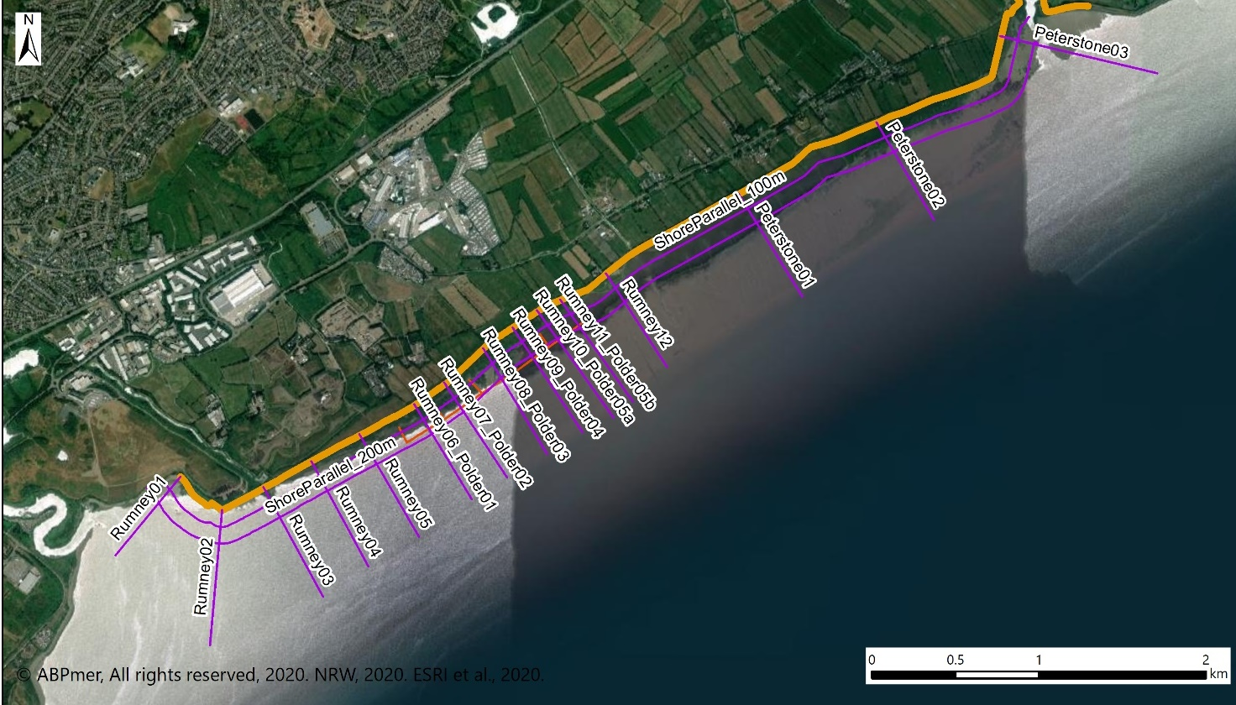
Figure A1 Location of the profiles
In each of the images, the following tidal levels have been inserted in the graphs:
- HAT: Highest Astronomical Tide;
- MHWS: Mean High Water Springs; and
- MHWN: Mean High Water Neaps.
Also, where polder fences intersect, this is indicated with a vertical brown line (set at 2 m height as standard).
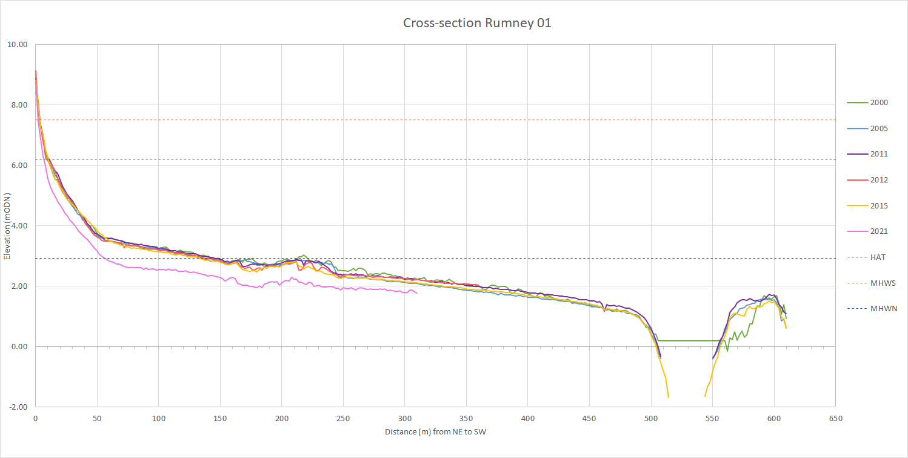
Image A1 LiDAR cross section Rumney 1, comparing available years (see Figure A1 for location)

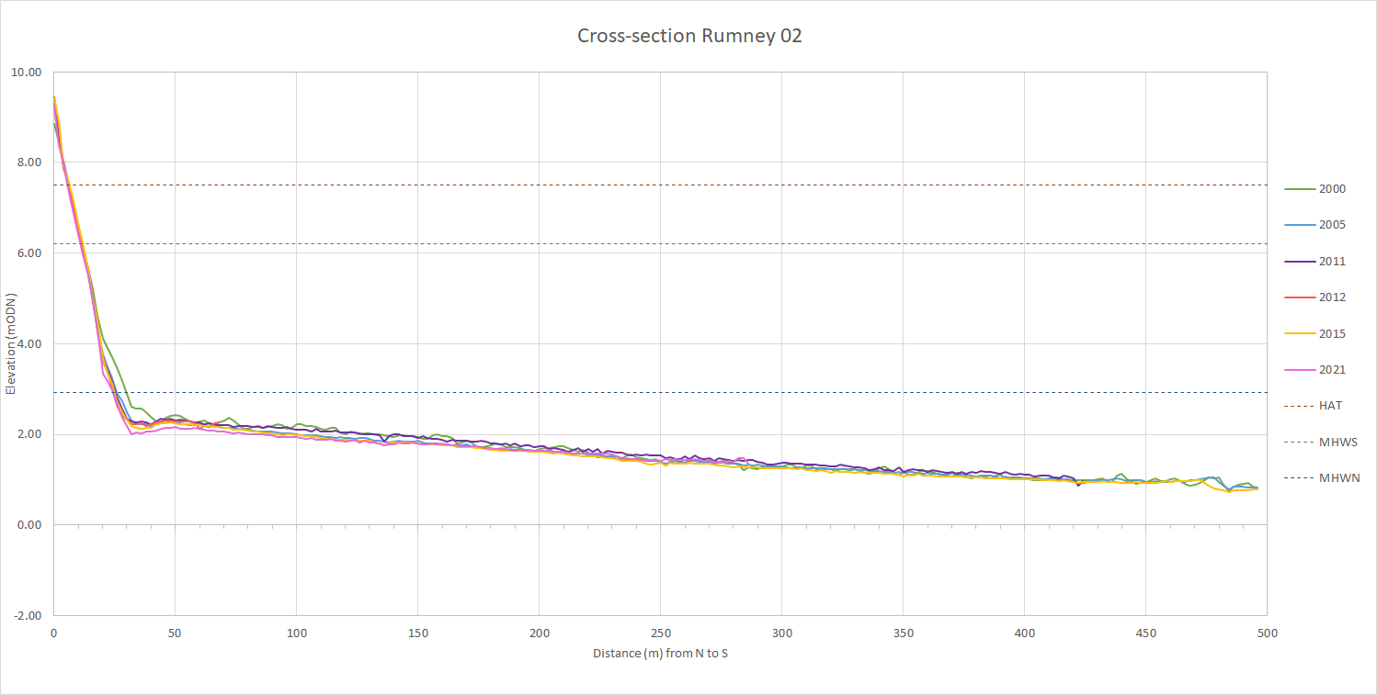
Image A2 LiDAR cross section Rumney 2, comparing available years (see Figure A1 for location)
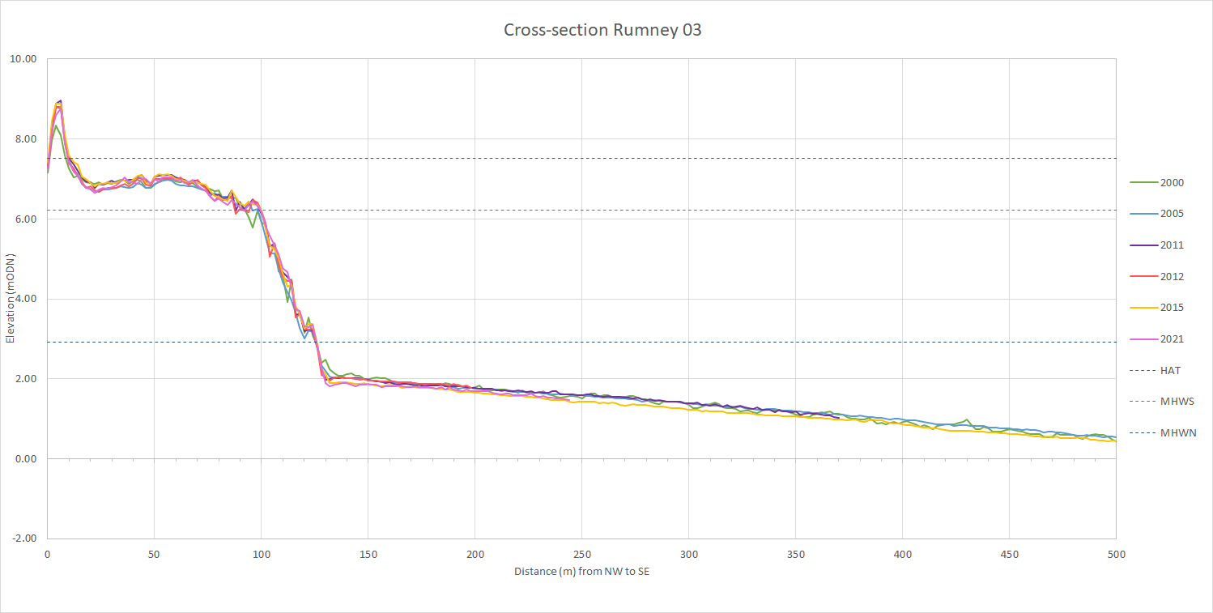
Image A3 LiDAR cross section Rumney 3, comparing available years (see Figure A1 for location)

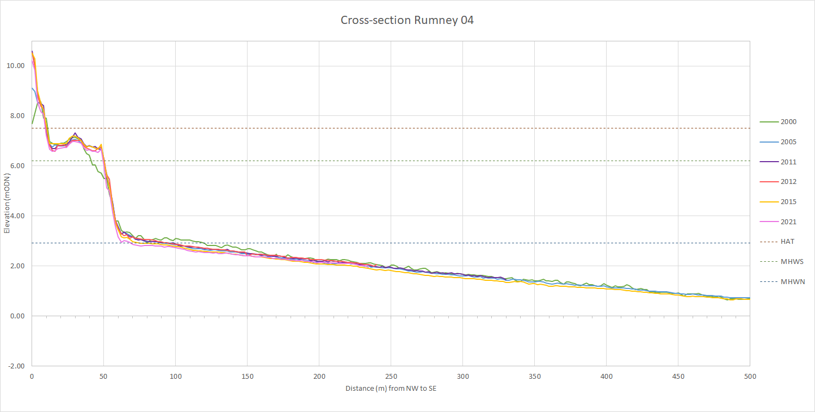
Image A4 LiDAR cross section Rumney 4, comparing available years (see Figure A1 for location)

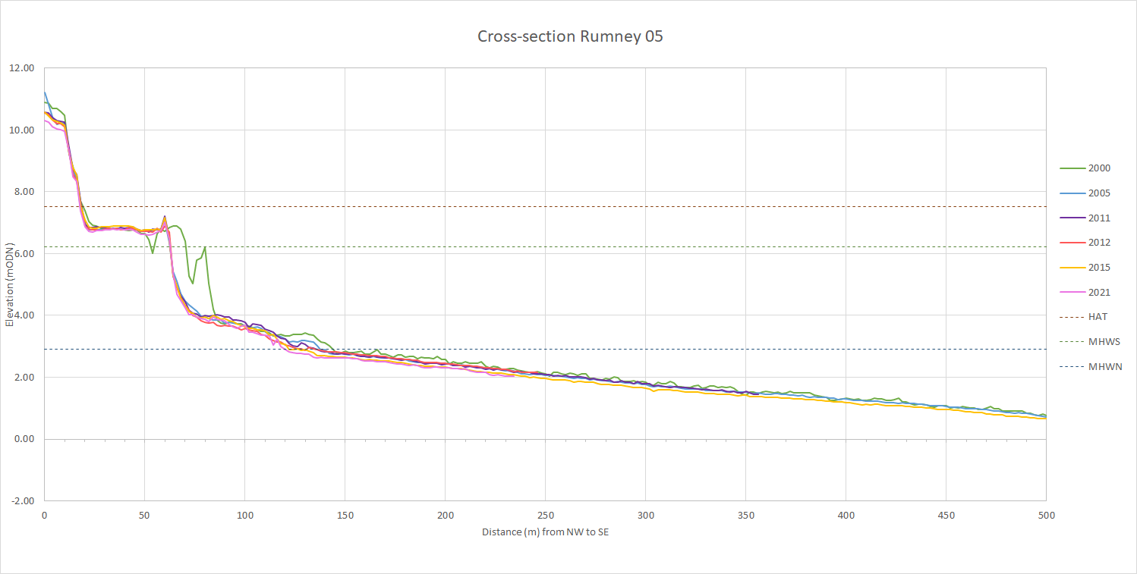
Image A5 LiDAR cross section Rumney 5, comparing available years (see Figure A1 for location)

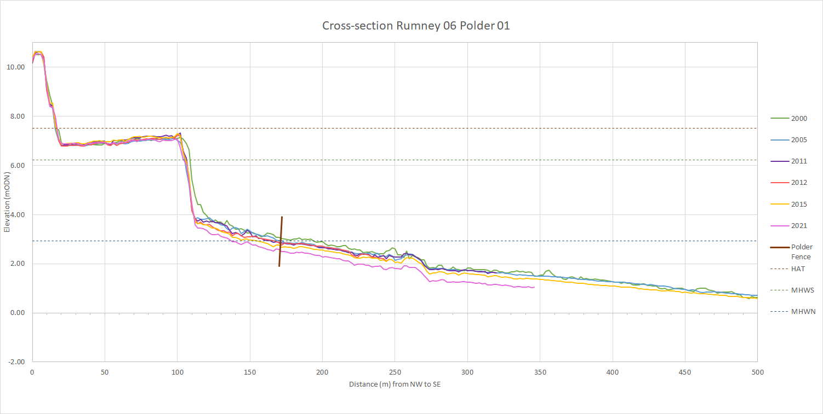
Image A6 LiDAR cross section Rumney 6 (Polder 1), comparing available years (see Figure A1 for location)

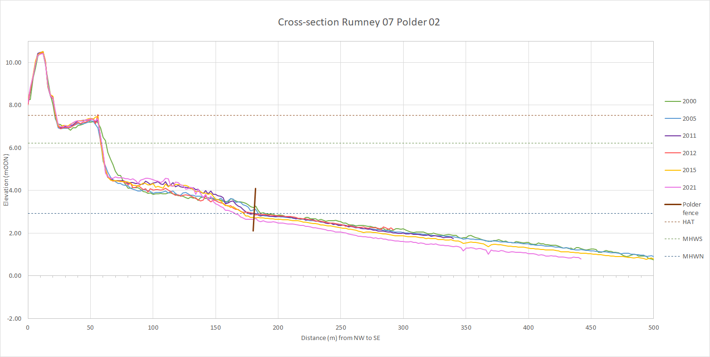
Image A7 LiDAR cross section Rumney 7 (Polder 2), comparing available years (see Figure A1 for location)

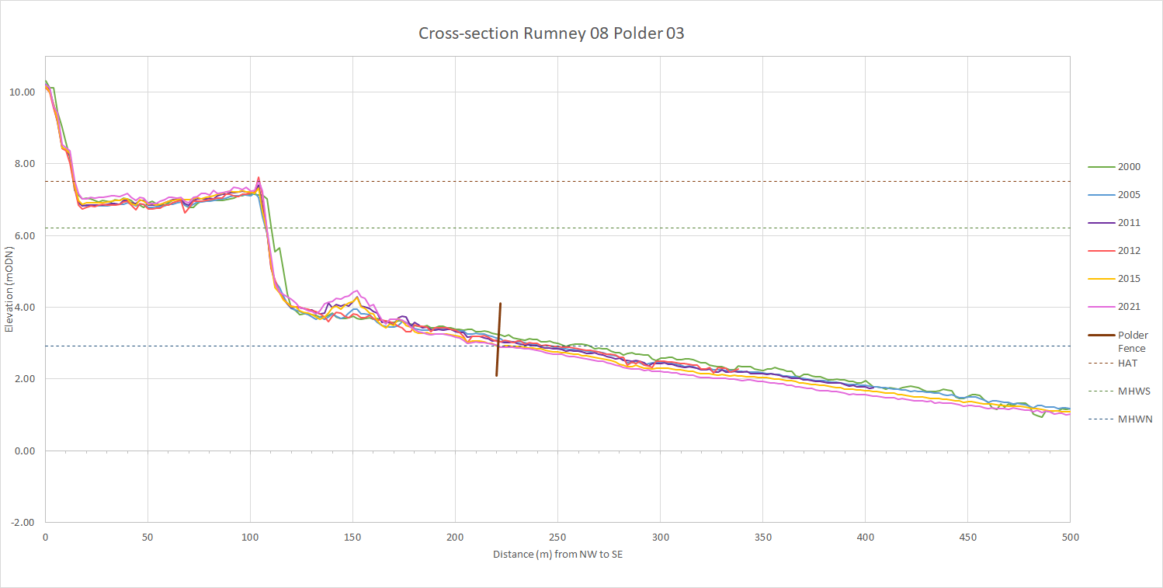
Image A8 LiDAR cross section Rumney 8 (Polder 3), comparing available years (see Figure A1 for location)

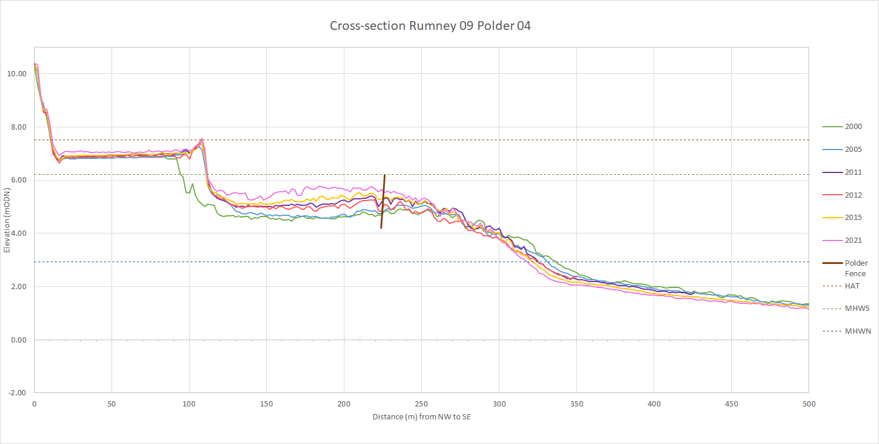
Image A9 LiDAR cross section Rumney 9 (Polder 4), comparing available years (see Figure A1 for location)

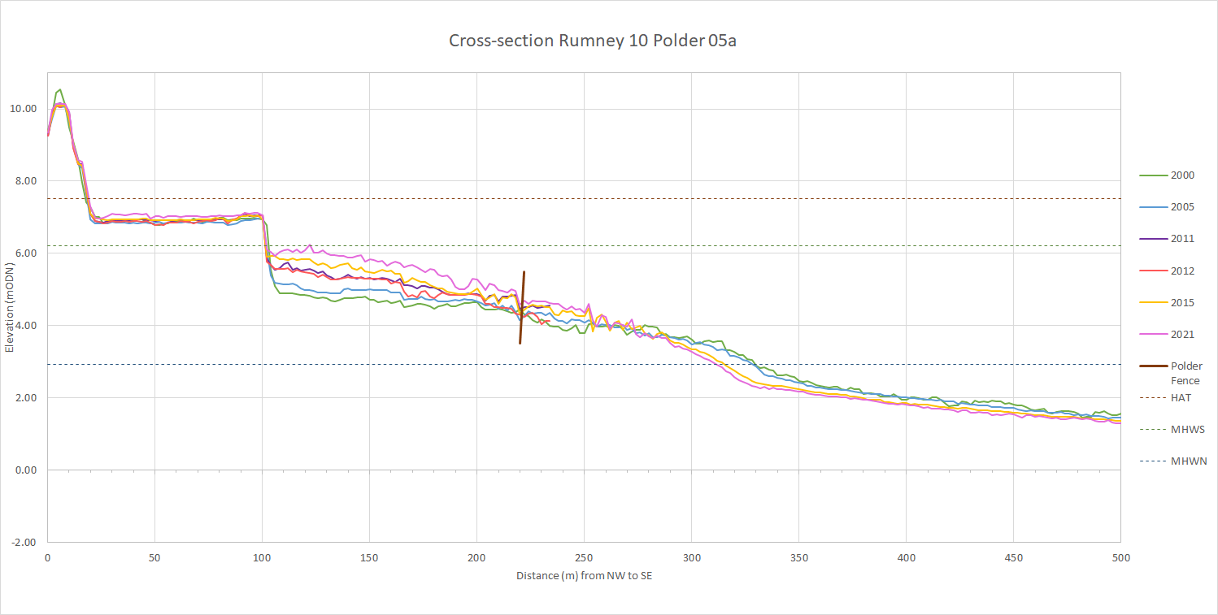
Image A10 LiDAR cross section Rumney 10 (Polder 5a), comparing available years (see Figure A1 for location)

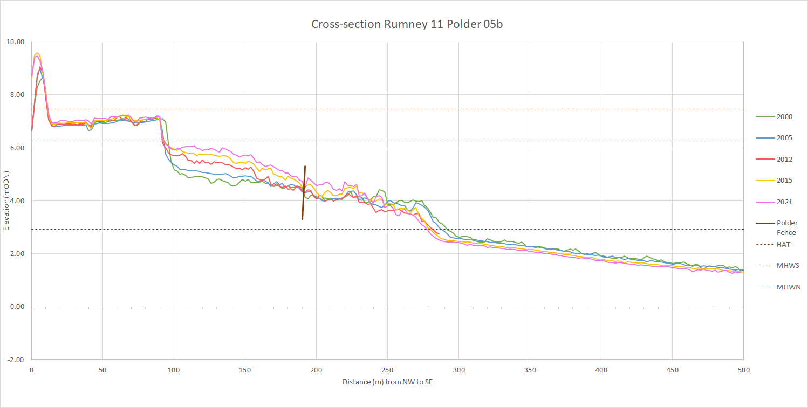
Image A11 LiDAR cross section Rumney 11 (Polder 5b), comparing available years (see Figure A1 for location)

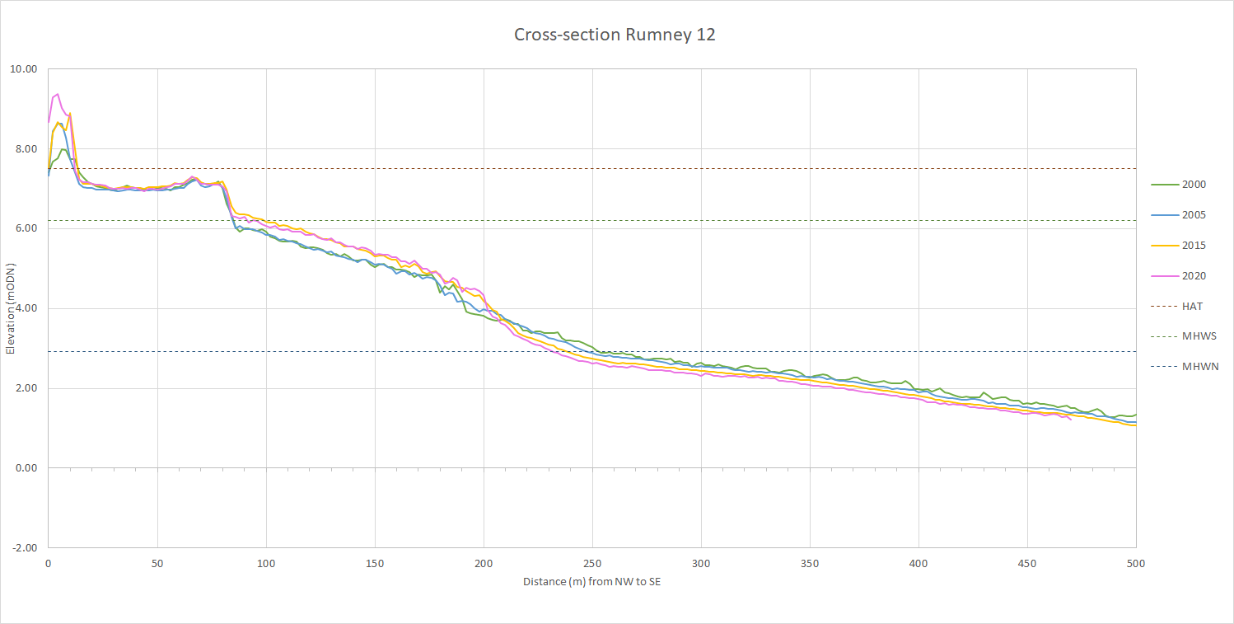
Image A12 LiDAR cross section Rumney 12, comparing available years (see Figure A1 for location)

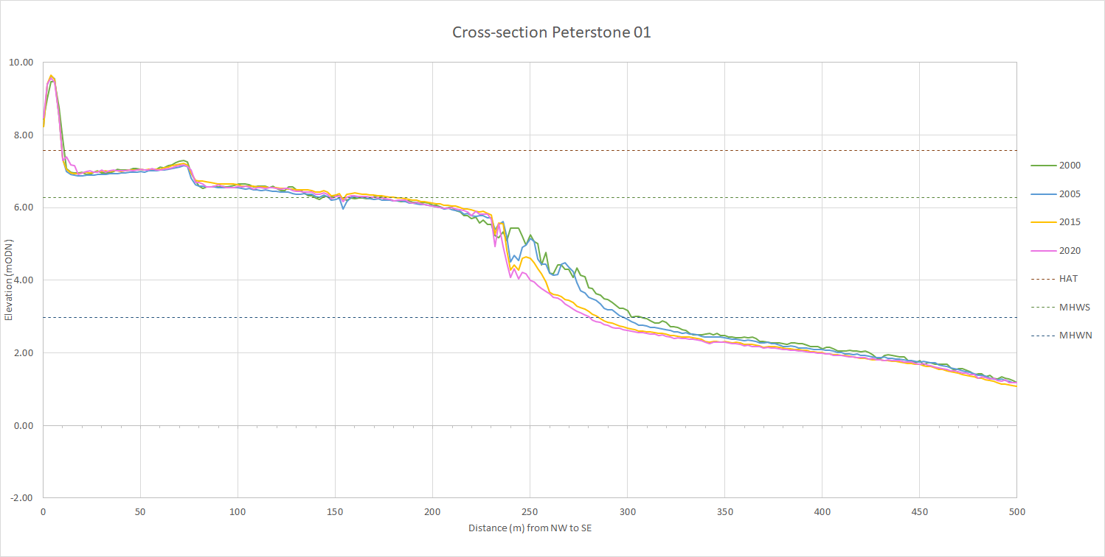
Image A13 LiDAR cross section Peterstone 1, comparing available years (see Figure A1 for location)

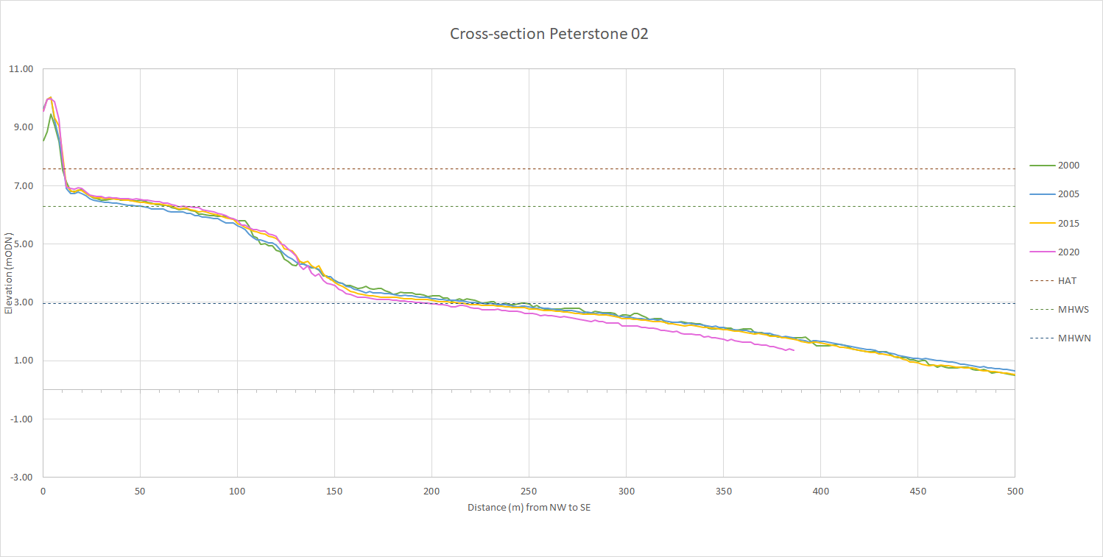
Image A14 LiDAR cross section Peterstone 2, comparing available years (see Figure A1 for location)

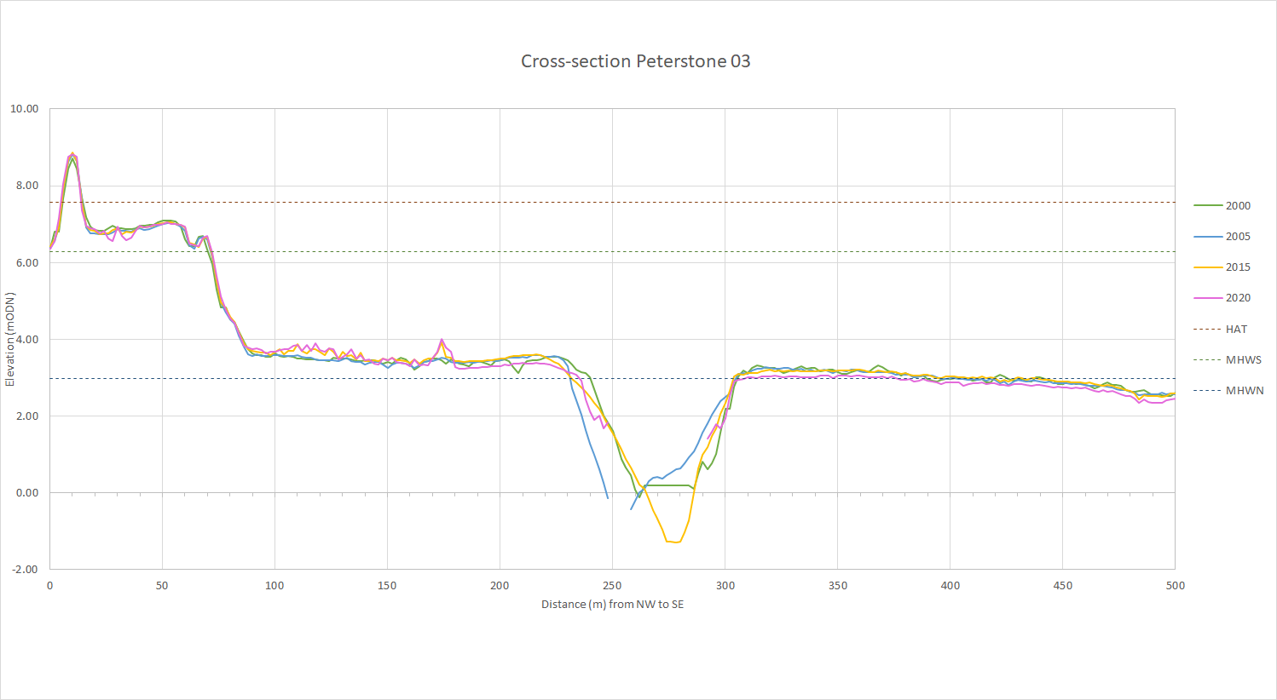
Image A15 LiDAR cross section Peterstone 3, comparing available years (see Figure A1 for location)

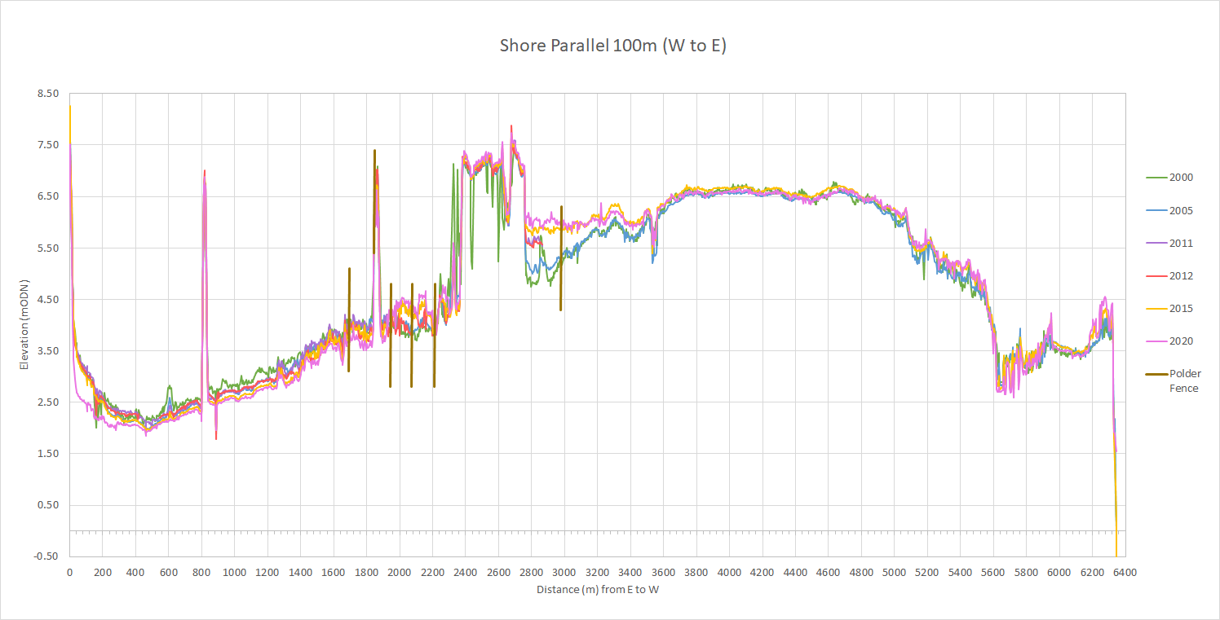
Image A16 LiDAR shore parallel long-section, 100 m from shore / embankment crest (see Figure A1 for location)

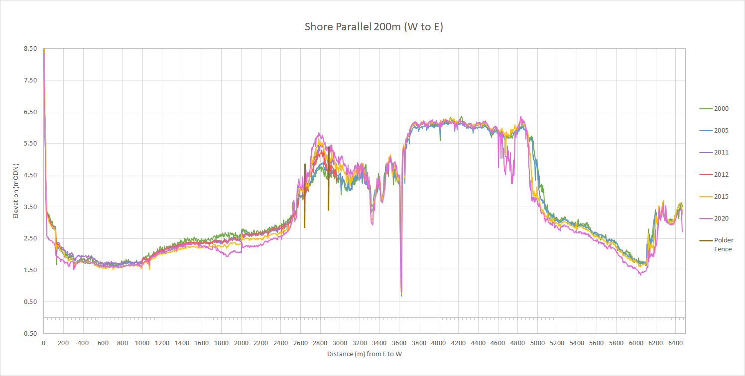
Image A17 LiDAR shore parallel long-section, 200 m from shore / embankment crest (see Figure A1 for location)

Data Archive Appendix
Data outputs associated with this project are archived in NRW Central Data Repository Archive on server–based storage at Natural Resources Wales.
The data archive contains:
[A] The final report in Microsoft Word and Adobe PDF formats held in our Document Management System.
[B] Aerial drone footage converted to an ASCII Grid format.
[C] A full set of images produced in a mixture of JPG and TIFF formats.
Metadata for this project is publicly accessible through Natural Resources Wales’ Library Catalogue https://libcat.naturalresources.wales (English Version) and https://catllyfr.cyfoethnaturiol.cymru (Welsh Version) by searching ‘Dataset Titles’. The metadata is held as record no 124922.

As determined by examining the saltmarsh edge from the 2017 NRW saltmarsh extent layer with 2015 LiDAR data (the most recent available LiDAR year). In the absence of data from the same year, this comparison gives a broad indication of marsh niches, and shows that, generally, saltmarsh becomes established at least 1 m above where it might otherwise be expected. This is because the level of MHWN is, in other locations, often associated with the mudflat-to-saltmarsh transition zone, but this is known to be higher in the estuaries with significant wave exposure and a high tidal range (e.g. Clarke et al., 1993), such as the Severn.
The naturally occurring 18.6-year lunar nodal cycle affects tidal range by around 4 %; this could impact saltmarshes through increased or decreased inundation (Jeuken et al., 2003). The cycle last peaked in September 2015, so the slightly increased inundation times and frequency up to 2015 may have also contributed to the higher rates of accretion seen between the years 2005 and 2015 (noting that the cycle’s trough had occurred just after 2006).
Whilst slightly closer discharge would be possible in the River Rhymney channel, this would still be at least 0.45 km distant. Furthermore, as the subtidal channel meanders and is fairly narrow at 25 m to 35 m, it may not be maneuverable by larger vessels.. Also, disposal in a river channel utilised by recreational craft (which the tidal section of the Rhymney is) may be undesirable.
With the latter value derived from interrogations of the ‘intertidal mudflat and sandflats - Marine Article 17 Reporting Habitat Features’ datalayer available on the Lle Geo-Portal. The saltmarsh extent was derived by deducting the areas which are expected to have been eroded from the totals derived from the last time saltmarsh was mapped at the frontage (in 2017).
Whilst current losses could not be calculated for mudflat in a similar vain to saltmarsh (see Section 3.3.1), the LiDAR review undertaken has nevertheless clearly shown that mudflats are becoming lower. Thus, this study assumes that such lowering continues to the low water mark, and mudflats are therefore becoming subtidal along the seaward edge. Mudflat losses have been assumed to be taking place at a similar rate / percentage rate to those derived for saltmarsh, accelerating from 2026 (as noted in Table 7).
These were included as saltmarsh types are typically being associated with a characteristic number of tidal inundations per year, which can broadly be related to tidal levels. In most locations, the level of MHWN closely relates to the transition between mudflat and saltmarshes (though in estuaries with high wave exposure and large tidal prism such as the Severn, this would tend to higher in the tidal frame (e.g. Clarke et al., 1993)). MHWS tends to be associated with the transition to upper marsh, and HAT with the very upper limit of saltmarshes (e.g. Davis et al., 2018).

