November 2022

“Baby it’s cold outside!” - How to ‘Carry on’ learning in the natural environment during the winter months
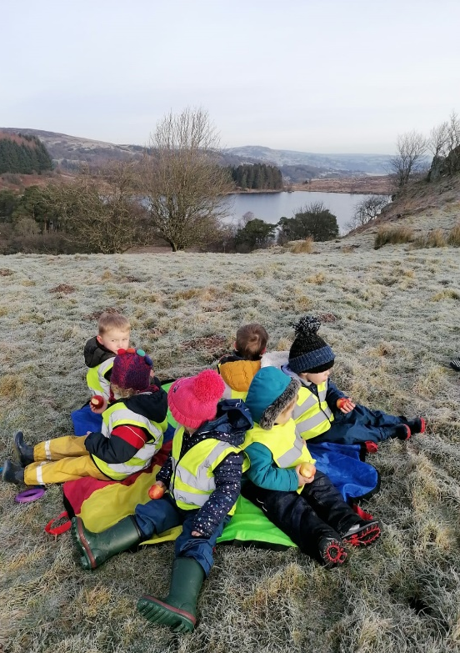
You look out the window and see a grey and dull day or feel a crisp, cold breeze drafting through the door as you open it. “We’ll leave it until tomorrow”, you say to yourself. It’s easy to put off venturing out into the natural environment with your learners when the temperature dips but just because it’s cold outside doesn’t mean your learners have lost their energy or desire to play. Even during the winter, children are growing, and prolonged sessions of inactivity are not conducive to their muscular development. Getting outside can lift your learners’ mood, recharge their vitamin D and immunity levels, and offers an opportunity to indulge in a spot of midwinter mindfulness. Here are our tips on how to enjoy the outdoors with your learners in the colder months ahead.

- Layer up – Suitable clothing for both children and adults. “There’s no such thing as bad weather only bad clothing” to quote the Scandinavians and they should know! Communicate with parents, let them know your learners will be heading outside in all weathers and to expect some washing. Learners of all ages should be layered up like pickled onions – plenty of layers, double socks, hat, gloves and scarves along with waterproofs and wellies if possible. Bringing in a change of clothes for after is advisable. Don’t be afraid to be specific with parents – it’s not them that will be spending time outdoors!

- Spare clothing - You can build up a bank of outdoor clothing by asking parents to donate outgrown items and asking local charity shops to put items to one side. You could also approach outdoor clothing retailers for donations – it can do no harm to ask!

- Drying clothing - it can be tricky to find places to hang up wet kit to dry or a place to store muddy wellies but there are lots of storage ideas online. Is there a tradesperson amongst your parents who might be happy to donate some unwanted lengths of wood and some time to rig up a drying horse or shed?

- Routine is king! Where possible encourage your children to do as much as they can for themselves in getting ready to go outside. This can be frustrating and cut into outside time, but these are important life skills so be patient and encouraging. It will be a hard slog to begin with but with practice and routine, learners will do this quickly and without fuss as they will be keen and eager to head outside.

- Short bursts - Take the lead from your learners. You don’t have to be outside for hours on end, even fifteen minutes outside can refresh your learners and allow them to let off steam. Explain the task before you venture out to minimise the time spent standing around on a cold day. Carry out your investigations or gather resources and carry on the learning once you are back inside.

- Keep active – It’s only cold if you and your learners are standing still!
Your learners won’t thank you if you keep them standing around out in the cold. Make sure anytime spent out in the natural environment is spent being physically active. Do a warm-up before they head outdoors so the cold blast doesn’t hit them quite so severely. Make the journey to your base part of the lesson – can you set a trail for your learners to follow? Set them challenges – “who can find 4 yellow leaves?”. Why not lead a ‘Wilderness workout’ (Activity 12 in our Health and well-being booklet) for your learners?

Hopefully you will find these tips and tricks useful in helping you and your learners to head out and stay warm this winter. If you have any further suggestions you would like to share please drop us a line or a message? Sharing is caring!

Looking for learning resources, information or data? Please contact:
education@naturalresourceswales.gov.uk or go to https://naturalresources.wales/learning
Alternative format; large print or another language, please contact:
enquiries@naturalresourceswales.gov.uk
0300 065 3000

